

**School of Social Sciences, Education and Social Work**

**MASTERS DISSERTATION**

**CONDITIONS OF USE**

Dear Reader

The author of this dissertation has kindly agreed that it can be housed and displayed, in electronic format, for reference only, for the use of Registered Students and Staff of the School of Social Science, Education and Social Work only.

The work is on display for reference and informational purposes only as part of your personal study. Under no circumstances can part or all of this work be copied or reproduced without the author’s permission. This work cannot be copied or downloaded or in any way reproduced or appear in someone else’s work.

For further information, please refer to the School’s Masters Handbook or Dissertation Handbook.

Educational Leadership  
through the use of Multiple Intelligences   
in Technology-Enhanced Learning Classrooms

by

Aleksei Krivetskii

**A dissertation submitted as part of the requirements for the  
Degree of Master of Science in Educational leadership  
in the School of Social Sciences, Education and Social Work,  
Queen's University, Belfast**

**September 2019**

Abstract

Issues of leadership, multiple intelligences and technology innovation are crucial for the transformative paradigm shift in education. However, relationships among all three dimensions have not been explored by researchers. This study examined educational leadership through the lens of Multiple Intelligences (MI) theory application in technology-enhanced learning classrooms. The research involved teachers of ICT/Computing departments from post-primary schools in Northern Ireland. The mixed concurrent nested method was selected for quantitative and qualitative data collection in a cross-sectional online survey to examine teachers’ awareness and perception of MI theory and frequency of MI categories promotion by choice of instructional technology tools. Also, leadership roles were explored in relation to instructional technology innovation. The results showed low overall levels of MI theory familiarity; however, MI theory was being applied by teachers without conscious knowledge about it. Common barriers to MI theory implementation were time and budget constraints, pressure of standardized tests, and lack of professional development, facilities and resources. School management type was found to correlate with perception of MI theory; grammar school teachers perceived MI theory as less applicable, useful and motivational than secondary school teachers. Classroom technology tools linked to core ICT skills were found to be most frequently used, catering mostly for intrapersonal, interpersonal, logical-mathematical and verbal-linguistic intelligences. It was evident that catering for MI may occur naturally due to the multimodal opportunities provided by expanded affordances of modern technology tools. Educational technology leaders were identified based on their high frequency of decision-making and high level of personal interest in technology innovation; they perceived other position-holders and pupils as decision-makers more frequently than other teachers, which highlighted the idea of distributed leadership. External social factors were found to have less impact on technology innovation than internal factors. Subsequent studies may extend research strategies, adopting methods which allow for the collection of more qualitative data, and to examine policymakers’ perception of MI theory and teacher leadership. Furthermore, worldwide developments and trends in technology-enhanced teaching and learning should be explored in relation to MI theory and the leadership role of the teacher.

Acknowledgements

I would like to express my sincere appreciation to everyone who has supported me, helping me to grow and learn throughout the process of writing this dissertation.

Firstly, I would like to thank my dissertation supervisor, Dr Pamela Cowan, for her guidance, support and invaluable feedback throughout the entire dissertation writing process. Your enormous optimism and encouragement have motivated me to complete this research project with the best of my ability.

I would like to extend my gratitude and appreciation to the tutors of my academic modules throughout the year: Dr Gavin Duffy, Prof Tony Gallagher, Dr Ibrar Bhatt, Dr Oscar Bladas Marti, and Dr Andy Biggart.

My heartiest appreciation goes to my friends and classmates Anastasia, Elmira, Puspa, Rafael and Svetlana, for the shared experience of the brightest and the toughest moments of our graduate education journey. I appreciate your enormous encouragement and support.

Finally, I would like to express my gratitude and appreciation to my loving and supportive family. My wife Ksenia and my mother Natalya have been an enduring source of inspiration, support and love. Without you, none of this would have been possible.

Table of Contents

Chapter 1 : Introduction 1

Chapter 2 : Literature Review 4

2.1 Multiple Intelligences theory 4

2.1.1 Multiple Intelligences theory development 4

2.1.2 MI theory and education 5

2.1.3 Critique of MI theory 7

2.2 Multiple intelligences in the classroom 8

2.2.1 Illustrations of each MI in the classroom 8

2.2.2 MI and technology in the classroom 10

2.3 School leadership 12

2.3.1 Change in education 12

2.3.2 Technology-enhanced learning and innovation 13

2.3.3 Leadership for technology-enhanced learning 17

2.3.4 Leadership styles and practices 18

2.3.5 Distributed leadership 20

2.4 Research objectives 21

2.5 Summary 22

Chapter 3 : Methodology 23

3.1 Introduction 23

3.2 Research objectives 23

3.3 Research strategy 23

3.3.1 Quantitative versus qualitative research methods 23

3.3.2 Mixed methods approach 25

3.4 Sampling of participants 25

3.4.1 Response rate 26

3.5 Data collection 27

3.5.1 Cross-sectional survey 28

3.5.2 Pilot study 29

3.5.3 Validity and reliability 29

3.6 Ethical considerations 31

3.7 Analysis of the data 33

3.8 Limitations of the research 34

3.9 Summary 34

Chapter 4 : Findings 36

4.1 Introduction 36

4.2 Descriptive statistics 36

4.2.1 Respondents’ characteristics 36

4.2.2 School characteristics 38

4.2.3 Multiple Intelligence (MI) theory familiarity 41

4.2.4 Perceived application of MI theory in the classroom 43

4.2.5 Perceived usefulness and motivation 48

4.2.6 Multiple intelligences categories and instructional technology 51

4.2.7 Drivers for innovation 55

4.2.8 Making decisions about introducing new technology 57

4.2.9 Frequency of making decisions by respondents 58

4.2.10 Perceived frequency of making decisions by others 59

4.2.11 ICT budget 61

4.3 Analysis of qualitative data 62

4.3.1 MI theory applicability to teaching techniques 63

4.3.2 Barriers for MI theory implementation in the classroom 64

4.3.3 ICT/Computing budget availability and processing 65

4.4 Summary of findings 66

Chapter 5 : Discussion of Findings 68

5.1 Introduction 68

5.2 Teachers’ awareness and perceptions of applicability of MI theory 68

5.2.1 Teachers’ awareness of MI theory 69

5.2.2 Teachers’ perceptions of the applicability of MI theory 70

5.2.3 Perceived barriers for MI theory implementation 70

5.3 Personal and school characteristics in relation to teachers’ perceptions of MI theory 71

5.4 Instructional technology and multiple intelligences 72

5.5 Leadership, change and drivers for innovation 74

Chapter 6 : Conclusions 78

6.1 Introduction 78

6.2 Research questions 78

6.3 Recommendations 82

6.4 Limitations of the study 82

6.5 Areas of future research 83

List of references 85

Appendices 99

Appendix A: Ethics review 99

Appendix B: Participant information and Consent form 100

Appendix C: Copy of online survey questionnaire 103

Appendix D: The types of intelligence 115

Appendix E: Thematic analysis of qualitative survey data 116

List of figures

Figure 4.1: Respondents' gender 37

Figure 4.2: Main subject taught 37

Figure 4.3: Age category by teaching experience 38

Figure 4.4: Number of respondents by school size 39

Figure 4.5: Respondents distribution by county 39

Figure 4.6: Number of respondents by school management type 40

Figure 4.7: MI theory familiarity 41

Figure 4.8: MI theory familiarity by gender 42

Figure 4.9: MI theory familiarity by age category 42

Figure 4.10: MI theory familiarity by teaching experience 43

Figure 4.11: MI theory familiarity and frequency of MI theory application in the classroom 44

Figure 4.12: Gender and frequency of MI theory application in the classroom 44

Figure 4.13: Teaching experience and frequency of MI theory application in the classroom 45

Figure 4.14: MI theory familiarity and perception of MI theory applicability to teaching techniques 46

Figure 4.15: Teaching experience and perception of MI theory application to teaching techniques 47

Figure 4.16: School management type and perception of MI theory applicability to individual teaching techniques 47

Figure 4.17: Perceived usefulness and motivation of MI theory application in ICT/Computing lessons at Key Stage 3 48

Figure 4.18: Perceived usefulness and motivation of MI theory application in ICT/Computing lessons at Key Stage 4 49

Figure 4.19: Perceived usefulness and motivation of MI theory application in ICT/Computing lessons at Post-16 50

Figure 4.20: Perceived usefulness by school management type 50

Figure 4.21: Perceived motivation by school management type 51

Figure 4.22: Frequency of use of E-safety and perception of MI applicability to classroom practice 54

Figure 4.23: Frequency of use of Email and MI theory familiarity 55

Figure 4.24: Frequency of use of presentation software and MI theory familiarity 55

Figure 4.25: Personal interest as a driver for innovation and frequency of making decisions about introducing new technology 58

Figure 4.26: Frequency of personal decision-making and perception of Principal/VP’s frequency of making decisions 60

Figure 4.27: Frequency of personal decision-making and perception of HOD’s frequency of making decisions 60

Figure 4.28: Frequency of personal decision-making and perception of the Senior Management Team’s frequency of making decisions 61

Figure 4.29: Frequency of personal decision-making and perception of pupils’ frequency of making decisions 61

Figure 4.30: ICT/Computing budget sufficiency 62

List of tables

Table 3.1: Reliability statistics 31

Table 4.1: Instructional technology: frequency of use 51

Table 4.2: MI categories and instructional technologies 52

Table 4.3: MI through technology in the classroom 53

Table 4.4: Drivers for innovation 56

Table 4.5: Who makes decisions about introducing new technology? 57

Table 4.6: MI theory applicability to teaching techniques 63

Table 4.7: Barriers to MI theory implementation in the classroom 64

Table 4.8: ICT/Computing budget sufficiency for teachers’ needs 65

# : Introduction

The emerging worldwide paradigm shift in education emphasizes the importance of globalization, localization, contextualized multiple intelligences and personification; therefore, effective leadership is crucial to facilitate the education reforms (Cheng, 2019). As the global society is becoming increasingly competitive, fast-paced and technologically advanced, there is a growing need for new approaches to teaching and learning skills for the 21st century, such as knowledge transfer, meta-cognition, teamwork, creativity and technology. It is crucial to advance critical thinking, problem-solving and communication skills (Saavedra & Opfer, 2012). Noguera (2015) defines today’s learners as multiprocessing and multiliterate. In order to engage digital learners, Kalkhurst (2018) claims that “the Millennials forced educators to begin using technology as a teaching tool”, while “Gen Zs were born with technology”, suggesting the importance of meaningful technology integration in the classroom.

Technology, as a catalyst for social transformation, has the potential to make a contribution to the transformational change of education. Educational organizations are viewed as slow-changing organisations, but rapid societal and technological changes force schools to “act in adaptive and innovative ways” to remain relevant (Eyal & Kark, 2004: 219). Innovative pedagogical practices can be introduced by enthusiastic teachers as pilot programmes or *islands of innovation* (Forkosh-Baruch *et al.*, 2005). It is anticipated that these islands of innovation will be able to reproduce their environment and lead to *comprehensive innovation* (Levin & Fullan, 2008). According to school improvement literature, organisational change and development can be enhanced by distributed leadership models in which teachers contribute to innovation and change, taking ownership and acting as drivers for innovation (Hopkins, 2005; Murphy & Datnow, 2003). Researchers support the view that the distributed leadership model can be effectively applied in schools (Robinson, 2008; Spillane & Healey, 2010; Harris & DeFlaminis, 2016).

Previous research in the field of technology-enhanced learning outlines the need for a culture of change which is created and led by learning leaders who have “the capacity to seek, critically assess, and selectively incorporate new ideas and practices” (Fullan, 2001: 44), which has the potential to replace currently technocentric technology integration practices that ignore the complex interdependencies among pedagogy, context, technology and content (Harris *et al.*, 2009).

Stanciu *et al.* (2011: 93) claim that “holistic approach to learning, a global perspective on the teaching-learning processes and a focus on differentiated instruction should be promoted” and propose that Gardner’s Multiple Intelligences (MI) theory offers effective ways to design and implement specific learning approaches. MI theory can be adopted as a framework for meaningful technology integration based on flexibility, personalization and active learning instead of merely replicating existing teaching techniques (Noguera, 2015). It is informed by instructional strategies that focus on understanding and understanding through adaptation to learners’ individualities; it can be applied in a variety of educational contexts and it addresses the content through “seven access points for introducing and constructing concepts: narrative, quantitative-numerical, logical, existential, esthetical, practical, and interpersonal” (Stanciu *et al.*, 2011: 93). This will ensure that pupils’ different learning modalities are served, resulting in their improved engagement and responsibility for learning outcomes (Jackson *et al.*, 2009).

Gardner (1993: 12) introduced Multiple Intelligences (MI) theory as a way to “increase the likelihood of our survival on this planet, and perhaps even contribute to our thriving”. MI theory has been embraced by experts in psychology, anthropology, and education (McCoog, 2007). There is evidence provided by numerous studies that application of MI theory has a positive impact on pupils’ academic outcomes (Hoerr, 2004; Armstrong, 2018). Researchers support Sword’s (2007: 247) view: “MI-inspired teaching can facilitate the kind of critical-creative thinking that will allow our students to flourish in an increasingly multidisciplinary social and intellectual environment”. Scholars researched MI theory application in the classroom and found improvement in the instruction of various subjects and metacognition skills, including creative thinking (Widiana & Jampel, 2016), foreign language acquisition (Madkour and Mohammed, 2016), students’ performance in a science course (Abdi, Laei and Ahmadyan, 2013). Also, Yurt and Polat’s (2015: 84) meta-analysis of existing research revealed “a large and positive effect” of MI theory application on academic achievement.

An in-depth review of the literature provides rich evidence of existing research in the fields of MI theory application in the classroom, distributed leadership at schools, and classroom technology integration. However, it appears that the area of leadership in relation to implementation of MI theory in teaching computer science or ICT has not been explored.

Drawing on the ‘gap’ in the available literature, the goal of this study is to examine educational leadership through the lens of MI theory application in technology-enhanced learning classrooms. Therefore, the following research questions will be addressed:

1. To what extent are teachers aware of MI theory, and what are teachers’ perceptions of MI theory applicability to their teaching practice?

2. What is the relationship between personal and school characteristics and teachers’ perception of MI theory applicability to their teaching practice?

3. Are all multiple intelligences promoted equally through the choice of technology tools being used in the classroom?

4. Who influences the change in topics being taught in ICT computing? Who/What are the drivers for innovation?

This dissertation consists of six key chapters. The first chapter, *Introduction*, sets out the background to this study. The chapter on *Literature review* will examine MI theory, integration of classroom technologies and school leadership. The chapter on *Methodology* will concentrate on the methodological considerations of this study in order to explore the research questions. The analysis and the findings of the study will be elaborated in the *Findings* chapter. The *Discussion* chapter will summarize the main findings of the research and relate them to the literature review. Finally, the *Conclusions* chapter will provide a synthesis of the findings, indicating the limitations of this study and outlining areas for future research.

# : Literature Review

## 2.1 Multiple Intelligences theory

### 2.1.1 Multiple Intelligences theory development

Human intelligence has been researched since the end of the 19th century when various theories of intelligence emerged (Denig, 2004). General intelligence has been widely defined in the field of psychology as the capacity for problem-solving (Visser *et al.*, 2006). However, Gardner (2003) claims that all people are in possession of multiple intelligences, questioning the idea of general intelligence which is based solely on logical and linguistic ability. Howard Gardner’s theory of Multiple Intelligences (MI) was developed in 1983 (Gardner, 2011) based on his research in the field of cognitive and developmental psychology (Gardner, 2003). As a professor of neuropsychology, Gardner (2003: 34) researched a variety of modes of human interaction with the world and proposed a definition of an intelligence: “a biopsychological potential to process information that can be activated in a cultural setting to solve problems or create products that are of value in a culture”.

Gardner (2003) suggested that the traditional IQ-based general intelligence concept does not provide a valid assessment of learner ability and is limited. Learners lacking exceptional linguistic or logical skills can be cognizant in different intelligences and are not void of cognitive abilities because “information comprises a collection of such inputs in any format that can be interpreted, understood, and made use of by the person (or, more precisely, by his or her computational capacities)” (Moran *et al.*, 2006: 228). Moreover, under-developed areas of intelligence can be improved by exercising activities that address different intelligences (Silver *et al.*, 2000). Rushton and Juola-Rushton, 2008: 88) explain that “the key to a brain-compatible classroom is to grow more synaptic connections between brain cells with minimal to no loss of existing connections”.

Gardner (2006: 56) states that it is important to differentiate the concepts of learning styles and multiple intelligence: “The concept of style designates a general approach that an individual can apply equally to every conceivable content. In contrast, an intelligence is a capacity, with its component processes, that is geared to specific content in the world (like musical sounds or spatial patterns)”.

According to Armstrong (2018: 2) “Gardner sought to broaden the scope of human potential beyond the confines of the IQ score”. The following seven MI were identified at the early stage of MI theory development: verbal-linguistic, logical-mathematical, visual-spatial, bodily-kinaesthetic, musical, intrapersonal, and interpersonal. Naturalistic intelligence was conceptualized later. MI theory was further developed in Gardner’s publication ‘*Intelligence Reframed*’ (2003), adding two more possible intelligences, existential and spiritual.

The key points of Gardner’s theory (2003) are the following:

1. The intelligences are related to different areas of the brain and therefore form different neural connections. According to Posner, 2004 (cited in Armstrong, 2018), recent neuro-imaging research proves Gardner’s suggestion of different intelligences located in separate areas of the brain.
2. Intelligence profile of each individual is unique, identifying a predominant way of learning and processing information.
3. Students’ intelligence profiles can be assessed in order to improve learning outcomes by designing activities that address the appropriate intelligences.

Gardner (1993: 12) emphasized the importance of MI theory for the humanity and claimed: “If we can mobilize the full range of human intelligences and ally them to an ethical sense, we can help to increase the likelihood of our survival on this planet, and perhaps even contribute to our thriving”.

### 2.1.2 MI theory and education

Over the past twenty years, Multiple Intelligences theory has been embraced by experts in various fields, such as psychology, anthropology, and education (McCoog, 2007). Originally, MI theory was not intended for educational practice, but the growing interest of researchers has led to a series of studies on the theory of MIs and its relationship to learning and teaching: instruction by means of MI (Campbell *et al.*, 2004), MI in primary classroom (Baum *et al.*, 2006), MI and leadership (Riggio *et al.*, 2002), teaching technology (Sánchez-Martín *et al.*, 2017), teaching science (Samsudin *et al.*, 2015), development of interpersonal or intrapersonal intelligence in problem-based learning (Talib & Bini-Kailani, 2014). Hsu (2011) explored potential of Kinect as interactive technology to cater for bodily-kinaesthetic affordances “to create enjoyable, interesting interactions types, to boost student motivation, and to promote learning via its multimedia and multi-sensory capacity”.

The growing popularity of MI theory in the field of education is supported by research in teachers’ perceptions of MI initiatives (Hanafin, 2014) and teachers’ performance improvement in MI-based instruction (Yaumi *et al.*, 2018). Baum *et al.* (2006: 3) created a teacher’s toolkit for the primary classroom and suggested the Pathway Model which includes ‘pathways’ to implement MI theory across the primary classroom: “Exploration, Bridging, Understanding, Authentic Problems, and Talent Development”. Educators are encouraged “to become familiar with a range of approaches and choose the one that makes most sense in light of their own goals and contexts” (Baum *et al.*, 2006: viii).

There is evidence for positive effects of MI-based strategy on academic outcomes in various disciplines (Abdi *et al.*, 2013; Campbell & Campbell, 1999; Armstrong, 2018). Abdi *et al.* (2013: 283) explored MI theory application to a science course, indicating that “the students who have been educated by a strategy based on Multiple Intelligences have become more successful than the students who have been educated by the traditional teaching methods”. Widiana and Jampel (2016) examined the implementation of MI strategies in a classroom action research study which showed students’ creative thinking improving by 16.56% and achievement in learning science improving by 11.46%. Similar positive effects were evidenced in foreign language acquisition: “when students became aware of their multiple intelligences profiles, they managed to enhance their motivation, which helped them improve their language skills” (Madkour & Mohammed, 2016: 92).

According to Armstrong (2018: 52), “it [MI theory] makes its greatest contribution to education by suggesting that teachers need to expand their repertoire of techniques, tools, and strategies beyond the typical Word Smart and Number/Logic Smart abilities predominantly tapped [in the classroom]”. Griggs *et al.* (2009: 60) indicate the benefits of MI awareness for both teacher and students: “the students gained insight into their educational process and instructors gained insight into the strengths of the students sitting in their classroom.” A study by Yurt and Polat (2015) examined the effect of MI theory application on academic outcomes, gathering research findings from a variety of disciplines in a meta-analysis. Their research revealed that “the multiple intelligence applications have a large and positive effect on academic achievement”, indicating increasing effect with increasing application period (Yurt and Polat, 2015: 84).

### 2.1.3 Critique of MI theory

Despite these positive effects, MI theory has been the subject of criticism from scholars for lacking empirical foundation (Waterhouse, 2006) or the lack of studies aimed at testing the whole theory (Davis *et al.*, 2011). Others have criticized the arbitrary character of intelligences categories (Hanafin, 2014). However, numerous empirical studies in a number of disciplines resulted in identification of the multiple intelligences (Moran *et al.*, 2006). Armstrong (2018: 192) agrees that “MI’s multiple sources of empirical data considerably expand its validity as a theoretical construct”.

Critics of MI theory have also suggested there is weak evidence of real-life applicability of MI theory for schools. Collins, 1998 (cited in Armstrong, 2018: 192) mentions weak evidence of MI theory, as “there is no firm research showing that its practical applications have been effective”. However, numerous research projects exist in response to this critique, sharing their successful implementation of MI theory (Greenhawk, 1997; Campbell & Campbell, 1999; Hoerr, 2004).

The third main critique reported by Armstrong (2018) is that the classroom application of Gardner’s theory makes pupils mistakenly believe they are smart. Barnett *et al.* criticize MI theory for promoting an artificial “feel-good” attitude, arguing that “the focus must be on displaying meaningful skills and competencies, not simply on feeling that one is smart” (2006: 101). Responding to their critique, Armstrong (2018: 196) claims that MI theory is useful for empowering learners by revealing their positive qualities; therefore, “the most authentic refutation of the critics of MI can be found in the children themselves”. This corresponds with the statement by Tomlinson and McTighe (2013: 46) that “the classroom has to be a place where each student feels safe (not seen as a failure, a nerd, a test score, a social pariah) and also challenged (to become the best it is in that student to be)”.

The next section will provide illustrations of MI theory application in the classroom, followed by a review of multiple intelligences use in relation to classroom technology application.

## 2.2 Multiple intelligences in the classroom

### 2.2.1 Illustrations of each MI in the classroom

**Verbal-linguistic** intelligence is widely used in formal and informal communication. “Linguistic intelligence is the capacity to use language—your native language, and perhaps other languages—to express what’s on your mind and to understand other people” (Baum *et al.*, 2006: 14). It is the ability to comprehend and use written and oral language, paying attention to language functions and the meaning of words. Teaching strategies to address verbal-linguistic intelligence are journal writing, brainstorming and storytelling (Armstrong, 2018). Development of this intelligence is facilitated by the activities of reading, creative writing, impromptu speaking and making speeches (Lazear, 1994). For example, McCoog (2007) suggests an activity which integrates technology for co-creating a poem in the classroom: “each computer has an open word processing document with the lines that are incomplete”, and students can complete the lines with rhyming words (McCoog, 2007: 26).

**Logical-mathematical** intelligence is linked to problem-solving, recognising relationships, patterns and categories by using deductive and inductive thinking (McKenzie, 2009). In order to incorporate logical-mathematical intelligence, Campbell, Campbell and Dickinson (2004) suggest various strategies for questioning that address open issues in real life. In a study by Douglas *et al.* (2008), a group of math class students incorporated MI strategies of “completing logic problems, creating rhymes to remember mathematical concepts, building or constructing a model, inventing a board game to illustrate learned material…”, scoring higher test results than the group which was not exposed to specific MI activities (Douglas *et al.*, 2008: 186).

**Musical-rhythmic** intelligence is the aptitude to recognize sounds, music, rhythms and tones and the ability to display auditory skills, or “the capacity to think in music” (Baum *et al.*, 2006: 15). People with developed musical-rhythmic intelligence are good at interpreting and manipulating patterns (Comeau *et al.*, 2018). According to Armstrong (2018), background music can be used to develop musical-rhythmic intelligence by linking tunes and classroom activities. This agrees with Campbell *et al.* (2004) who suggested using music to set the mood and create an engaging atmosphere during the lesson, giving students options according to their preferences. McCoog (2007) suggests another technology-enhanced classroom activity related to musical-rhythmic intelligence: “A good technology to use with musical learners is a software program that synthesizes music into waves” to assist in the visualization of the repetition in the rhythms (McCoog, 2007:26).

**Bodily-kinaesthetic** intelligence is the ability to express ideas and transform objects through physical movement, action and practical demonstration, and “the capacity to use your whole body or parts of your body—your hands, your fingers, and your arms—to solve a problem, make something, or put on some kind of production” (Baum *et al.,* 2006:16). Development of such skills as flexibility, coordination and strength is beneficial for this intelligence (Tracey & Richey, 2007). Drama, dance, field trips and movement-oriented games are classroom activities that employ tactile experiences and foster bodily-kinaesthetic intelligence (Armstrong, 2018).

**Visual-spatial** intelligence is connected to visualizing and transforming the visual and spatial perception of colours, shapes or images (Rettig, 2005). “Spatial intelligence refers to the ability to represent the spatial world internally in your mind” (Baum *et al.*, 2006: 16). Painting pictures and drawing maps, playing board games and using visual symbols and three-dimensional shapes can be employed to address visual-spatial intelligence, as well as “engaging in hands-on science projects” (Willis, 2007: 54). In a visual-spatial learning environment, rotating sitting positions might be used for changing perspectives, and access to visual tools should be provided by instructors (Campbell *et al.,* 2004).

**Interpersonal** intelligence is the ability to recognize and adequately communicate the motivations, desires and moods of others (Gardner, 2011). Interpersonal intelligence can be addressed in such activities as group or pair work which focus on communication skills. Peer teaching, sharing, brainstorming and community involvement might be incorporated into teaching and learning (Armstrong, 2018).

**Intrapersonal** intelligence is the ability for self-understanding, and “intrapersonal learners are keenly self-aware” (McCoog, 2007: 27). Its core components are self-control, self-discipline and self-respect (Armstrong, 2018). Baum *et al.* (2006: 18) explains that intrapersonal intelligence is also ”knowing who you are, what you can do, what you want to do, how you react to things, which things to avoid, and which things to gravitate toward”. Self-paced instruction implies the use of Internet research, computer-based journaling and concept mapping; for sharing with others, blogs might be used as a tool for structured self-expression (McCoog, 2007).

**Naturalistic** intelligenceis linked to making connections with the natural world. Naturalist learners are keen on recording and presenting the natural world (McCoog, 2007), making digital cameras an excellent technology resource to record visual images (Ibid.). Shepard (2004: 215) suggests an activity that connects naturalistic and intrapersonal intelligences: “photograph nature and reflect and write on how this photo relates to your life”. Utilizing database and electronic spreadsheet technology for gathering data in order to reflect and record the change processes allows naturalists to create a tangible product for further use and research (Gen, 2000).

**Spiritual** or existential intelligence is “any discussion of the spirit - whether cast as spiritual life, spiritual capacity, spiritual feeling, or a gift for religion mysticism or the transcendent” (Gardner, 2003: 53). It includes the ability to focus on the big picture. Existentialists make an attempt to understand how systems work. Problem-solving and communication applications can be used to cater to this kind of intelligence (McCoog, 2007). Existentialists also have strong logical, naturalistic or spatial intelligence (Ibid.).

### 2.2.2 MI and technology in the classroom

Educators should focus on meeting the needs of ‘digital learners’ of today’s technological society (Jackson *et al.*, 2009). Technology is potent to enhance the learning environment if it is used in order to alter existing patterns rather than sustain them (Cuban *et al.*, 2001). Technology application in education will gain more value only in cases where there is teachers’ will to “raise the level of digital inclusion” (Valdez *et al.*, 2010: 1). Nelson *et al.*, 2009: 80) claim that latest communication technologies “can promote student learning and facilitate the development of lifelong skills such as collaboration, creative thinking, and knowledge construction” when applied by skilful teachers.

There are different ways of technology integration based on educational practices and learning theory. Learning activities should be structured to meet students’ learning needs. Jackson *et al.* (2009) claim that integrating technology into the curriculum serves different learning modalities, resulting in students’ engagement and responsibility for learning outcomes. According to Valdez *et al.* (2010: 1), “the unavoidable conclusion is that successful improvement of technology is of high importance to our future”.

In order to meet diverse pupils’ learning needs, Gardner’s theory should be coupled with a view on effective ways of enhancing the learning community by means of technology. Levy (2008: 162) suggests that “the core of differentiated instruction is flexibility in content, process, and product based on student strengths, needs, and learning styles”. Jackson *et al.* (2009) propose project-based learning as a way to keep students involved and increase their ability to achieve better learning outcomes. Combined with technology use and understanding of students’ multiple intelligence profiles, project-based learning with access to authentic data can result in meaningful learning outcomes. Research by Baş and Beyhan (2010) indicates that project-based learning in combination with multiple intelligence awareness resulted in better academic outcomes and a higher motivation level compared with a traditional instructional approach.

A study by Chuang *et al.* (2010) suggests that video game applications and puzzles have the capacity to strengthen learners’ multiple intelligences. However, overall student success has not been influenced by the technology itself (Hoerr, 2004). Curricular activities should be supported by technology in engaging ways, involving technology for learning enhancement. They should focus on instructional goals, not technology (Christensen *et al.*, 2018). McCoog (2007: 28) argues that “a curriculum that incorporates technology and time-tested theories such as MI supplements students’ strengths and expands their possibilities”, with technology’s role in providing the setting, and effective instruction directly influencing on learners’ ability to acquire 21st-century skills.

The next section will concentrate on school leadership. Aspects of change and innovation in education will be presented, followed by a review of teacher professional development as foundation for successful technology integration. Then, leadership for technology-enhanced learning will be observed with regard to leadership styles and practices and emphasis on the model of distributed leadership.

## 2.3 School leadership

### 2.3.1 Change in education

A changing environment forces organizations to change in order to survive, and there is a view that “change starts with failures to adapt and that change never starts because it never stops” (Weick & Quinn, 1999: 381). Organizations have several challenges in managing change: firstly, the acknowledgement of the need for change; secondly, the introduction of effective transformation strategies (Self & Schraeder, 2009). Types of change can be defined by the level of occurrence (discontinuous, smooth incremental, or bumpy incremental), the character (planned or emergent) and the scale (fine-tuning, incremental adjustment, modular transformation, corporate change) (Senior, 2002, cited in By, 2005). Weick and Quinn (1999: 382) report change as a process rather than a one-time occurrence, therefore “to understand organizational change one must first understand organizational inertia, its content, its tenacity, its interdependencies”.

Schools are regarded as both conservative and inflexible organizations, slowly accepting the need to change (Weick, 1976; Drucker, 1985, cited in Eyal & Kark, 2004). In relation to schools, Foote *et al.* (2016: 010103-3) claim that “while some modern businesses might be able to escape a traditional structure, educational reform still largely operates within a hierarchical structure”. However, schools are forced to “act in adaptive and innovative ways” by rapid social and technological change (Eyal & Kark, 2004: 219). These changes expose schools to uncertainties.

### 2.3.2 Technology-enhanced learning and innovation

Today, technology is prevalent in all spheres of society, and the use of technology for pedagogical purposes is in high demand among 21st-century students (Saavedra & Opfer, 2012; Noguera, 2015; Kalkhurst, 2018).

Three educational paradigms have been outlined (Chandra & Mills, 2015). *Didactic* paradigm is teacher-centred; it requires loyalty and uniformity. A*uthentic* paradigm is learner-centred but led by the teacher, curriculum and textbook. Emergent *transformative* paradigm “redistributes the balance of agency by enabling both learners and teachers to assume active roles as designers of the newly emerging social world”, enabling development of collaboration, critical thinking and problem-solving skills. Forkosh-Baruch *et al.* (2005: 204) define ICT-supported innovation as pedagogical solutions and tools promoting the transition from traditional educational paradigms to new pedagogical approaches based on “learner-centred and constructivist processes and the acquisition of lifelong learning skills”. Mioduser, 2005 (cited in Forkosh-Baruch *et al.*, 2005: 204) emphasizes that “an innovation is much more than a technical development, but rather a qualitative educational shift towards a new paradigm as a result of an ongoing process”.

According to Albion *et al.* (2015) integration of technology serves as an example of innovation in education. Therefore, it must be considered through the prism of the focal points: “vision-building; evolutionary planning; initiative-taking and empowerment; staff development and resource assistance; monitoring, and coping with, problems; and restructuring” (Fullan, 1991, cited in Albion *et al.*, 2015: 656). Research also indicates the significance of school leaders' vision and insight into the potential of technology to experience a transformative paradigm shift (Chandra & Mills, 2015).

According to Forkosh-Baruch *et al.* (2005), there are two paths of diffusion of innovation in relation to ICT implementation: *islands of innovation* and *school-wide implementation*. The islands of innovation are commonly stimulated and supported by a pioneer or group of leaders who face the task of introducing innovative educational solutions or new technologies into teaching and learning processes (Ibid.). Innovation may be implemented in a subsystem or a part of the organization as an island of innovation before it is extended to comprehensive innovation, becoming an integral part of its culture (Carter, 2008; Fullan, 2000, cited in Avidov-Ungar, 2010). However, in school-wide implementations, the nature of the teacher-teacher relationship changes through the collaboration and mutual support needed to overcome the challenges of innovation (Forkosh-Baruch *et al.*, 2005). The vision and motivation of the school principal is key to innovation, and the formal school policies are the foundation for their widespread adoption (Ibid.). Furthermore, before it becomes a school-wide technological change, it requires a change in values, attitudes and pedagogy about the teaching and learning process (Avidov-Ungar, 2010). Such change does not occur immediately, but in a gradual and continuous process (Kotter & Cohen, 2002). A fundamental change in values and assumptions about the educational paradigm is crucial for the successful implementation of an innovation; otherwise, it will fail if adopters of the innovation return to their previous, long-established values and assumptions (Ibid.).

For technology-based learning to be innovative and effective, it must be led by learning leaders who can create a culture of change. Organizational culture consists of three layers: (a) *external* - features which are visible, (b) *values* - perceptions of desired behaviours, (c) *basic assumptions* - beliefs dictating the worldview (Avidov-Ungar, 2010). According to Fullan (2001: 44), cultural change requires change on all these levels: “It does not mean adopting innovations, one after the other, it does mean producing the capacity to seek, critically assess, and selectively incorporate new ideas and practices—all the time, inside the organization as well as outside it”.

The diffusion of educational innovations depends on many social and systemic factors. Forkosh-Baruch *et al.* (2005) claim that internal factors are present in the school and involve the principal, teachers, the technology coordinator, as well as the school vision and history, teacher development, ICT infrastructure and maintenance. Internal social factors are emphasized as they are linked to overcoming barriers in existing thinking patterns and human behaviour, therefore the first step towards innovation adoption requires conceptual change among school staff members (Forkosh-Baruch *et al.,* 2005). External factors are located beyond the boundaries of the school and range from government, municipality, parents, experts, intervention institutions, to the national and district policies and funding (Ibid.).

Forkosh-Baruch *et al.* (2005) also state that diffusion paths of ICT-based school innovations are determined by the following two factors: key function holders and school background. Key function holders or communication agents, including the principal and computer experts, are “opinion leaders who mediate between the new technology and the teachers and promote the diffusion of the innovation” (Forkosh-Baruch *et al.*, 2005: 205). Background factors are school size, level (primary or post-primary), location (central or periphery) and settlement type (urban or rural); these factors impact “processes such as interpersonal communication, solidarity among teachers, or the effectiveness of peer pressure”, impacting the overall process of innovation communication, adoption, and time frame for the diffusion (Ibid.).

According to Pachler *et al.*, the academic curricula should be revised “in view of the potential of new technologies to represent knowledge in a multimodal and multimedia way” (2010: 13). However, adoption of technology innovation is a gradual process, and adopters of innovations go through the five stages as identified by Rogers (2003): awareness, interest, evaluation, trial, and adoption.

The process of technology adoption can be hindered by the technocentric nature of technology adoption practices which ignore interdependencies between technology, content, pedagogy and context (Harris *et al.*, 2009). Also, researchers attribute lack of technology integration to the challenges that prevent teachers from using technology (Ertmer *et al.*, 2012). Ertmer *et al.* (2012: 433) makes a distinction between external barriers as an obstacle for technology integration (access to resources, training, support,) and internal barriers (beliefs, confidence and perceived value of technologies), suggesting that external barriers are easier to reduce than internal barriers which are “the true gatekeepers”. Similarly, researchers argue that major differences in technology adoption depend on the core elements of the will, skill, tool (WST) model which is linked to educators’ technological attitudes, competencies and access to digital technologies (Knezek & Christensen, 2016). The next section will provide a detailed account of these points.

#### 2.3.2.1 Professional development

The professional development of teachers is regarded as an essential element in the assimilation of technology into the school environment, because “professional development experiences can motivate, inform, and support the development of teachers’ instructional practices, and teachers’ ability to implement innovation in teaching and learning” (Ainley & Carstens, 2018: 49). The key role of the teacher at the classroom level is crucial to predetermining learning outcomes. It is argued that in order to change learners’ performance, teacher performance can be enhanced through integrated professional learning, rather than through the conventional provision of information on isolated skills and competencies (Mujis *et al.*, 2014).

In Plomp *et al.’s* (1996) view, teaching methods can exceed several expected technological shifts: small group learning, coaching, as opposed to lecturing, assessment of achievements and efforts, incorporation of verbal and visual thinking and individual educational pathways. Plomp *et al.* (1996) claim that teachers’ technological competence goes through these stages: first, support for *traditional* teaching methods, then the introduction of elements of *innovative* learning, and finally, experimentation at the *inventive* level to promote the creativity and collaborative learning. Consequently, these steps will lead to changes in teaching methods. As Chandra & Mills (2015: 298) note, “sustained use of ICT by teachers who believe in the possibilities that it presents is likely to manifest into a paradigm shift and deliver fruitful learning outcomes”.

However, the commitment to introducing technology requires that teachers identify the obstacles and review their beliefs and attitudes about the use of technology which might contribute to, or inhibit, effective application of technology in the classroom.

#### 2.3.2.2 Teacher beliefs and barriers for technology integration

Technology use in the classroom is related to teachers’ pedagogical beliefs (Hermans *et al., 2008*; Prestridge, 2010; cited in Albion, 2015), and therefore addressing these beliefs should be the primary focus of any approach to teacher professional development. Mouza & Barrett-Greenly (2015) propose continuing professional development for teachers as a means of encouraging them to rethink pedagogy, curricula and boundaries. It is recommended to obtain challenging and intensive professional learning experience in order to make significant changes in practice and “not only extend teachers’ repertoire of strategies and approaches but also engage them in activities and dialogue to allow them to examine their existing beliefs in order to identify the difference between the beliefs they hold and the beliefs underpinning the new ideas” (Mujis *et al.,* 2014: 250).

Barriers for technology integration are usually based on anxiety about the unknown and the potential impact of these changes on the individuals in positions of responsibility, especially teachers (Levin & Fullan, 2008). Another factor hindering the use of creative technologies by teachers is the fact that the cultural and organizational context of pedagogical practice influences their practical implementation of professional development methods, while the overall limitations are related to the constraints of standardized testing, resources and curricula, allowing little space for risky actions and experiments (Mouza & Barrett-Greenly, 2015). Also, when innovation is imposed by a top-down policy without teachers’ cooperation, “the change ‘lands’ in an environment that already has its own well-defined practices and norms in addition to built-in resistance based on previous failures to implement innovation” (Levin & Fullan, 2008, cited in Avidov-Ungar, 2010: 260). Therefore, top-down and bottom-up processes of changing organizational culture for implementing technology innovation should be combined in leadership practices (Avidov-Ungar, 2010). The next section will give an overview of leadership for technology-enhanced learning.

### 2.3.3 Leadership for technology-enhanced learning

Successful implementation of digital technologies in the classroom requires leadership roles. However, leadership needs to be reshaped in a VUCA (Volatile, Uncertain, Complex and Ambiguous) world (Bennett & Lemoine, 2014), where change occurs on a daily basis rather than an action scheduled by a leader, and the role of the leader is to involve the organization in the process of gradual change through the development of internal resources of the organization (Pearse, 2017). Technology has been developing rapidly over past three decades, and at present educators seem to face the same challenges overcoming many uncertainties outlined by Fullan (1992: 55):

“We do not know very clearly what good quality use will look like or what the real impact on students will be. So, boards, principals and teachers do not have clear guidelines. Furthermore, New Educational Technologies (NET) hardware and software are changing and developing continuously. We must invent our own future.”

School leadership has been found by researchers to be a critical factor influencing the effectiveness of technology-enhanced learning (Anderson & Dexter, 2005). Findings by Chang (2012) indicate that instructional leaders’ ideas and beliefs are connected to the successful or unsuccessful implementation of instructional technology. According to Christensen *et al.* (2018: 458), “leaders need to understand and enact school reform including how to: (a) build a shared vision (including elements of ownership, using data, gap analysis, strategies), (b) focus on pedagogy appropriate for technology, (c) support mentorship/coaches, and (d) provide infrastructure”.

Christensen *et al.* in their study on the contribution of learning leaders in successful classroom technology integration conclude that leadership can be distributed and “learning leaders may include principals, curriculum specialists, technology coordinators, teacher team leaders, instructional technology specialists, teacher leaders or others charged with enhancing education” (2018: 459). This point will be further developed in the next section which provides an overview of leadership styles and practices.

### 2.3.4 Leadership styles and practices

According to Hallinger (2018), a strong leader is defined by the capability to adjust his or her leadership practices to a variety of contexts, including institutional, socio-cultural, economic, etc. Hoy and Tarter (2010: 2) concur that “effective leadership is dependent upon matching the right style with the appropriate situation”. Leithwood *et al.* (2008) determine several personal qualities of effective leadership: flexibility, non-dogmatism, openness and willingness to learn from others, perseverance, resilience and optimism. These traits play a key role in alleviating appalling conditions, allowing progress to be made in an environment where progress is unlikely (Ibid.).

Successful leaders similarly apply basic leadership practices, and the contexts in which they work define the ways these practices are applied (Leithwood *et al.*, 2008). The basic repertoire of core leadership practices is shared by the majority of successful school leaders who operate in four domains of practice: setting directions, improving the instructional program, developing the organization to support desired practices, building relationships and developing people (Ibid.). However, there is no single model for achieving success, as successful leadership is context-sensitive and leadership practice is shaped by the following types of school contexts: school improvement, institutional, community, economic, political, socio-cultural (Hallinger, 2016, cited in Leithwood *et al.,* 2019).

In relation to leadership styles, Li and Ma (2010) claim that learner-centred approaches are applied by teachers for successful implementation of digital resources and tools. These digital tools should contribute to the achievement of learning objectives, and their equipment and materials should be available both in schools and at home. It is highlighted by Hopkins that “the prime function of leadership for authentic school improvement is to enhance the quality of teaching and learning” (2001: 114). It is agreed that leadership is “more potent when it focuses on developing students’ learning and strengthening the teaching” (Southworth, 2009: 93).

Turning to the significance of emotional intelligence in leadership practice, there is a view that “intellect alone will not make a leader; leaders execute a vision by motivating, guiding, inspiring, listening, persuading – and, most crucially, through creating resonance” (Goleman *et al.*, 2016: 27). It is thus imperative to maintain a constructive emotional atmosphere in the group, and if collective emotions are neglected by the leader, there is a discord that leads to low performance and group distress.

### 2.3.5 Distributed leadership

There is a growing interest in the distributed leadership model for schools due to the fact that there is evidence of its potential to create long-lasting, positive change (Harris & Spillane, 2008) and contribute to pupils’ academic improvement (Day *et al.*, 2016). Leithwood *et al.* (2008) proposed that distributed leadership is a key element of successful schools, and “a considerable body of relevant evidence has been reported since 2008 significantly increasing certainty about the validity of these claims” (Leithwood *et al.*, 2019: 8). Distributed leadership allows emerging leaders to take ownership and grow professionally while taking up leadership qualities and roles suitable for them (Spillane & Diamond, 2007).

Levin and Schrum (2017) claim that currently, teacher leadership is a manifestation of distributed leadership. According to researchers, “today, teacher leaders may lead formally by taking on assigned roles or lead informally by speaking about their classroom practices, sharing their expertise, asking questions of colleagues, mentoring new teacher, and modelling how teachers can collaborate on issues of practice” (Ackerman & Mackenzie, 2006; Raffanti, 2008, cited in Levin & Schrum, 2017: 3).

According to Gronn’s (2008) insightful historical perspective, until recently the role of distributed leadership was overshadowed by theories focusing on the role of the individual which dominated the field of leadership studies throughout the 20th century. The notion of distributed leadership was originally articulated by Gibb (1968a, cited in Gronn, 2008: 146) who dismissed the leader-followers dichotomy, arguing that “leaders and followers frequently exchange roles and observation has shown that the most active followers often initiate acts of leading”. Later, French and Snyder introduced the concept of power as a leadership attribute, suggesting that a degree of leadership is possessed by a group member who has power over another group member (French & Snyder, cited in Gronn, 2008). Malen (1995, cited in Leithwood, 2008) states that power is an unrestricted resource and argues that principals retain their influence and power, even though the distributed leadership model assumes that influence and power are growing among those with whom they are shared. This resonates with Hopkins’s view: “school leaders in continuously developing schools give away leadership and coach others to be successful” (2005: 133).

Principal’s technological leadership is able to facilitate and improve the efficiency of the process of integration of classroom technologies by teachers, recognizing “professional development as a deciding factor to facilitate technology integration in the classroom” (Thannimalai & Raman, 2018: 221). School principals succeed as leaders when they act in a facilitating and cooperative manner when seeking solutions to teaching-related problems: “collaborative leaders recognize that in today’s schools, one person cannot adequately address the needs of all members of the school community” (Anfara & Angelle, 2007: 56). According to Day *et al.* (2010:19), the key to successful distribution of leadership is the establishment of trust among staff, pupils and the community, which requires principals’ possession of “high levels of emotional and intellectual qualities, and an ability to combine positional power with personal and social influence”. Perry (2010: 7) concludes that effective principals distribute leadership by staff development, encouragement and talent support, stating that “the traditional idea of a ‘hero-head,’ or an indispensable individual leader, is therefore not thought to be a sustainable approach for schools”.

## 2.4 Research objectives

Emerging from this literature review it is evident that there is a clear understanding of Multiple Intelligence theory and its implementation throughout teaching and learning practice. However it should be noted that a ‘gap’ in the literature exists in the area of leadership in relation to implementation of MI theory in teaching computer science or ICT.

Although MI theory is not part of Northern Ireland curriculum, this research aims to use this concept as a lens for viewing creative and imaginative teaching approaches typically demonstrated by learning leaders capable of implementing systemic change in a school. The following research objectives build on the key features of educational leadership in technology-enhanced learning as identified in the literature review:

1. To determine the extent of teachers’ awareness of MI theory and evaluate teachers’ perceptions of MI theory applicability to their teaching practice.

2. To analyse the relationship between personal and school characteristics and teachers’ perception of MI theory applicability to their teaching practice.

3. To find out whether all multiple intelligences are promoted equally through the choice of technology tools being used in the classroom.

4. To identify who influences the change in topics being taught in ICT/Computing and who/what are the drivers for innovation.

Teachers of ICT, Computing or Digital Technology across schools in Northern Ireland are the target population of this research. Using a quantitative approach, data will be gathered by means of an online survey to establish the role of educational leadership through MI theory application in the teaching of these three elements of Computer Science in the context of Northern Ireland schools.

## 2.5 Summary

This chapter has provided an in-depth literature review on research in the fields of MI theory, technology-enhanced learning and leadership. It was notable that little research had been completed in the area of MI theory and teaching computer science. In addition, much of the school leadership literature has focused on whole school embedding of educational technology using top-down approaches rather than distributed leadership. Therefore, this study will explore educational leadership in post-primary schools in Northern Ireland through the lens of MI theory application in ICT/Computing lessons.

The next chapter will outline the methodology adopted to address the research objectives. It will identify research strategy, methods for sampling, data collection and analysis. Ethical considerations and study limitations will be highlighted.

# : Methodology

## 3.1 Introduction

Methods for planning and designing research vary in accordance with the kinds of questions being researched and the overall purpose of the research (Cohen *et al.*, 2018). Therefore, a researcher should carefully work on research design, adopting appropriate methodologies and research techniques to establish rigour and trustworthiness which were highlighted by Lincoln and Guba (1985) as important in any research project. Since both approaches have different strategies and focal points, the choice of research method depends on what the study seeks to explore (Silverman, 2014).

## 3.2 Research objectives

The previous chapter presented existing research on the topics of Multiple Intelligences theory, leadership and technology integration in the classroom. It was discovered that existing studies concentrate on the exploration of MI theory in various classroom settings; however, the literature review identified a gap existing in exploring teachers’ leadership practices in relation to application of MI theory in technology-enabled learning classrooms. Therefore, the research strategy and the processes of data collection and analysis in this study will be adopted to address the research objectives and questions outlined in Chapter 1 and Chapter 2.

The next section will summarize the rationale of the research strategy that was adopted in order to clarify the aforementioned research objectives.

## 3.3 Research strategy

### 3.3.1 Quantitative versus qualitative research methods

The research strategy should be based on a specific belief system that offers appropriate methodologies and techniques for data collection and analysis (Teddlie and Tashakkori, 2009). Research literature suggests that quantitative and qualitative research approaches have their strengths and weaknesses, and the choice of research approach is determined by the objective of the research. Hammarberg *et al.* (2016) state that quantitative and qualitative research approaches are often juxtaposed, representing two different world views. Quantitative research methods place emphasis on generalizability of findings for the target population, and qualitative methods seek to obtain a comprehensive understanding, placing emphasis on saturation (Miles & Huberman, 2009). Thus, quantitative methods are designed to obtain breadth of coverage and qualitative methods are targeted at achieving depth of understanding (Patton, 2015).

Quantitative research approach focuses on “hypothesis testing and theory testing” (Johnson & Christensen, 2012:33). As a confirmatory scientific method, it is based on the collection of numerical data of a certain phenomenon and studying the “cause-and-effect relationships” between variables (Ibid.). This enables the researcher to measure outcomes and analyse data using statistical methods. The scientific paradigm usually associated with quantitative approach is known as positivism which takes the ontological position of realism, the view that objective reality exists independently of the researcher (Cohen *et al.*, 2018). The positivist paradigm is based on the epistemological assumption of objectivism. Therefore, in positivism, the social world is viewed as a scientific phenomenon that can be observed and measured through empirical research by an objective researcher in order to make generalizations and new theories (Ibid.). In the positivism paradigm, research is deemed good if it is replicable and reliable, “objective as possible and robust to empirical refutation”, and can be generalised to other populations or situations (Scotland, 2012: 11).

Qualitative research approach adheres to the interpretative paradigm which explores social reality built up by people as the object of research. The ontological stance of interpretivism is relativism, the position that reality is subjective and people interpret the world in a different manner (Denzin & Lincoln, 2005). The philosophical underpinning of interpretive epistemology is subjectivism. Therefore, no single truth exists, and the qualitative approach is used by researchers trying to understand human behaviour instead of explaining it, with a view that “our realities are mediated by our senses” (Scotland, 2012: 10). In the interpretive paradigm, research is deemed good if it “provides rich evidence and offers credible and justifiable accounts” and can be transferred to be used in another situation (Ibid.: 12). Both research methods can be combined into a mixed-methods research design to explore the same phenomenon (Bryman, 2016).

### 3.3.2 Mixed methods approach

The use of a mixed-methods approach provides strengths that offset weaknesses inherent to quantitative and qualitative methods, such as limited insight provided by quantitative data and more difficult analysis of qualitative responses. The strength of mixed methods approach “lies in its ability to move beyond the confines of existing methodological approaches and develop innovative solutions to important and complex problems” (Palinkas *et al.*, 2013). Therefore, the researcher decided to include qualitative types of questions in the survey instrument in order to gain some in-depth perspectives that would help to answer the research questions or suggest a direction for further research.

Two major categories of mixed methods designs were classified by Creswell *et al.* (2003): *sequential* and *concurrent*. This study incorporated a concurrent research design due to time constraints and convenience for the researcher and participants. Three types of concurrent mixed methods designs were identified by Creswell *et al.* (2003): concurrent triangulation, concurrent nested, and concurrent transformative designs. In this study, a concurrent nested design is adopted for the purpose of converging data generated by qualitative and quantitative methods. In concurrent nested design, a predominant method, which is quantitative in this study, nests or embeds the other method (qualitative) during one data collection phase. Then, the data collected from both methods are integrated during the analysis phase (Ibid.).

## 3.4 Sampling of participants

The sample is viewed as a portion of a population or universe (Tailor, 2005, cited in Etikan, 2016). According to Cohen *et al.* (2018), a larger sample size is beneficial for quantitative research; also, higher sample size results in increased statistical power of the convenience sample (Etikan, 2016). As this study focuses on quantitative research approach, a probability-based sampling strategy would be preferable to provide better external validity. However, due to time and resource constraints, non-probability convenience sampling strategy was found appropriate for the scope of this research, whereby a particular section of the population is targeted and selected (Cohen *et al.*, 2018).

In convenience sampling, subjects are selected based on their higher accessibility, making participation “not equal for all qualified individuals in the target population”, which might result in lack of generalizability to the population (Etikan, 2016: 4). Convenience sampling method is considered by many academics to be appropriate for studies constrained by time and expense: “non-probability sampling is typically used in small-scale research because, despite the disadvantages that arise from its non-representativeness, they are far less complicated to set-up, [and] are considerably less expensive” (Cohen, 2018: 113).

Teachers of ICT/computing departments from 95 post-primary schools were invited to take part in the online survey. The total number of post-primary schools in Northern Ireland (NI) is 196 (DENI, 2019a); thus, the sample comprises 48.5% of the target population. Participant recruitment letters were sent out in May 2019 to school principals who could pass them to heads of ICT/computing departments. The survey was open for participants during two summer months, June and July. Reminders were sent at 2-week intervals in July.

### 3.4.1 Response rate

Twenty-six teachers from 25 post-primary schools fully completed the survey, which resulted in a 26.3% response rate from the invited schools. There could be a number of reasons for low response rate. First, time constraints during report writing and examination period in schools (from May to June). Summer holidays is another factor which could make taking part in the survey a low priority. Then, teachers’ lack of personal interest in MI theory or lack of awareness of MI theory could discourage them from fully completing the questionnaire.

School principals’ consent was necessary for a school to take part in the study, and in some cases permission may not have been granted by the Principal. The survey link was originally distributed to heads of departments and they could make a decision whether to pass the link to other ICT/computing teachers or not. Only Heads of ICT/computing departments may have responded rather than all ICT/Computing teachers in the school.

According to Bryman (2016: 184), “most sample surveys attract a certain amount of non-response”, suggesting that only some members of a sample will be contactable, of which some will refuse to participate. Cohen *et al.* (2018) consider a 50% response rate as satisfactory. Denscombe (2017) quotes less than a 20% response rate in internet-based questionnaires. In this study, 26.3% (n=25) of the ninety-five invited schools returned at least one completed survey; however, it is not possible to calculate exact response rate as the number of potential participants was unknown.

There are different factors influencing completion of online surveys and, consequently, overall response rate. Thus, Bryson (2016) suggests minimizing the number of open-ended questions in a Web survey to prevent respondents from abandoning their questionnaires part of the way through completion. Also, a progress indicator which shows a relative amount of remaining survey items can reduce the number of respondents who abandon their questionnaires before completion (Bryson, 2016).

The researcher followed these recommendations when designing the online survey instrument. The survey was designed with the thought to ensure the maximum possible response rate and to limit the number of required survey items in order to make the process less time-consuming. Therefore, it was decided to make open-ended questions optional which made possible for participants to skip them without providing an answer. Otherwise, the necessity to answer open-ended questions would result in increased consumption of time and effort from respondents and that could prevent them from fully completing the survey. Consequently, response rate could be lower because of higher quantity of abandoned questionnaires (Bryson, 2016).

## 3.5 Data collection

There are two main types of survey instruments: questionnaire and interview (Mitchell and Jolley, 2013). For this study, a web-based questionnaire design was considered appropriate. There are many advantages of online questionnaires: they are available to respondents 24 hours a day, providing a choice of a suitable timeframe and location (Bryman, 2016). Also, self-completed anonymous questionnaires are likely to provide more honest responses, reducing bias caused by respondents’ skills variability and the researcher’s presence (Check and Schutt, 2011). However, in online surveys “response rates tend to be low and it is difficult to know the characteristics of those who have not filled in the survey and how their non-response will affect the findings” (Bloch *et al.*, 2011: 185). Also, an online survey might have a bias towards more digitally literate respondents (Basit, 2010). In this study, though, high level of digital literacy is characteristic of the target population who are ICT/Computing teachers.

### 3.5.1 Cross-sectional survey

According to Creswell (2010), cross-sectional surveys are commonly used in educational research, because they allow collecting large amounts of data from a large pool of participants in a limited time. They are useful tools for guiding further experimental studies as data may be collected on a range of different variables, allowing researchers to see how these variables might correlate with the critical variable of interest. A cross-sectional survey design was adopted for this study in order to gather relevant information to address the research objectives emerging from the literature review. Four sections of the survey were constructed to address the research questions.

The first section included questions relevant to personal and school characteristics of respondents, including school size, age, gender, teaching experience and main subject taught.

The second section sought to measure teachers’ perceptions towards Gardner’s MI theory, its applicability to respondents’ teaching techniques, usefulness and motivation at different key stages, and frequency of its implementation in the classroom. At the end of the section, participants could reflect on their perception of barriers for MI theory implementation in the classroom and provide any other comments.

The third section was designed to measure the frequency of teachers’ application of various instructional technology tools associated with different MI categories. It was comprised of 27 pre-defined items ranging from *Never* to *Very frequently* on a 5-point Likert scale. Also, the comments section was included to allow respondents list additional items and reflect on their practice.

The final section of the survey referred to leadership in relation to technology innovation. In order to examine the role of various drivers for innovation and identify those participating in the decision-making process, this section employed two 5-point Likert scales with 18 and 12 items respectively, listing perceived frequency of their appearance from *Never* to *Very frequently*. Additionally, questions about budget availability and sufficiency were included, allowing participants to provide their perceptions on financial issues in detail.

### 3.5.2 Pilot study

A small-scale pilot study was conducted prior to sending out participant recruitment letters in order to eliminate potential errors in survey design, evaluate the internal consistency of the survey instrument and collect feedback on survey questions. In response to the feedback, slight changes were made to the wording of questions which is considered to be “one of the most difficult features of questionnaire design” (Denscombe, 2017: 152). Brief definitions were provided for the terms ‘MI theory’ and ‘drivers for innovation’ in order to clarify their meaning. A brief description of the study and the survey sections was added to the introductory section of the survey. Also, approximate amount of time needed for completion of the survey was specified based on Denscombe’s recommendation to “pilot the questionnaire to see how long it takes to answer” (Ibid.). In addition, comment boxes were provided at the end of each section to allow participants to add any further information on points not raised in the survey or to offer the opportunity for clarification on their responses.

### 3.5.3 Validity and reliability

Morse *et al.* (2002:14) stated that “without rigour, research is worthless, becomes fiction, and loses its utility”. This refers to concepts of validity and reliability which should be of paramount importance for a researcher during a quantitative study (Johnson & Christensen, 2017). In qualitative enquiry, ensuring the rigour of the research is usually referred to by concepts of credibility (transferability) and dependability (trustworthiness) (Ibid.).

External validity is the quality of transferability of the research findings to a wider population or situation (Steckler & McLeroy, 2008). External validity of quantitative research is referred to as generalizability which can be achieved by careful sampling, instrument development, and data analysis (Basit, 2010). Internal validity “relates to whether the findings or results of the research relate to and are caused by the phenomena under investigation and not other unaccounted for influences” (Winter, 2000: 9).

Reliability refers to the quality and consistency of measurement of a research instrument. There are three aspects of reliability in quantitative research: equivalence, stability and internal consistency (Bannigan & Watson, 2009).

Equivalence refers to the use of equivalent forms of the research instrument in order to achieve similar results. When research is conducted by multiple individuals, equivalence is referred to as interrater reliability. In order to achieve interrater reliability, researchers should negotiate an identical way of data coding (Basit, 2010).

Stability is the extent to which repeated administrations of the instrument return the same results (Polit & Hungler, 1995, cited in Bannigan & Watson, 2009). It suggests that a measuring instrument will return similar results over time or over similar samples.

Internal consistency is measured to assess the reliability of the survey instrument. Internal consistency is usually measured using tests which return a reliability score, such as Cronbach’s alpha coefficient. This refers to the consistency of answers across the items of the survey instrument. The instrument is reliable if the items are answered in a similar way by a participant throughout the survey instrument. Cronbach’s alpha coefficient of 0.7 and above is considered by Cohen *et al.* (2018) as reliable.

For this study, Cronbach’s Alpha coefficient scores were calculated for each of the survey sections by conducting a reliability analysis of corresponding variables in SPSS as demonstrated in Table 3.1.

Table .: Reliability statistics

|  |  |  |
| --- | --- | --- |
| **Survey section** | **Cronbach’s Alpha** | **N of items** |
| Usefulness and motivation | .886 | 6 |
| Instructional technology use | .851 | 28 |
| Drivers for innovation | .839 | 18 |
| Decision-making | .803 | 13 |

Results of reliability analysis indicated that the level of internal consistency is satisfactory and therefore the quantitative data generated by the survey instrument is suitable for further statistical analysis.

## 3.6 Ethical considerations

Educational research should be operated within an ethic of respect for every person touched by or involved in the research process; individuals should be treated in a fair and sensitive manner, “with dignity and freedom from prejudice, in recognition of both their rights and of differences arising from age, gender, sexuality, ethnicity […] or any other significant characteristic” (BERA, 2018).

As this research involves human participants, ethical principles should be followed in order to protect participants’ rights (Cohen *et al.*, 2018). To fulfil these requirements, it was essential to obtain ethical clearance before the commencement of the study. A research proposal was submitted to the School of Social Sciences, Education and Social Work Ethics Committee in April 2019. The researcher could proceed with the recruitment of participants and the data collection phase upon receiving the ethics approval in May 2019 (see Appendix A).

Ethical guidelines on research transparency rule that “researchers should aim to be open and honest with participants” (BERA, 2018), and plagiarism and deception should be avoided (Creswell & Creswell, 2018). Informed consent about all aspects of participation in the study should be obtained before the data collection phase (Johnson & Christensen, 2017).

Prior to obtaining participants’ consent for this research, they were provided with an information sheet (Appendix B) containing detailed information about all aspects of participation and data use. Briggs and Coleman (2007) emphasize the importance of explanatory letters as a means to gain informed consent. The information sheet was designed with a view to ensuring that potential participants clearly understand what is involved in the study and what they will be asked to do (BERA, 2018).

It was highlighted in the information and consent document that participants were free to withdraw from the study at any point in time (Queen’s University Belfast, 2014). The researcher, being an international student, has no personal or professional relationship with any of the proposed participants that would place him in position of authority. No incentives were offered to potential participants that could influence their decision to take part in the study (Cohen *et al.*, 2018). Therefore, the participants could be free from any moral obligations to complete the survey. Completion of the online survey implied participants’ consent, and they could withdraw at any stage before submitting the electronic questionnaire; after submission, it would be impossible to withdraw as responses were anonymous and the survey didn’t collect any personal information.

According to BERA (2018) guidelines on consent, institutions also have an interest in the research and it is recommended to “approach gatekeepers before directly approaching participants”. Therefore, the researcher decided to obtain school principals’ consent to recruit their employees for this study. There was no direct communication between the researcher and participants, and it was in principals’ disposition to decide whether to forward the survey link to their employees or not.

Anonymity and confidentiality of the data collected should be guaranteed (Cohen *et al.*, 2018). Therefore, it is essential to assure the confidentiality and anonymity of the data by removing identifiers, safely keeping the data and disabling sharing with third parties (Basit, 2010). To ensure these requirements are met, the data were anonymized and no personal details were collected. Real names of participants or schools were not used to eliminate the risk of identifying individual participants; similarly, the researcher avoided identifying job roles or titles. In order to protect participants’ interests, these conditions were carefully observed throughout the duration of this study.

As the sample was small, anonymity and confidentiality were addressed by the exclusion of questions referring to personal details from the survey. An online version of the survey was designed and a link to the survey was distributed to participants by email. Therefore, there were no face-to-face contacts and no security concerns anticipated for participants or the researcher. The anonymous nature of the survey allowed the participants to be honest when providing responses to the questionnaire; that could ensure internal validity of the survey instrument.

Researchers should explicitly inform potential participants about data storage and reuse policy (BERA, 2018). Participants were made aware that raw survey data would be stored in a password-protected online repository and would be further processed and kept on the researcher’s password-protected QUB student account for a period of no less than five years following the completion of the study and then destroyed in accordance with Queen’s University Belfast policy (Queen’s University Belfast, 2014). Participants were also informed that the study materials could be used for subsequent conference and academic publications. It was highlighted that the research project obtained ethical approval from the Ethics Committee for School of Social Sciences, Education and Social Work, Queen’s University Belfast (see Appendix A).

## 3.7 Analysis of the data

The quantitative data generated by survey responses were aggregated in a spreadsheet located in the researcher’s Google Drive account. Then, the raw survey data were exported to MS Excel to be edited and coded for further statistical analysis. The quantitative data were analysed with the SPSS software package, version 25, using procedures of descriptive statistics. The qualitative data from open-ended survey questions were exported to MS Word and colour-coded using thematic analysis. All electronic files generated during this study were securely stored in the researcher’s QUB student account.

## 3.8 Limitations of the research

Several limitations should be considered in the course of this study. A common criticism referred to quantitative research is that it creates a sense of a static social world which is independent of people’s lives (Bryman, 2016: 179). Also, the quantitative approach involves complexity of the statistical aspect of the findings which might be difficult to understand for an unprepared reader (Burns, 2000). Bryman (2016) suggests that a quantitative study ignores the meaning of various phenomena for individuals in their everyday context which leads to vagueness of findings for them.

In this study, the sample size, being too small, lacks representativeness for the entire population. Convenience sampling which was chosen for this study is prone to bias in choosing the participants of the study which might affect the quality of the findings; therefore, “this impedes the researcher’s ability to draw inferences about a population” (Etikan, 2016: 4).

The generalizability of the outcomes could possibly be weakened by these factors (Johnson and Christensen, 2017). However, despite the limitations, the sample size is suitable for this study in terms of time and resources constraints. As for the possible bias, participants were not chosen directly and were not known to the researcher before; therefore, notwithstanding these limitations, the outcome generated in the process of data analysis provided valid findings for this research.

## 3.9 Summary

This section provided an overview of the methodology adopted for this study. The research strategy was identified based on research questions, and convenience sampling method was applied based on accessibility of participants. The mixed concurrent nested method was selected as appropriate for quantitative and qualitative data collection in a cross-sectional online survey. The pilot study was performed to improve the survey instrument. Ethical considerations, validity and reliability issues and study limitations were also addressed.

# : Findings

## 4.1 Introduction

This chapter reports on the analysis of the survey data represented in quantitative and qualitative forms. The survey (described in Chapter 3 and included in Appendix C) sought to measure respondents’ perceived engagement with Multiple Intelligences (MI) theory and leadership practices in the classroom and on the school level. The chapter will firstly present findings based on the quantitative data obtained from the online survey responses completed by ICT/Computing teachers at post-primary schools in Northern Ireland. The quantitative analysis is followed by the analysis of qualitative data, which allowed to enrich the data with respondents’ perspectives and gain valuable insights.

## 4.2 Descriptive statistics

Using SPSS Statistics software package version 25, descriptive statistics were computed to summarise and visualise the demographic details of the sample.

### 4.2.1 Respondents’ characteristics

The researcher approached 95 post-primary schools in Northern Ireland; these schools were included in the sample based on their accessibility; the sample size comprised 48.5% of the target population represented by 196 post-primary schools. Twenty-six respondents from 25 schools completed the survey, providing a response rate of 26.3%.

In this study, according to the survey statistics represented in Figure 4.1, respondents’ gender distribution is 61.5% female (n=16) and 38.5% male (n=10). These numbers correspond with the proportions of invited heads of ICT/Computing departments: 57 female (60%) and 38 male (40%), representing gender distribution rate in ICT/Computing departments. According to DENI (2019) statistical bulletin, relative gender proportions of teachers of all subjects in post-primary schools across Northern Ireland are 69.5% female and 30.5%, male. These figures indicate that male teachers are generally under-represented in post-primary schools in Northern Ireland. However, for male teachers teaching ICT/Computing may be more attractive than the majority of other school subjects.

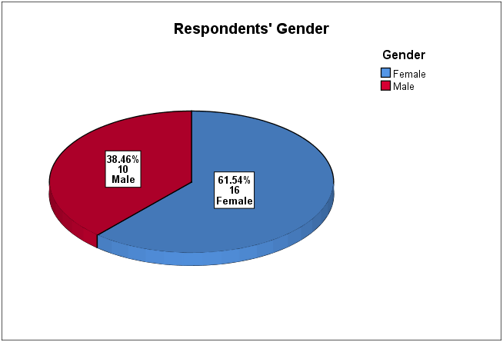

Figure .: Respondents' gender

Figure 4.2 demonstrates that the majority of respondents (88.5%, n=23) reported that their main subject taught is related to Information Technology: ICT (65,4%, n=17) Computing (15,4%, n=4), and Digital Technology (7.7%, n=2). Other main subjects taught were Geography (7.7%, n=2) and Maths (3.9%, n=1).

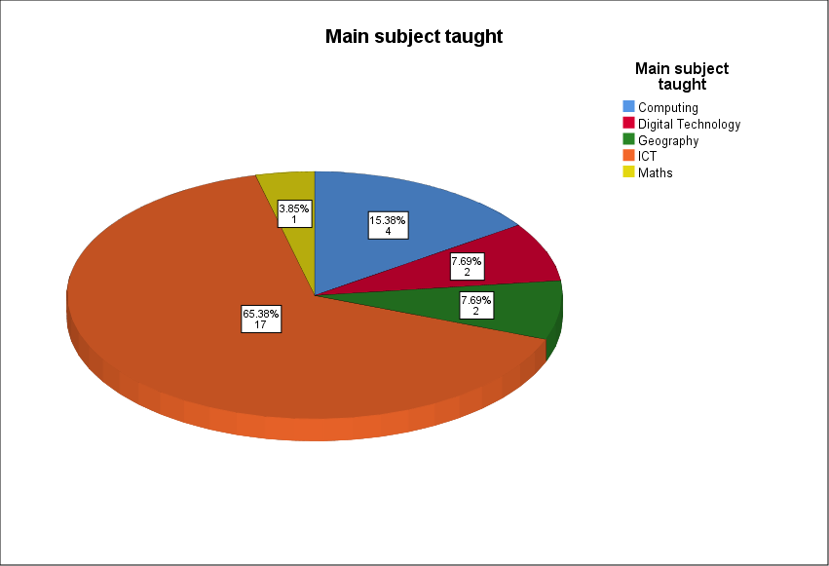

Figure .: Main subject taught

Figure 4.3 illustrates the relative proportions of age and teaching experience of the 26 respondents. Nine respondents (34.6%) between 40 and 49 years old comprise the largest age category of the survey population. Seven respondents (26.9%) are under 30 years old, and six teachers (23.1%) are between 50 and 59 years old. There are only three respondents in the age category ‘30-39’.

As expected, the survey results indicated a general correlation between respondents’ age category and their teaching experience, with the following exception: one respondent in the age category ‘<30’ reported to have 11 to 15 years of teaching experience. This person may have included pre-qualification teaching experience. None of the respondents reported their teaching experience in the range of seven to ten years which aligns with the lack of respondents in the ‘30-39’ age category.

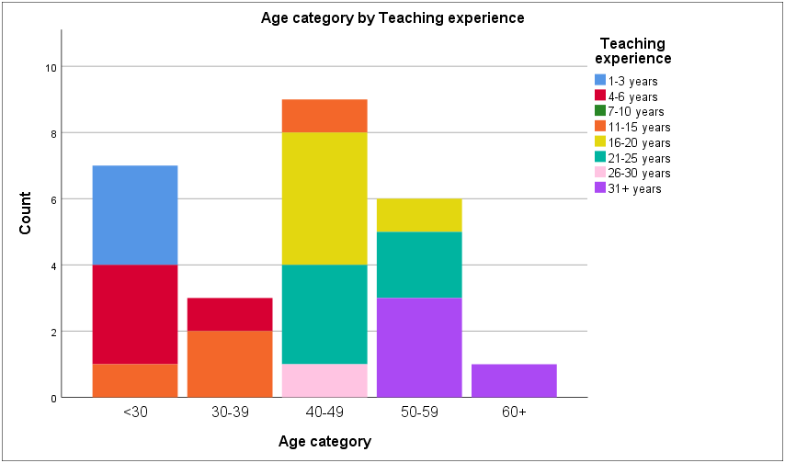

Figure .: Age category by teaching experience

### 4.2.2 School characteristics

Responses were obtained from a range of post-primary schools across Northern Ireland as denoted by school size and school management type. The majority of the respondents, 54% (n=14) teach at middle-size schools (700-999 pupils), while 23% (n=6) are from smaller schools (400-699 pupils), and 11.5% (n=3) of teachers are from schools with capacity of 1000-1299 pupils. One of the teachers works at a school with less than 400 pupils. Two other teachers are from schools with 1300-1599 and over 1600 pupils respectively as shown in Figure 4.4.

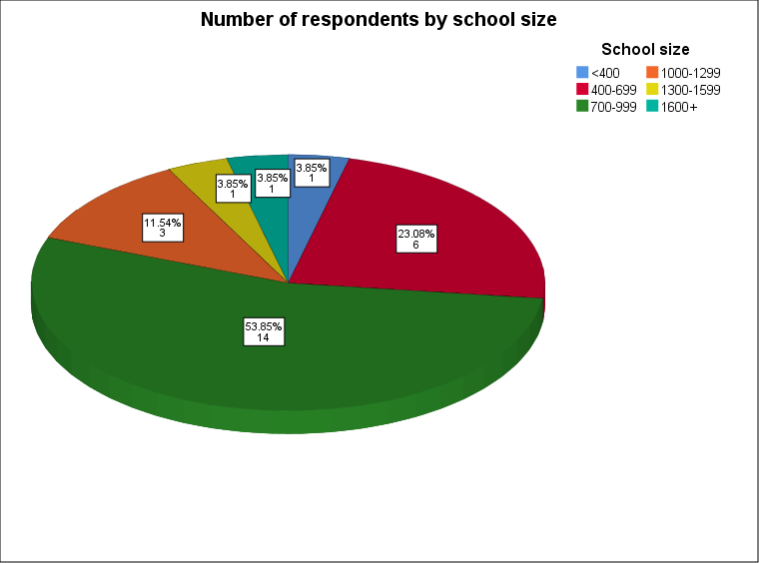

Figure .: Number of respondents by school size

All respondents were from post-primary schools located across the six counties in Northern Ireland. Figure 4.5 indicates that the majority of responses were received from schools located in counties Antrim (38.5%, n=10) and Tyrone (30.8%, n=8).

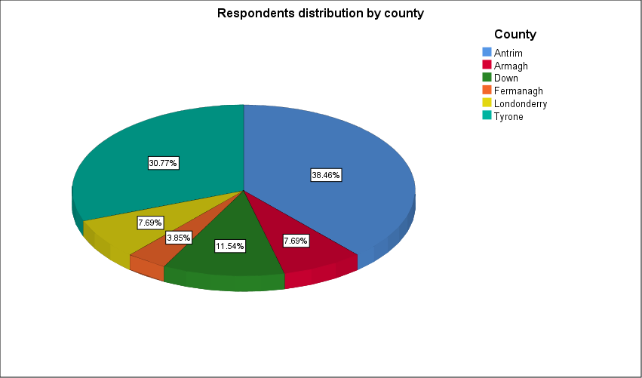

Figure .: Respondents distribution by county

There are three main types of school management in Northern Ireland: controlled, maintained and integrated. Controlled schools are funded and managed by the Education Authority (EA) through Boards of Governors which consist of representatives of transferors (mainly the Protestant churches). Maintained schools are managed by Boards of Governors which consist of members nominated by trustees who are mainly Roman Catholic. For both school management types, Boards of Governors also include teachers, parents and the EA (NI Education Authority, 2018a). Post-primary schools in Northern Ireland are also traditionally subdivided into secondary and grammar schools types, among which some are selective, admitting pupils on the basis of academic ability, and others are non-selective (NI Education Authority, 2018b).

Figure 4.6 shows the proportion of respondents from each of the school management types. The majority of survey respondents (57.7%, n=15) are from grammars schools, and the rest (42.3%, n=11) are from secondary schools; however, none of the integrated schools responded. According to DENI (2019) statistical bulletin, “one-third (66) of post-primary schools are grammar schools and the remaining two-thirds (130) are non-grammars [including 20 integrated]”. With reference to these data, these proportions are not completely representative of the schools in Northern Ireland, as the sample included more than 50% of grammar schools.

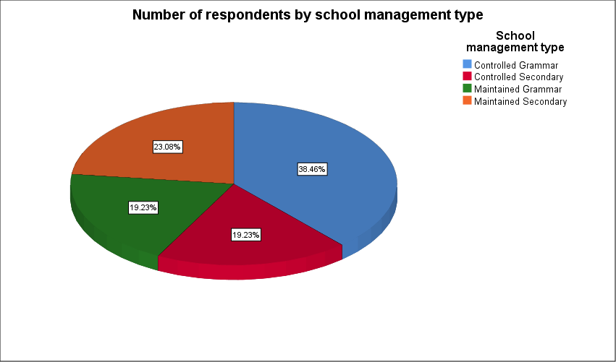

Figure .: Number of respondents by school management type

### 4.2.3 Multiple Intelligence (MI) theory familiarity

In this section, a 5-point Likert scale was used ranging from 1 ‘Unfamiliar’ to 5 ‘Very familiar’. Participants were asked to indicate their level of familiarity with Gardner’s MI theory. As a reminder, a self-explanatory diagram (see Appendix D) was included at the start of this section of the survey. This infographic presented the names of MI categories and activities associated with them. The diagram was placed for respondents’ information to facilitate recollection of the essence of MI theory or perform a quick introduction to it.

Seven respondents (26.9%) indicated that they were unfamiliar with Gardner’s MI theory. Thirteen participants (50%) replied that they are “somewhat familiar”, four (15.4%) replied that they are familiar, and only two (7.7%) answered “reasonably familiar”. The number of respondents who were “very familiar” with MI theory is zero as shown in Figure 4.7.

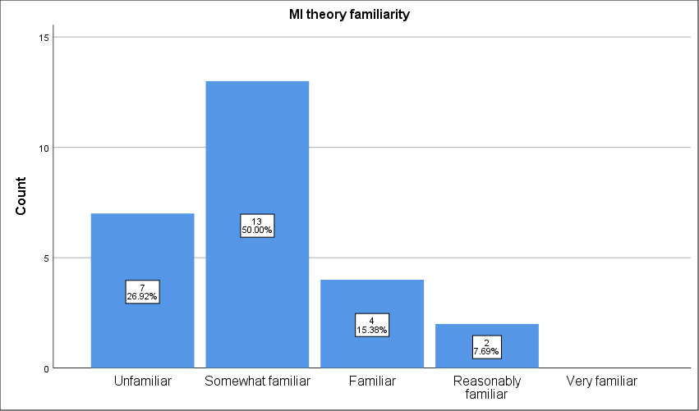

Figure .: MI theory familiarity

Figure 4.8 shows MI theory familiarity distributed by gender. Female respondents indicated slightly higher level of MI familiarity (mean=2.25) than male (mean=1.70).

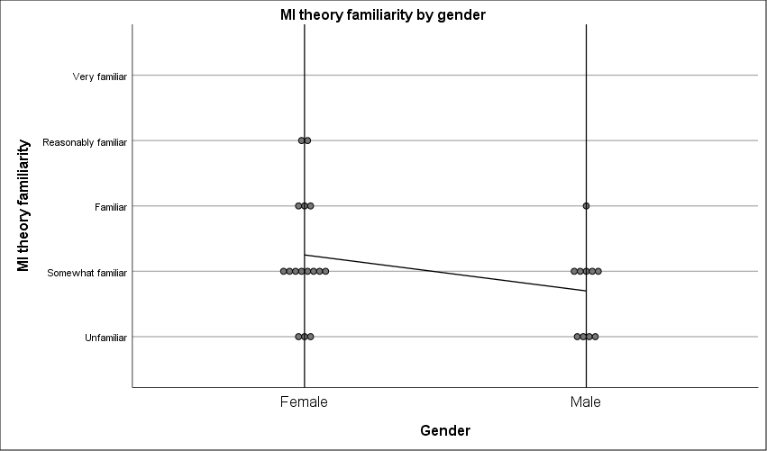

Figure .: MI theory familiarity by gender

Age categories were grouped into three wider categories. Figure 4.9 demonstrated higher levels of familiarity with MI theory for participants aged 50 or older (mean=2.43, n=7) and lower levels of MI familiarity for participants aged under 40 (mean=1.90; n=10) and participants aged between 40 and 49 (mean=1.89; n=9).

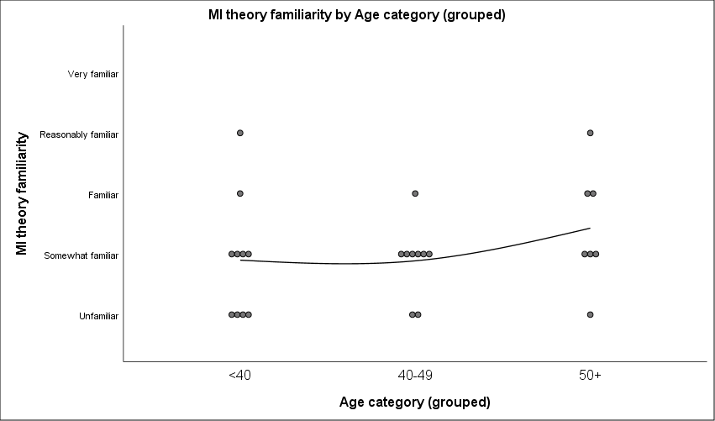

Figure .: MI theory familiarity by age category

Similarly, teaching experience categories were grouped into two combined categories which demonstrated the following levels of MI familiarity: mean 1.81 (n=16) for respondents with teaching experience less than 20 years and mean 2.40 (n=10) for respondents with teaching experience of 21 or more years (Figure 4.10).

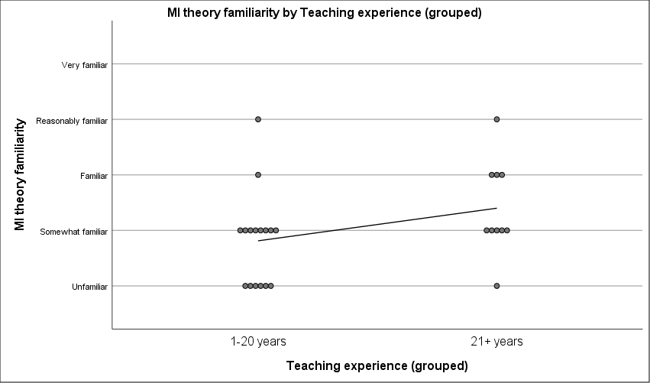

Figure .: MI theory familiarity by teaching experience

### 4.2.4 Perceived application of MI theory in the classroom

Respondents were asked about the frequency of their application of MI theory in the classroom. The distribution of responses was as follows: 42.3% (n=11) apply MI theory *occasionally*, 26.9% (n=7) try to apply MI *sometimes*, and 15.4% (n=4) of respondents *often* refer to MI practices in the classroom. Few respondents apply MI theory *never* (7.7%, n=2) or *always* (7.7%, n=2).

Figure 4.11 demonstrates a positive correlation between perceived MI theory familiarity and perceived frequency of MI theory application in the classroom. However, the graph is incomplete due to lack of responses in *reasonably familiar* and *very familiar* categories.

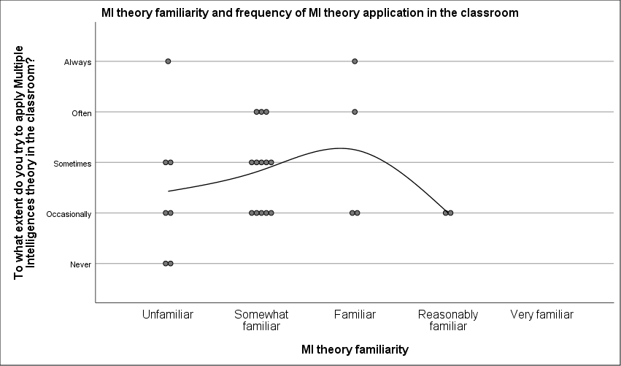

Figure .: MI theory familiarity and frequency of MI theory application in the classroom

In relation to respondents’ gender, it was found that respondents’ perceptions indicated similar scores in central parts of the 5-point scale, but returned opposite scores in extreme values of *never* and *always*. 12.5% (n=2) female respondents *always* try to apply MI theory in the classroom, with zero male respondents selecting this option. At the same time, zero female respondents and 20% (n=2) of male respondents indicated that they *never* try to apply MI theory (Figure 4.12).

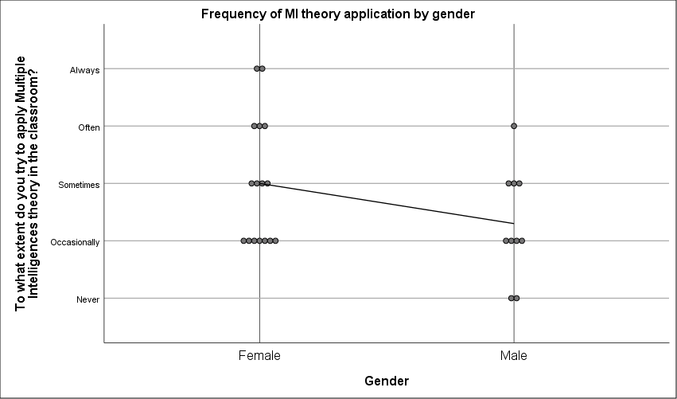

Figure .: Gender and frequency of MI theory application in the classroom

In relation to teaching experience, statistical analysis indicates that there is a positive correlation with the frequency of MI theory application in the classroom. Figure 4.13 demonstrates a scatter graph with interpolation line which represents general tendency, indicating positive correlation between teaching experience and frequency of MI theory application in the classroom. The gap in *7-10 years* category of teaching experience category is due to absence of responses from this category.

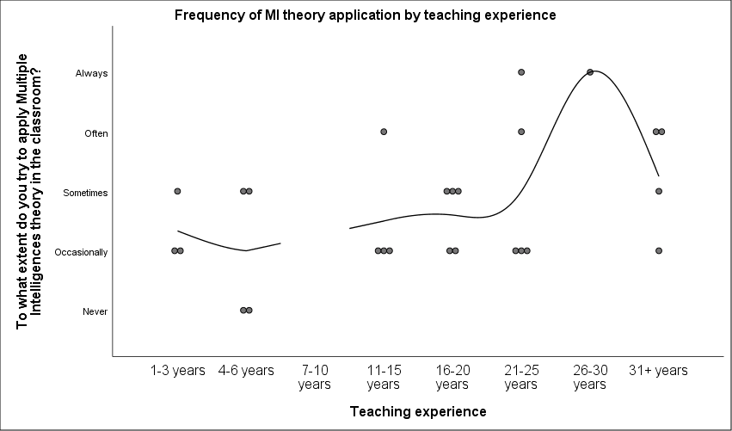

Figure .: Teaching experience and frequency of MI theory application in the classroom

The participants were asked about their perception of MI theory applicability to their current teaching techniques. Seven respondents (26.9%) believe that MI theory doesn’t apply to their teaching techniques. As figure 4.14 indicates, two of them (7.7%) were *unfamiliar* with Gardner’s theory, while other five (19.2%) were in the range from *somewhat familiar* to *reasonably familiar*. Nineteen participants (73.1%) perceived MI theory as applicable to their current teaching techniques, however, five of them (19.2%) indicated an absence of previous knowledge about MI theory.

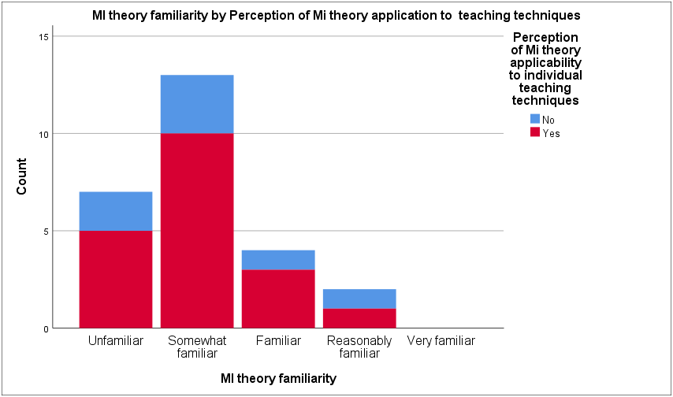

Figure .: MI theory familiarity and perception of MI theory applicability to teaching techniques

Figure 4.15 represents the correlation between teaching experience and MI theory applicability to teaching techniques. It is interesting to see that the majority of respondents with teaching experience from 1-3 years to more than 31 years perceived MI theory as applicable to their teaching techniques. It would be justifiable to find that less experienced teachers might not consider MI theory as part of their pedagogic repertoire, but the survey results indicate only one newly qualified teacher (3.8%) as such. However, there is a distinct gap in perception of MI applicability among those teachers with 16-20 and 21-25 years of teaching experience with four (15.4%) and two (7.7%) participants who replied ‘No’. In order to discover possible reasons for this gap, it is interesting to note that 100% of teachers participating in the survey who have 16-20 years of teaching experience work at grammar schools, either controlled or maintained.

Figure .: Teaching experience and perception of MI theory application to teaching techniques

Thus, these survey results highlighted that school management type is a factor contributing to ICT/Computing teachers’ perception about the application of MI theory to their teaching techniques: six (85.7%) respondents of those who believe that MI theory doesn’t currently apply to their teaching practice are from grammar schools, and all of them have teaching experience from 16 to 25 years; and only one respondent (14.3%) is from a controlled secondary school with 1-3 years of teaching experience (Figure 4.16).

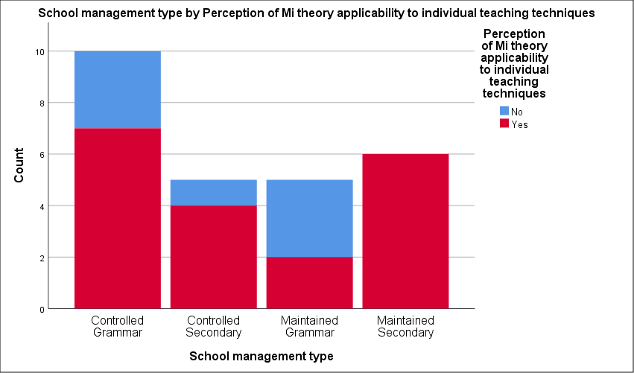

Figure .: School management type and perception of MI theory applicability to individual teaching techniques

### 4.2.5 Perceived usefulness and motivation

At post-primary school level of the education system of Northern Ireland, there are two compulsory stages: Key Stage 3 (Years 8, 9 and 10) and Key Stage 4 (Years 11 and 12); then, “pupils may continue education for a further two years (Key Stage 5), after they become 16, although this is not compulsory” (NI Education Authority, 2018b).

In this section of the survey participants were asked to indicate their perception of how useful and motivating MI theory is at different stages in ICT/Computing lessons. A 5-point Likert scale was used for Key Stage 3, Key Stage 4 and Post-16, ranging from 1 ‘Not useful’ to 5 ‘Very useful’ and from 1 ‘Not motivating’ to 5 ‘Very motivating’.

As Figure 4.17 indicates, at Key Stage 3 ten respondents (38.5%) perceive MI theory as ‘quite motivating’ or ‘very motivating’, eight respondents (30.8%) consider it to be ‘somewhat motivating’ or ‘neutral’, and three (11.5%) believe it is not motivating. Usefulness is perceived in similar proportions, with only one respondent indicating MI theory as ‘not useful’ for Key Stage 3.

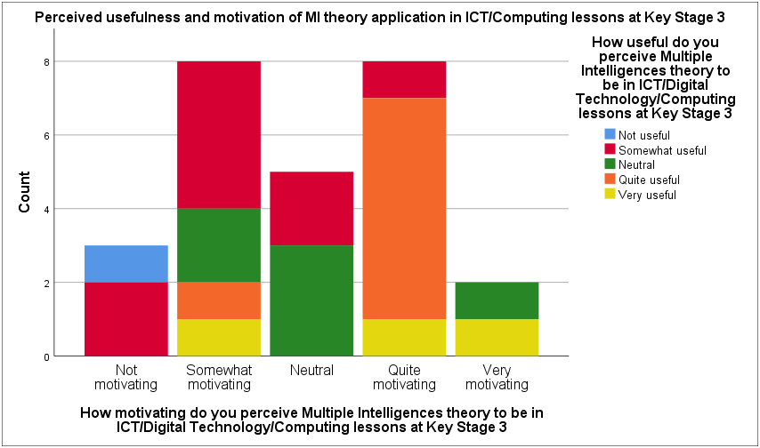

Figure .: Perceived usefulness and motivation of MI theory application in ICT/Computing lessons at Key Stage 3

At Key Stage 4, 19.2% (n=5) respondents consider MI theory ‘not motivating’, and 7.7% (n=2) perceive it as ‘not useful’. The number of those with ‘neutral’ attitude is 30.8% (n=8) which is also higher than at Key Stage 3. Also, Figure 4.18 demonstrates increased levels of polar values of ‘Not motivating’ and ‘Very motivating’.

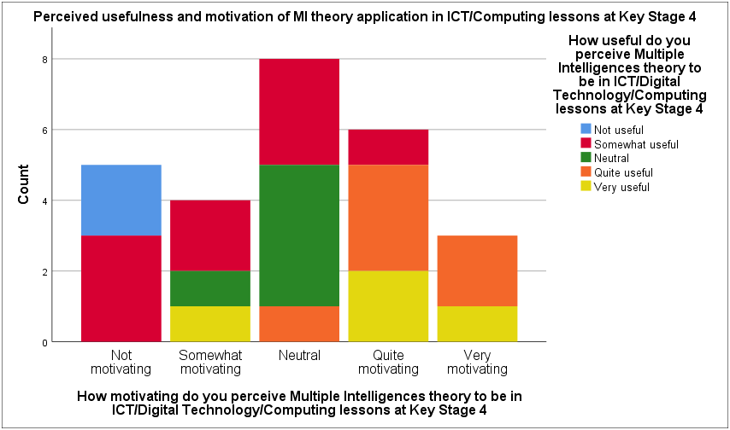

Figure .: Perceived usefulness and motivation of MI theory application in ICT/Computing lessons at Key Stage 4

The graph representing perceived usefulness and motivation at Post-16 stage (Figure 4.19) also demonstrates increasing levels of the opposite values. Although all Key stages received very similar mean ratings for motivation (2.88–2.92) and usefulness (3.04–3.12), the standard deviation associated with these items was found to be relatively large (1.12–1.34), indicating high variation in the perception of participants.

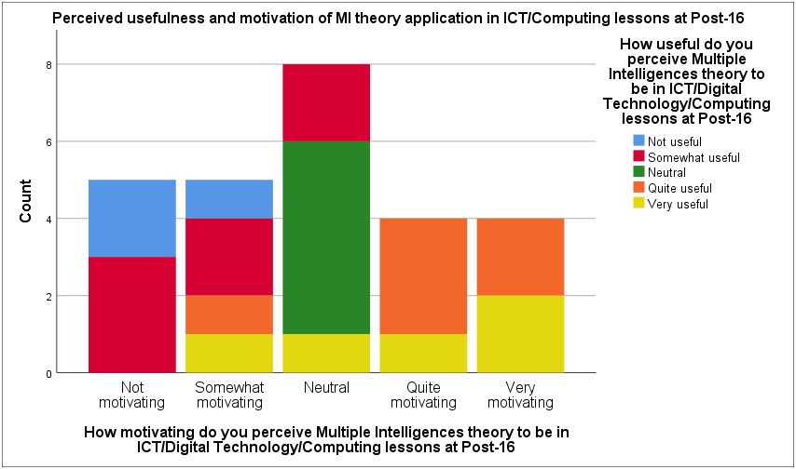

Figure .: Perceived usefulness and motivation of MI theory application in ICT/Computing lessons at Post-16

There is correlation between school management type and perceived usefulness and motivation of MI theory in ICT/Computing lessons. Figures 4.20 and 4.21 show that several respondents from grammar schools perceived MI theory *not useful* and *not motivating*, while respondents from secondary schools demonstrated none of such perceptions. This corresponds with our previous observation on perceived MI applicability to teaching practice in different types of school management.

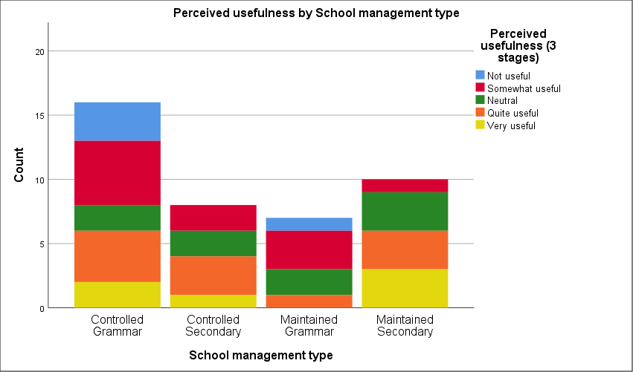

Figure .: Perceived usefulness by school management type

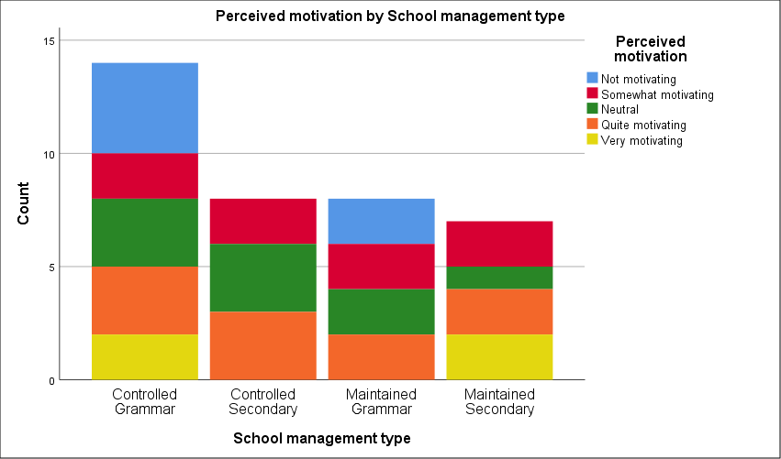

Figure .: Perceived motivation by school management type

### 4.2.6 Multiple intelligences categories and instructional technology

In this section, a 5-point Likert scale was used ranging from 1 ‘Never’ to 5 ‘Very frequently’. Participants were asked to indicate how often they used various instructional/educational technologies. Statistical analysis was performed to calculate frequency of use of instructional technology tools as shown in Table 4.1.

Table .: Instructional technology: frequency of use

|  |  |  |  |
| --- | --- | --- | --- |
| **Instructional technology** | **Mean** | **Std. Deviation** | **Variance** |
| E-safety | 4.35 | .892 | .795 |
| Email | 4.35 | .936 | .875 |
| Presentation software | 4.15 | .925 | .855 |
| Games Design | 3.77 | 1.142 | 1.305 |
| Awareness of Digital Footprint | 3.65 | 1.093 | 1.195 |
| Draw/Paint, e.g. Photoshop | 3.50 | .860 | .740 |
| Desktop publishing programmes | 3.38 | 1.061 | 1.126 |
| Role as Digital Citizen | 3.35 | 1.198 | 1.435 |
| Computer programming tutors | 3.12 | 1.306 | 1.706 |
| Collaboration, e.g. wiki | 3.08 | 1.093 | 1.194 |
| Animation programmes | 2.88 | 1.107 | 1.226 |
| Logic games | 2.88 | .816 | .666 |
| Critical thinking programmes | 2.81 | .981 | .962 |
| Word Games | 2.58 | .945 | .894 |
| Social media, e.g. Blog/Twitter | 2.50 | 1.175 | 1.380 |
| Mathematical skills tutorials | 2.31 | 1.087 | 1.182 |
| Robotics, e.g. Sphero | 2.23 | .951 | .905 |
| Spatial problem solving games | 2.23 | .951 | .905 |
| Simulation games | 1.96 | .824 | .678 |
| Interactive storybooks | 1.92 | .891 | .794 |
| Pattern Recognition in Nature | 1.88 | .993 | .986 |
| Video-conferencing, e.g. Collaborate | 1.81 | .895 | .802 |
| Virtual-reality system software | 1.77 | .951 | .905 |
| Mimicking processes in nature, e.g. motion | 1.77 | .765 | .585 |
| Geometry programmes | 1.58 | .703 | .494 |
| Composition software | 1.50 | .762 | .580 |
| Musical instrument digital interfaces (MIDI) | 1.38 | .637 | .406 |

Table 4.2 represents how MI categories match instructional technologies. Each of the instructional technology tools caters at least for one category of multiple intelligences. Several technology tools can be linked to several MI categories: Virtual-reality system software, Presentation software, Social media, e.g. Blog/Twitter, Email.

Table .: MI categories and instructional technologies

|  |  |
| --- | --- |
| **MI category** | **Instructional technologies** |
| Verbal-linguistic | Desktop publishing programmes  Interactive storybooks  Word Games  Presentation software  Social media, e.g. Blog/Twitter |
| Logical-mathematical | Mathematical skills tutorials  Computer programming tutors  Logic games  Critical thinking programmes  Games Design |
| Visual-spatial | Animation programmes  Draw/Paint, e.g. Photoshop  Spatial problem-solving games  Robotics, e.g. Sphero  Geometry programmes  Presentation software  Games Design  Virtual-reality system software |
| Bodily-kinaesthetic | Virtual-reality system software  Robotics, e.g. Sphero |
| Musical-rhythmic | Virtual-reality system software  Composition software  Musical instrument digital interfaces (MIDI) |
| Interpersonal | Presentation software  Simulation games  Social media, e.g. Blog/Twitter  Collaboration, e.g. wiki  Video-conferencing, e.g. Collaborate  Role as Digital Citizen  Email  E-safety |
| Intrapersonal | Social media, e.g. Blog/Twitter  Email  Role as Digital Citizen  Awareness of Digital Footprint |
| Naturalistic | Pattern Recognition in Nature  Mimicking processes in nature, e.g. motion |

In order to understand which intelligences are mostly catered for, statistical analysis was performed based on matching instructional technology tools and MI categories and calculating mean value of each of the composite variables (Table 4.3). The statistical analysis indicates that in ICT/Computing classrooms, intrapersonal intelligence received the highest mean rating of 3.46 (on a five-point scale), and interpersonal intelligence received mean rating of 3.19. Logical-mathematical (mean 2.98) and verbal-linguistic (mean 2.91) receive similar mean scores as the intelligences traditionally catered for in the classroom. Visual-spatial intelligence (mean 2.76) is also catered for by a number of technology tools. However, bodily-kinaesthetic (mean 2.0), naturalistic (mean 1.83) and musical-rhythmic (mean 1.55) intelligences are least frequently addressed in ICT/Computing lessons.

Table .: MI through technology in the classroom

|  |  |  |
| --- | --- | --- |
| **MI Category** | **Mean** | **Std. Deviation** |
| Intrapersonal | 3.4615 | .71306 |
| Interpersonal | 3.1923 | .51748 |
| Logical-mathematical | 2.9769 | .75964 |
| Verbal-linguistic | 2.9077 | .47068 |
| Visual-spatial | 2.7644 | .50166 |
| Bodily-kinaesthetic | 2.0000 | .82462 |
| Naturalistic | 1.8269 | .77385 |
| Musical-rhythmic | 1.5513 | .62498 |

Instructional technology tools most frequently used in ICT/Computing lessons are *E-safety*, *Email* and *Presentation software*. These tools are linked to a range of MI categories: interpersonal, intrapersonal, verbal-linguistic, and visual-spatial. However, Figures 4.22–4.24 indicate that these technology tools are also commonly used by those respondents who indicated that they were unfamiliar with MI theory.

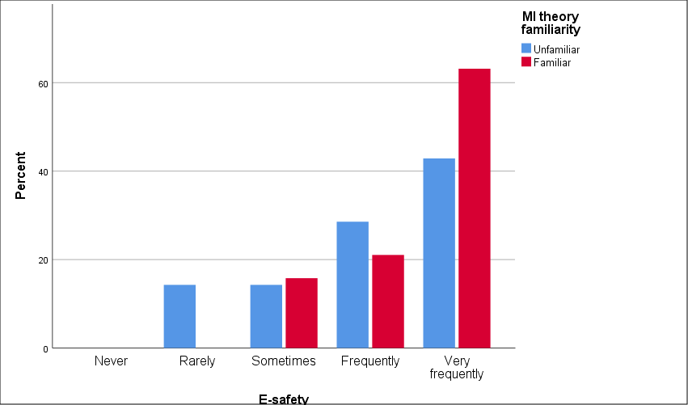

Figure .: Frequency of use of E-safety and perception of MI applicability to classroom practice

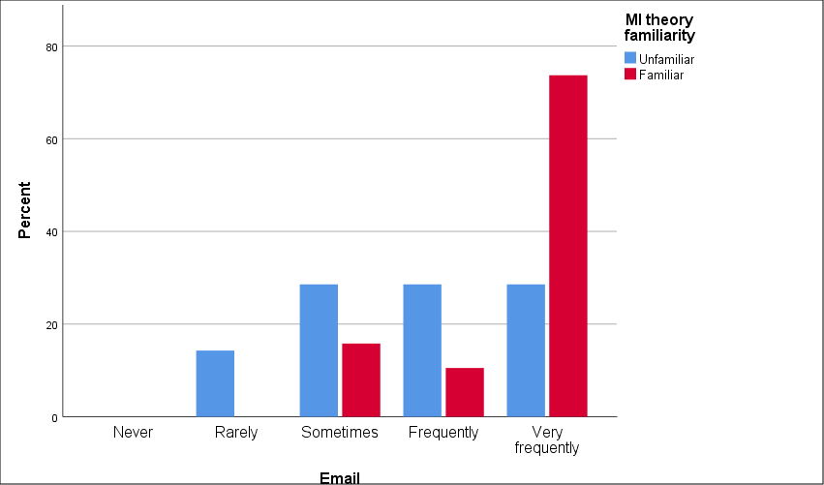

Figure .: Frequency of use of Email and MI theory familiarity

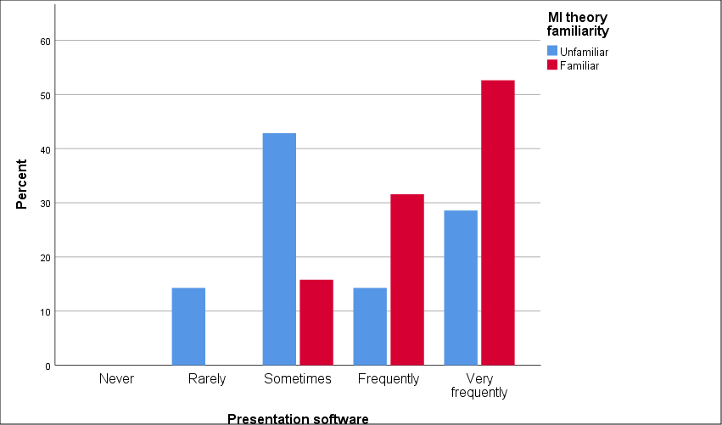

Figure .: Frequency of use of presentation software and MI theory familiarity

### 4.2.7 Drivers for innovation

In this section, participants were asked to indicate the drivers for innovation in their departments. In order to estimate the frequency of each option, a 5-point Likert scale was used ranging from 1 ‘Never’ to 5 ‘Very frequently’. The results can be grouped into four categories: departmental, personal, school and external.

As shown in Table 4.4, the most frequent driver for innovation in ICT/Computing departments is ‘Guidance from Head of Department’ (mean 4.35). The standard deviation of this item as perceived by respondents is 0.69 indicating that their responses clustered around the mean. Input from colleagues (mean 3.88) is also perceived as a frequent driver for innovation on the departmental level.

On a personal level, respondents’ personal interest (mean 3.96) and professional development as a teacher (mean 3.85) frequently drive innovation. Employment opportunities have similar mean score value of 3.77.

On the school level, curricular specifications (mean 3.96) are among the top drivers for innovation. Requests from colleagues at school (mean 3.08), pupils’ requests (mean 3.04), and school principal/senior management team (mean 3.04) are perceived as factors that *sometimes* drive technological advancement in the classroom. The standard deviations associated with these items range from 0.96 to 1.04, indicating moderately variating perceptions of respondents.

External social factors are perceived as less frequent drivers for innovation. Some factors are higher than others, e.g. ideas from social media (mean 3.35) and mass media influence (mean 3.31). Collaboration with teachers from neighbouring schools (mean 2.46) and participation in the area learning communities (mean 2.42) have a similar score between *rarely* and *sometimes*. ‘Parental requests’ is the least frequent driver for innovation as perceived by respondents (mean 2.08).

Table .: Drivers for innovation

|  |  |  |
| --- | --- | --- |
| **Driver for innovation** | **Mean** | **Std. Deviation** |
| Guidance from Head of Department | 4.35 | .689 |
| My own personal interest(s) | 3.96 | .774 |
| Curricular specifications | 3.96 | .958 |
| Input at departmental meetings from colleagues | 3.88 | .952 |
| Professional development as a teacher | 3.85 | .732 |
| Employment opportunities | 3.77 | .992 |
| Ideas from social media e.g. Twitter | 3.35 | 1.093 |
| Media influence | 3.31 | .884 |
| Societal needs | 3.12 | 1.071 |
| Requests for technology support from other school colleagues | 3.08 | 1.017 |
| Pupils’ requests | 3.04 | .958 |
| School Principal/Senior Management Team | 3.04 | 1.038 |
| Local/national competitions | 2.69 | 1.192 |
| Neighbouring schools | 2.50 | 1.105 |
| Requests from teachers from other schools to collaborate on a project | 2.46 | 1.029 |
| Area learning community focus | 2.42 | .857 |
| Parental requests | 2.08 | .891 |

### 4.2.8 Making decisions about introducing new technology

In this section, participants were asked ‘Who makes decisions about introducing new technology?’ For this question, a 5-point Likert scale was used ranging from 1 ‘Never’ to 5 ‘Very frequently’, with a list of stakeholders potentially capable of making such decisions. The survey results indicated that frequent decision-making persons are heads of departments (mean 3.96) and respondents themselves (mean 3.88). The fact that these figures mostly coincide suggests that a significant number of teachers who completed the survey are actually heads of ICT/Computing departments.

Principals, vice-principals (mean 3.27), e-learning leaders (mean 3.23) and senior management team (mean 3.08) are perceived by respondents to make decisions about introducing new technology less frequently.

The majority of respondents (57.7%, n=16) consider that pupils *sometimes* take part in the process of decision-making (mean 2.50). On the contrary, parents (mean 1.73) and parent-teacher association (mean 1.54) are perceived to make technology-related decisions *never* or *rarely* by 88.5% (n=23) of respondents.

Table .: Who makes decisions about introducing new technology?

|  |  |  |
| --- | --- | --- |
| **Who makes decisions** | **Mean** | **Std. Deviation** |
| Head of Department | 3.96 | .871 |
| Myself | 3.88 | 1.275 |
| Principal/VP | 3.27 | 1.079 |
| E-learning/technology leader(s) | 3.23 | 1.243 |
| Senior Management Team | 3.08 | 1.164 |
| Pupils | 2.50 | .949 |
| Technician | 2.42 | .902 |
| Placement/work experience person | 2.04 | .916 |
| Student teacher | 1.92 | .891 |
| Finance Officer in school/Bursar | 1.81 | 1.059 |
| Parents | 1.73 | .778 |
| Parent Teacher Association | 1.54 | .811 |

### 4.2.9 Frequency of making decisions by respondents

Figure 4.25 presents a correlation between respondents’ personal interest as driver for innovation and frequency of their making decisions about introducing new technology in the classroom.

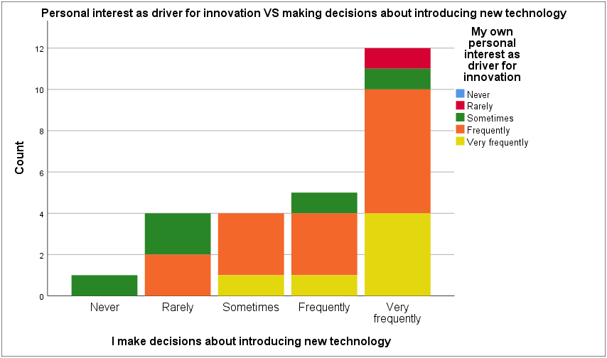

Figure .: Personal interest as a driver for innovation and frequency of making decisions about introducing new technology

Twelve respondents (46.2%) make decisions about introducing new technology in the classroom very frequently, and it can be assumed that they are in a position of leadership as heads of departments. Four of them responded that their personal interest drives innovation *very frequently* and other six perceive their personal interest as a *frequent* driver for innovation.

Five respondents (19.2%) are *frequent* decision-makers, and four of them are personally interested in driving innovation, either *frequently* (n=3) or *very frequently* (n=1). Four respondents (15.4%) *sometimes* make technology-related decisions, however, members of this group are highly motivated to drive innovation, *frequently* (n=3) or *very frequently* (n=1). Other four respondents (15.4%) *rarely* make decisions but are *sometimes* (n=2) or *frequently* (n=2) interested in innovation. Only one respondent (3.8%) *never* makes decisions about new technology but *sometimes* acts as a driver for innovation on a personal level.

Two participants indicated a lack of personal interest (*rarely* and *sometimes*) in driving technology innovation but very high level of decision-making on introducing new technology.

To sum up, the survey results indicate that fourteen respondents (53.8%) are *frequently* or *very frequently* interested in innovation and are frequently or *very frequently* able to make decisions, thus leading the change.

### 4.2.10 Perceived frequency of making decisions by others

Figures 4.26-4.29 demonstrate the perceived frequency of making decisions by principal, head of department, senior management team and pupils in relation to respondents’ own frequency of making decisions.

Principal’s frequency of making decisions is perceived as *rarely* or *sometimes* by the majority of respondents who are *very frequent* decision-makers, as shown by Figure 4.26.

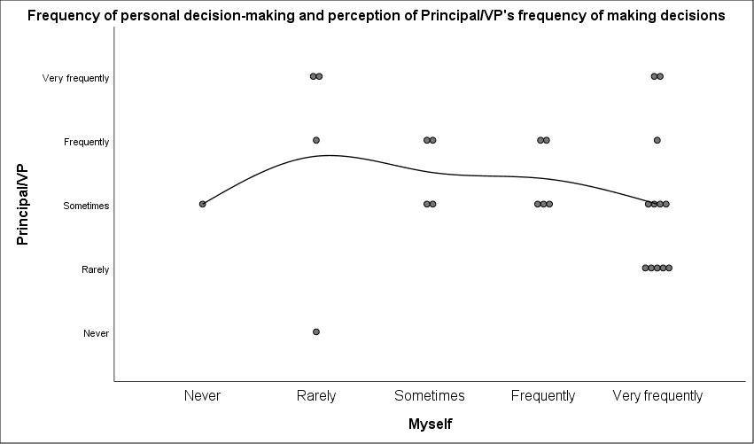

Figure .: Frequency of personal decision-making and perception of Principal/VP’s frequency of making decisions

Head of department is perceived by the majority of respondents as making decisions at the same rate as they do themselves (in most cases, *frequently* or *very frequently*), which leads to an assumption that a number of those respondents can actually be heads of departments (Figure 4.27).

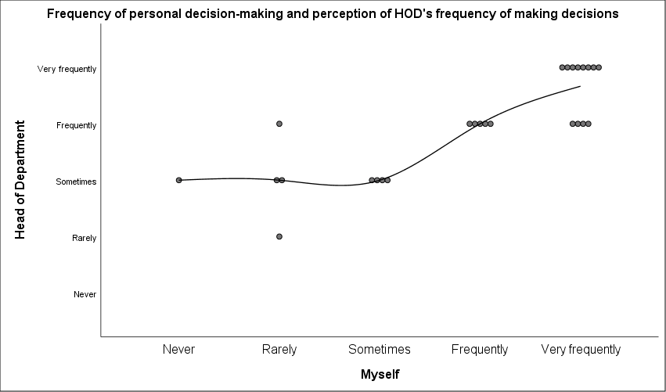

Figure .: Frequency of personal decision-making and perception of HOD’s frequency of making decisions

The senior management team is perceived as making decisions *sometimes* as indicated by the interpolation line which represents a general tendency, as Figure 4.28 demonstrates.

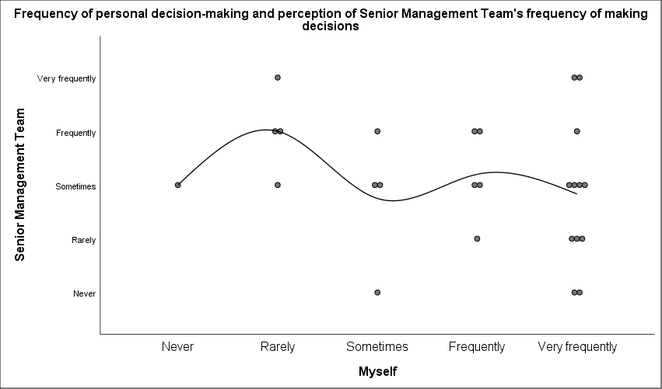

Figure .: Frequency of personal decision-making and perception of the Senior Management Team’s frequency of making decisions

Pupils’ frequency of decision making is perceived as *sometimes* by the majority of *frequent* and *very frequent* decision-makers, and *rarely* by those respondents who make decisions *rarely* themselves, as demonstrated by Figure 4.29.

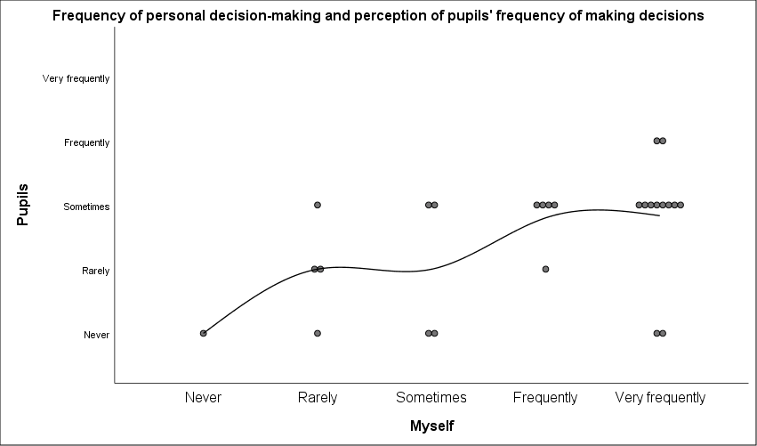

Figure .: Frequency of personal decision-making and perception of pupils’ frequency of making decisions

### 4.2.11 ICT budget

ICT budget availability at schools is another topic connected with introducing new technology and upgrading existing technology tools in the classroom. One of the survey questions was aimed to discover whether the ICT/Computing budget of the school is sufficient for respondents’ needs. Figure 4.30 shows a summary of the answers: 50% (n=13) of respondents indicated that the budget is not sufficient; 30.8% (n=8) have sufficient budget; 19.2% (n=5) of respondents have no available ICT/Computing budget.

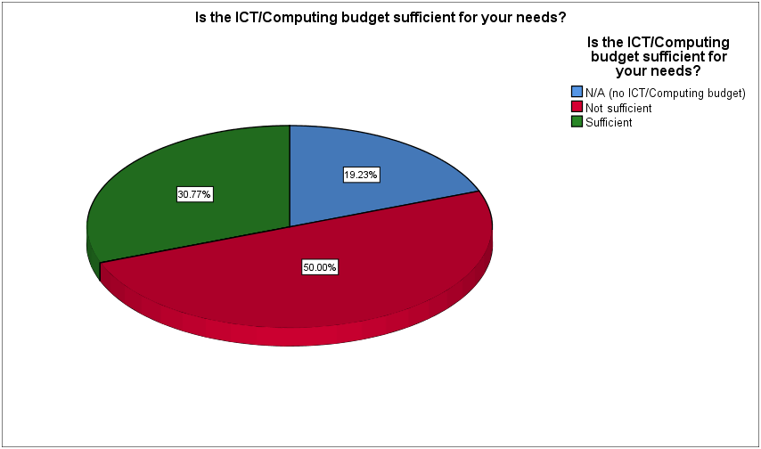

Figure .: ICT/Computing budget sufficiency

## 4.3 Analysis of qualitative data

Qualitative data were gathered from open-ended optional questions at the end of each survey section with the purpose to enrich quantitative data with respondents’ perceptions, thus expanding the scope and illuminating insights beyond the numbers. These questions sought to collect full-length responses from the participants and were aimed at obtaining respondents’ perspectives for further content and thematic analysis.

The list of open-ended survey questions and the list of corresponding responses which were utilised for qualitative data analysis can be found in Appendix E. Thematic and content analysis was performed based on the emanating themes and counting the number of their occurrence in the textual data. The key themes arising from open-ended questions are summarised below, with consideration of the following factors which could be helpful to draw implications for possible correlations: frequency of theme occurrence, respondents’ gender and type of school management.

### 4.3.1 MI theory applicability to teaching techniques

Fourteen respondents (53.8%) filled in comments regarding MI theory applicability to their teaching techniques. The themes that emerged are divided into seven categories for thematic analysis as shown in Table 4.6.

Table .: MI theory applicability to teaching techniques

|  |  |  |  |
| --- | --- | --- | --- |
| **Theme** | **N** | **Gender** | **School management type** |
| Using a variety of techniques; MI theory applies to all subjects | 5 | 4F  1M | 1CG  3MS; 1CS |
| Different ways of learning; all pupils are unique | 5 | 3F  2M | 1CG  3MS; 1CS |
| Examples of activities catering to MI categories | 4 | 2M  2F | 2CG  1MS; 1CS |
| Focus on logical-mathematical intelligence in teaching ICT/Computing | 2 | 1F  1M | 1CG; 1MG |
| The subject dictates the method to use | 1 | 1F | 1CG |
| Enhanced quality of learning when catering for MI | 1 | 1M | 1CG |
| Low priority of teaching techniques and process in the classroom | 1 | 1M | 1CS |

Typical comments include:

*“partly, interpersonal can be interpreted of the paired programming I am experimenting with at present. Its actually slower than individual work, but more accurate and stays with the pupil longer”.*

*“During my career I have always found that students all have different ways of learning remembering performing etc. It is vital that I use a range of strategies to establish what suits each student”.*

### 4.3.2 Barriers for MI theory implementation in the classroom

Comments emerging from respondents regarding the Barriers for MI theory implementation in the classroom fell into 8 categories as shown in Table 4.7. Twenty-one respondents (80.8%) filled in this optional question; that indicates the high importance of the topic for respondents.

Table .: Barriers to MI theory implementation in the classroom

|  |  |  |  |
| --- | --- | --- | --- |
| Theme | N | Gender | School management type |
| Time | 10 | 6F  4M | 4CG  2CS, 4MS |
| Pressure of results/specification requirements/content | 5 | 3F  2M | 3CG  1CS, 1MS |
| Lack of facilities/resources and budget cuts | 4 | 3F  1M | 1MG  3MS |
| CPD/training | 3 | 2F  1M | 1CG  1CS, 1MS |
| Some MI types irrelevant to ICT teaching | 3 | 2F  1M | 1CG, 2MG |
| Differentiation at skills level/student needs | 3 | 1F  2M | 1CG  1CS; 1MS |
| Class size | 2 | 1F  1M | 1MG  1MS |
| Complex content, hard to adapt | 1 |  | CG |

The category of time occurs as the most frequent theme in the classification of barriers for MI theory implementation in the classroom. Ten respondents (38.5%) indicated that time limitation is a contributing factor to lack of activities to cater for pupils’ multiple intelligences during a lesson. Typical comments include:

*“Confined by the specification requirements, limited time and timetable constraints. Budget cuts, lack of training and effective CPD” .*

*“The main difficulties are class sizes and the time needed to establish which of the multiple intelligences suit best each student”.*

The pressure of results and curriculum specification requirements is another common barrier suggested by five respondents (19.2%). This factor seems to be a major concern especially for teachers from grammar schools, as one of them stated:

*“it is wrong but many schools are still exam factories and this will not change while we have to school system operating in its existing results-driven format. many have no choice but to teach to the test”.*

Lack of facilities and resources is a barrier indicated by four respondents (15.4%), and three of them are from secondary schools. Comments here include budget cuts; outdated facilities and high cost to upgrade them; lack of resources for all pupils.

Other factors that appear to be barriers for MI theory implementation are lack of CPD/training, differentiation at skills level and teachers’ perception that some MI types are irrelevant to ICT teaching. Each of these factors was mentioned by three respondents (11.5%), and the latter factor of irrelevance was mentioned only by teachers from grammar schools. Two respondents (7.7%) indicated class size as a barrier, and one (3.8%) pointed out the complexity of content which is hard to adapt for MI-related classroom activities.

### 4.3.3 ICT/Computing budget availability and processing

Seventeen respondents (65.4%) filled in comments regarding ICT/Computing budget sufficiency at their schools. The themes that emerged are divided into four categories for thematic analysis as shown in Table 4.8.

Table .: ICT/Computing budget sufficiency for teachers’ needs

|  |  |  |  |
| --- | --- | --- | --- |
| **Theme** | **N** | **Gender** | **School management type** |
| Identification of a problem with budget sufficiency | 9 | 5F  4M | 3CG; 2MG  4MS |
| Personal leadership initiative / solving a problem | 3 | 2F  1M | 2CG  1MS |
| Specific drivers for innovation | 3 | 2F  1M | 1CG  1MS; 1CS |
| Suggestions for innovation needed | 2 | 1F  1M | 1MG  1MS |

## 4.4 Summary of findings

In this chapter, the results of quantitative and qualitative data analysis have been presented. The majority of respondents indicated to be either somewhat familiar or unfamiliar with Gardner’s MI theory. Most respondents perceived MI theory as applicable to their teaching techniques, though some of them indicated the absence of previous knowledge about multiple intelligences. Grammar school teachers perceived MI theory as less applicable, useful and motivational than secondary school teachers. Findings indicate that positive correlation exists between frequencies of MI theory application and MI theory familiarity.

Intrapersonal and interpersonal intelligences resulted as most frequently catered for by corresponding technology tools in ICT/Computing lessons. Logical-mathematical, verbal-linguistic and visual-spatial intelligences received average mean scores. Bodily-kinaesthetic, naturalistic and musical-rhythmic intelligences were found to be least frequently catered for in ICT/Computing lessons. It was also found that most commonly used technology tools can be linked to a range of MI categories; these tools were also commonly used by those respondents who considered that MI theory was not applicable to their teaching techniques.

Next, the analysis of drivers for innovation and decision-making in integrating new technology addressed the questions of change and educational leadership. Personal and departmental levels factors were identified among frequent drivers for innovation, as well as curricular specifications. Other school and external factors had less impact and indicated variating perceptions of respondents. Respondents also demonstrated a high level of personal decision-making in introducing new technology which was found to be combined with personal interest in driving innovation in a significant number of cases.

The analysis of qualitative data raised important themes in questions about common barriers for MI theory integration and ICT budget availability and processing. Time, curricular specifications, lack of facilities and lack of professional development were identified as the most common barriers for MI theory integration.

The following chapter will provide a discussion of the findings in the light of the literature review on existing studies in the research topic field, explaining emergent insights on the research objectives.

# : Discussion of Findings

## 5.1 Introduction

The purpose of this study was to establish the role of educational leadership in technology-enhanced learning classrooms through the use of multiple intelligences. Teachers’ perceptions and practices of Multiple Intelligence theory were evaluated. This chapter presents a summary and discussion of the analysed data.

The study sought to evaluate the following research questions:

1. To what extent are teachers aware of MI theory, and what are teachers’ perceptions of MI theory applicability to their teaching practice?

2. What is the relationship between personal and school characteristics and teachers’ perception of MI theory applicability to their teaching practice?

3. Are all multiple intelligences promoted equally through the choice of technology tools being used in the classroom?

4. Who influences the change in topics being taught in ICT computing? Who/What are the drivers for innovation?

A quantitative research approach was used for this study. Respondents were asked to complete an online survey in order to measure their perceived engagement with MI theory and leadership practices in the classroom and on the school level. To enrich quantitative data with valuable insights, open-ended questions were added at the end of each survey section which could be optionally filled in by participants willing to provide extended responses. Further, thematic analysis was performed and emerging themes identified in accordance with their frequency.

## 5.2 Teachers’ awareness and perceptions of applicability of MI theory

First, respondents’ demographic characteristics were evaluated, including school size and management type, main subject taught, gender, age and teaching experience.

The majority of respondents were between 40 and 49 years old. While age categories ‘<30’ and ’50-59’ were represented with similar frequency, there were only three respondents in the age category ‘30-39’. The fact that this age group was under-represented in the survey can be explained by the following assumption: there is a high probability that a number of heads of departments completed the survey themselves but did not share the survey link with their colleagues.

### 5.2.1 Teachers’ awareness of MI theory

The second section of the online survey was designed to examine teachers’ perceptions of Gardner’s MI theory. It was important to examine instructional leaders’ ideas and beliefs because they are connected to the successful or unsuccessful implementation of instructional technology (Chang, 2012; Hughes & Zachariah, 2001). In order to address the research objectives, three different dimensions of perception were examined: MI theory familiarity, its applicability to current teaching techniques, and frequency of MI theory application in the classroom. Also, it was important to understand common barriers experienced by teachers when trying to embed multiple intelligences in the classroom.

The majority of participants were *somewhat familiar* (50%) or *unfamiliar* (26.9%) with MI theory. Several respondents reported to be *familiar* (15.4%) or *reasonably familiar* (7.7%), and none were *very familiar*. Several factors should be considered in understanding possible reasons for such answers. First, lack of information on MI theory which may not be part of Initial Teacher Education (ITE) courses. Where MI theory has been encountered, there may be little opportunity to further develop one’s understanding of MI theory in teacher professional development courses, so the concept of multiple intelligences might be simply forgotten by individual teachers. Another important factor which may account for zero *very familiar* responses might be teachers’ self-depreciation, indicating they are not ‘experts’ in the area. As previously mentioned, MI theory awareness is beneficial for both teacher and students, helping them to gain insight into their educational thought processes and individual strengths (Griggs *et al.,* 2009).

In terms of gender differences, female respondents tended to report slightly higher levels of familiarity with MI theory (79% *somewhat familiar* or higher) than male respondents (60% *somewhat familiar* or higher). Looking across the age categories, there were no high differences by age indicating no perceived change in the content of ITE or Continuing Professional Development (CPD) training sessions over the years to produce a ‘spike’ in the familiarity pattern. However, there was a slight rise in MI theory familiarity by years of teaching experience when the sample was bisected into more or less than 20 years teaching experience; also, only one respondent from the group with high teaching experience was unfamiliar with MI theory.

### 5.2.2 Teachers’ perceptions of the applicability of MI theory

The findings indicate a positive correlation between MI theory familiarity and frequency of MI theory application in the classroom. Thus, higher awareness of MI theory generally leads to higher level of MI use, when it is applicable to the teaching context. When asked about their perception of MI theory applicability to their current teaching techniques, the majority of respondents (73.1%) replied positively, however, 19.2% (n=5) of them indicated absence of previous knowledge about MI theory. It is possible that the five respondents who were unfamiliar with MI used the diagram (see Appendix D) to raise their awareness of MI before responding to this question. In general, it can be concluded that teachers are optimistic about multiple intelligences in the classroom and tend to acknowledge their potential role in broadening “the scope of human potential” (Armstrong 2018: 2) in the classroom even without a formal introduction to the theory. However, despite their positive disposition, a number of barriers to the inclusion of MI in the classroom emerged. These are discussed in the next section.

### 5.2.3 Perceived barriers for MI theory implementation

Respondents indicated that time constraints and pressure of achieving good examination results are the most frequent barriers for multiple intelligences implementation in the classroom. Lack of facilities and resources, budget cuts and an insufficient amount of professional development were also reported as common barriers for the lack of MI theory practice. This finding is in agreement with Tithi and Arafat (2013: 38) who reported similar barriers for MI theory implementation, namely “teachers’ low-level motivation, large class size, traditional evaluation system”. Large class size would have impact on resources and the use of facilities especially if there were budgetary constraints. Weber (1998: 63) suggests that new assessment approaches should be implemented, for which “busy teachers require time and support”, suggesting that teachers should rethink their assessment strategies for brain-based learning in accordance with MI theory.

## 5.3 Personal and school characteristics in relation to teachers’ perceptions of MI theory

In relation to respondents’ gender, it was found that their perceptions indicated opposite scores in extreme values of *never* and *always* when asked about their frequency of multiple intelligences use in the classroom*.* Female respondents perceived their application of MI theory to a higher extent than male respondents. The findings also indicate that the proportion of female teachers of ICT/Computing is significantly greater (61.5%) than males (38.5%) who are more likely to enter industry. This fact suggests that in recent years, the gender divide in ICT/Computer teaching has radically changed. Johnson (2008, cited in Morris & Trushell, 2014) notes that information and communications technology is stereotypically a male domain, reporting gender imbalance in education workforce with only 22% of female IT teachers in UK post-primary schools. After a decade, the combination of technology being more user-friendly and less ‘technical’, the need for teachers to be creative and engaging their learners and also the drive for more women in the STEM subjects, may have contributed to the increased number of female role models in ICT/Computing departments in schools in Northern Ireland.

Teaching experience is another personal characteristic that has an impact on MI theory perception. The findings demonstrate positive correlation between respondents’ teaching experience and their perceived frequency of MI theory application in the classroom. Higher level of teaching experience suggests more well-established class management which allows for implementing various teaching techniques including multiple intelligences. This assumption is supported by Berger *et al.*’s research (2018: 8) which reported that “self-efficacy for classroom management and student engagement was positively related to years of experience”.

Turning to school characteristics, school management type was found to be a factor contributing to ICT/Computing teachers’ perception about the applicability of MI theory to their current teaching techniques. Almost half of respondents from grammar schools (n=6), and only one respondent from secondary schools perceived MI theory as not applicable. It can be explained by an assumption that grammar schools put more emphasis on pupils’ academic achievement, and according to the findings published in the British Journal of Sociology of Education, “on average, grammar school pupils are less likely to have special educational needs, less likely to speak English as an additional language, more likely to be among the older children in their year group, and to live in wealthier areas” (cited in The Irish News, 2018). Possibly the exam-driven culture prevents consideration of the use of MI theory at high achieving grammar schools. Also, these respondents may teach mainly GCSE and A-level classes, so time is restricted and there is little opportunity for experimenting with other pedagogical approaches.

In relation to the perception of MI theory usefulness and motivation, the findings indicate high variation in the perception of respondents. While at Key Stage 3 perception of usefulness and motivation is concentrated between *somewhat useful/somewhat motivating* and *quite useful/quite motivating*, Key Stage 4 and Post-16 receive higher scores in *neutral* and higher polar values of *not useful/not motivating* and *very useful/very motivating.* The findings reveal that school management type also contributes to perception of MI theory usefulness and motivation: 100% of *not useful/not motivating* scores were from grammar schools. To sum up, respondents from grammar schools are more likely to perceive MI theory less useful and less motivating than respondents from secondary schools.

## 5.4 Instructional technology and multiple intelligences

Discussing instructional technology, Schrum and Levin (2017) indicated its vital role in quality education in the 21st century. The needs of a new generation of learners growing up in a technological society should be addressed by educators (Jackson *et al.,* 2009). This agrees with Jonassen *et al.*’s (1999) view of changing role of the teacher from information giver to mediator, co-learner, guide and technology manager.

This study examined teachers’ practices of eight intelligences in the classroom which were evaluated through 26 statements on classroom technology use. The findings indicate that intrapersonal and interpersonal intelligences are most frequently catered for in ICT/Computing classrooms. This goes along with statutory requirements of NI school curriculum which emphasises “the development of skills and capabilities for life-long learning and for operating effectively in society” (CCEA, 2007). Cross-curricular skills include communication, using mathematics, and using information and communication technology. Thinking skills and personal capabilities include self-management, working with others, being creative, managing information and problem-solving.

Logical-mathematical and verbal-linguistic are the intelligences traditionally highly catered for in the classroom, and education system is oriented towards their daily utilisation and development (Gardner, 2011). These intelligences are most widely accepted by teachers because they are commonly measured by state assessment tools such as standardized tests. Specifically, in relation to ICT/Computing lessons, two respondents indicated that there was a focus on logical-mathematical intelligence.

Visual-spatial intelligence is also catered for by a number of technology tools. However, bodily-kinaesthetic, naturalistic and musical-rhythmic intelligences are least catered for in ICT/Computing lessons. Some tools linked to them are subject-specific and not associated with core ICT skills, others are rarely used at school (e.g. virtual reality/augmented reality systems). However, it is possible to develop musical-rhythmic intelligence in ICT/Computing lessons by playing background music which links the tunes and classroom activities (Armstrong, 2018). It might require some initial preparation, but it does not require the allocation of additional lesson time and resources. Campbell *et al.* (2004) also suggested that music can create an engaging atmosphere during the lesson in accordance with pupils’ preferences.

As stated by Gardner (2006), naturalistic intelligence was proposed as an area of cognitive ability only several years after the initially proposed seven intelligences (Gardner, 2011) which are more commonly known. Although nature is usually opposed to technology, Kahn (2017) argues that human beings are technological species. In his research, he examines the concept of ‘technological nature’ which can be represented in digital representations of the wild, such as VR simulations, video games and nature-focused documentaries. In an urbanistic society, technological nature might become an alternative in terms of access to naturalistic intelligence in the classroom, as “engaging with it makes us feel good by triggering our innate ‘biophilia’, a term for humanity’s inborn, primordial affiliation with the environment” (Kahn, 2017). For example, Kahn (2017) mentions research findings demonstrating that playing nature videos in prisons provided relaxing influence translated through screens; at workplaces, playing live streams of the outdoors had a positive impact on mental health of workers and helped them to be more productive.

The instructional technology tools can be subdivided into subject-specific (e.g. composition software, geometry programmes, word games) and core ICT Skills (E-safety, email, presentation software, role as a digital citizen). It is important to note that respondents who indicated that they are unfamiliar with MI theory were actually avid users of technology tools matching core ICT skills. In fact, modern technology tools for core ICT skills have affordances which allow them naturally cater to pupils’ multiple intelligences in practice even when teachers are not aware of MI theory.

## 5.5 Leadership, change and drivers for innovation

Statistical analysis of the responses to the survey section which was designed to examine drivers for innovation and leadership practices indicates that the majority of respondents (53.8%) are ‘frequently’ or ‘very frequently’ interested in innovation and are ‘frequently’ or ‘very frequently’ able to make decisions, thus leading the change. This combined group of leaders can be labelled as ‘educational technology leaders’ who can create a culture of change and have the capacity to guide technology-enhanced learning by a critical assessment and selective incorporation of new ideas and practices (Fullan, 2001). Schrum and Levin (2015) defined the role of the educational technology leader as one who integrates technology focused on collaboration into the school and its respective classrooms.

Harris and Spillane (2008) note the significance of recognizing the key competencies of emerging leaders and encouraging them to take on leadership roles. The role of learning leaders in successful technology integration in the classroom can be taken by “principals, curriculum specialists, technology coordinators, teacher team leaders, instructional technology specialists, teacher leaders or others charged with enhancing education” (Christensen *et al.*, 2018: 459). Anfara and Angelle agree that “empowering others to lead alongside the principal builds collegiality and shares opportunities for active participation in the improvement of the school” (2007: 56).

As for the rest of the respondents, a significant number of them are less likely to make formal decisions but their personal interest acts as a driver for innovation more frequently, possibly contributing to personal teacher leadership in the classroom. Respondents who expressed personal interest as a frequent driver for innovation are likely to join the nucleus group of *adopters*, those who effectively implement the innovation (Rogers, 2003).

Distributed leadership is considered to be a key element of successful schools (Leithwood *et al.,* 2008). Overall, it can be seen that distributed leadership is the approach to leadership commonly practised by the majority of respondents in relation to technology innovation. For example, it was interesting to examine educational technology leaders’ perception of how frequently their colleagues and pupils make decisions about technology innovation. The findings indicate that those respondents who make decisions *frequently* or *very frequently* perceive pupils as capable to make decisions to a greater extent than those respondents who make decisions *rarely* or *sometimes*.

Exploring the previous point further, it was discovered that the role of Principal/VP in making decisions about technology innovation was perceived as less significant by those respondents previously labelled as ‘leaders’: the majority of them acknowledged that Principal/VP makes decisions *rarely* or *sometimes.* This finding is in agreement with Hopkins (2005) who states that leadership is given away by school leaders in continuously developing schools. In contrast, the role of Principal/VP was perceived as *frequently* making decisions by those few respondents who indicated that they make decisions *rarely* themselves; however, one respondent indicated that Principal/VP *never* makes decisions related to technology innovation. The findings indicate that the respondents’ perception of Principal’s role is very different from Malen’s (1995, cited in Leithwood, 2008) who claims that power is an unlimited resource, arguing that principals’ level of influence and power remains strong even when it is shared with others. Therefore, Anfara and Angelle warn that “this sharing of power by the principal is critical to the success of teacher leadership but does not come without some risk and sacrifice from the school administration” (2007: 56).

The findings indicate that external social factors are less likely to become drivers for innovation. Some factors are higher than others, e.g. ideas from social media and mass media influence are perceived as drivers for innovation in the range of *sometimes* and *frequently*. Collaboration with teachers from neighbouring schools and participation in area learning communities have less influence, driving innovation in the range of *rarely* and *sometimes*.

The majority of respondents indicated that pupils *sometimes* make decisions about instructional technology innovation. According to “Every School a Good School” policy for school improvement (DENI, 2009), leadership practice of making decisions in good schools should be distributed not only across teaching staff but also pupils. Similarly, in agreement with DENI policy of distributing leadership, schools should encourage parent participation as key stakeholders in the educational process and ensure “good relationships that facilitate engagement and communication between the school and its parents and the wider community that it serves” (2009: 16). However, it is evident from the findings that parents are least frequently perceived as a driver for innovation and decision-makers. Parental engagement is considered by researchers and policymakers to be an important factor which has a large and positive effect on children’s learning (Education Endowment Foundation, 2018). It is recommended that schools should have “a consistent approach that results in high levels of parental involvement”, proactively listening to parents and taking into account their suggestions (UK Department for Education, 2011:24).

The following chapter will outline the conclusions derived from this research study, provide recommendations for schools and suggest areas of future research.

# : Conclusions

**6.1 Introduction**

This study intended to examine educational leadership through the lens of MI theory application in technology-enhanced learning classrooms. Effective leadership, contextualized multiple intelligences for personification of learning, and opportunities offered by technology are issues related to the thirdwave transformative paradigm shift in education (Cheng, 2019). Therefore, these concepts have been extensively researched by scholars from different angles and in different combinations, e.g. MI and academic achievement (Yurt & Polat; Widiana & Jampel, 2016; ), MI and teacher performance (Yaumi *et al.,* 2018; Hanafin, 2014), technology as catalyst for teaching and learning (Valdez *et al.*, 2010), technology and leadership (Thannimalai & Raman, 2018; Hughes & Zachariah, 2001; Forkosh-Baruch *et al.,* 2005), integrating MI and technology (Tajularipin *et al.,* 2011; Sánchez-Martín *et al.,* 2017; McKenzie, 2009; McCoog, 2007; Hsu, 2011; Gen, 2000), MI and leadership (Moran et al., 2006). However, relationships among all three dimensions have not been examined yet by researchers, and therefore, this study was aimed at filling this gap in the literature resulting in the following research questions.

**6.2 Research questions**

*RQ1. To what extent are teachers aware of MI theory? What are teachers’ perceptions of MI theory applicability to their teaching practice?*

The study examined teachers’ level of familiarity with MI theory and its applicability to their teaching practice. The results showed low overall level of familiarity; female respondents reported slightly higher levels of familiarity than males. Respondents’ with more years of teaching experience correlated with higher levels of familiarity with MI theory. Increasing levels of awareness of MI theory resulted in higher MI theory application in the classroom; however, several respondents reported applying MI theory without previous knowledge about it. The latter aligns with McKenzie’s claim that “good teachers have been instinctively catering to different intelligences without even knowing of the multiple intelligences model” (2005, cited in Tajularipin *et al.*, 2011: 1147).

Findings indicated that common barriers to MI theory implementation were time constraints, pressure of standardized tests, lack of facilities and resources, lack of CPD and budget cuts. These comments address the majority of key themes related to classroom and school improvement as outlined by Fullan: “vision-building; evolutionary planning; initiative-taking and empowerment; staff development and resource assistance; monitoring, and coping with, problems; and restructuring” (Fullan, 1991, cited in Albion *et al.*, 2015: 656).

*RQ2. What is the relationship between personal and school characteristics and teacher perception of MI theory applicability to their teaching practice?*

Female respondents reported higher frequency of MI theory application than male respondents. It was found that years of teaching experience contributed to perceived frequency of MI theory application. School management type impacted on teachers’ perception of MI theory applicability: grammar schools teachers perceived it as not applicable to their teaching techniques more often than teachers from secondary schools. Findings indicated high variation in perceived usefulness and motivation of MI theory. School management type also impacted teachers’ perception of usefulness and motivation with grammar schools more likely to perceive MI theory less useful and less motivating than secondary schools.

*RQ3. Are all multiple intelligences promoted equally through the choice of technology tools being used in the classroom?*

It was evident from the literature review that integration of technology and MI theory into classroom learning not only personalizes instruction and content, but also empowers learners to take ownership of their own learning and encourages teachers to be techno-constructivists (Tajularipin *et al*., 2011). However, teachers should be aware that equal promotion of multiple intelligences is not absolutely necessary, and it would be unreasonable to try to embed all of them into one lesson (McKenzie, 2009). Based on findings of quantitative data analysis from the survey, it was discovered that intrapersonal and interpersonal intelligences were frequently catered for through the choice of classroom technology tools that refer to core ICT skills, which addresses the CCEA (2007) requirements of Northern Ireland school curriculum to develop skills and capabilities “for life-long learning and for operating effectively in society”. Similarly, logical-mathematical and verbal-linguistic intelligences received high frequency scores as traditionally used and widely accepted by teachers (Gardner, 2011). Visual-spatial intelligence received a slightly lower mean value, notwithstanding a relatively high number of survey items representing software associated with it. Bodily-kinaesthetic, musical and naturalistic intelligences were found to be promoted least frequently, possibly due to subject-specific software tools linked to them which were listed in the survey, or due to pedagogical constraints such as “difficulties in shifting to kinaesthetic [musical, naturalistic] pedagogical practices and limited understanding of [their] effect” (Hsu, 2011: 365).

Several technology tools listed in the survey received low frequency rates due to their limited presence at schools, such as virtual reality/augmented reality systems. However, it was discovered that technology tools related to core ICT skills are widely used by teachers who indicated unfamiliarity with MI theory, revealing that multiple intelligences may occur naturally due to the affordances of modern technology tools which provide high usability, availability, portability, integration of multiple features within one device (Hsu, 2011; Major *et al.*, 2016).

*RQ4. Who influences the change in topics being taught in ICT computing? Who/What are the drivers for innovation?*

Findings indicate that the majority of respondents can be called ‘educational technology leaders’ (Schrum & Levin, 2015) due to their high frequency of decision-making and high level of personal interest in technology innovation. Other respondents who selected ‘personal interest’ as a driver for technology innovation are potential innovation ‘adopters’ who are able to implement innovation effectively while going through the five stages of adoption (Rogers, 2003).

The results showed that respondents who were identified as leaders tend to perceive other position-holders and pupils as decision-makers more frequently than those who indicated their own frequency of decision-making as low. This leads to the idea of distributed leadership which is viewed by researchers as an effective leadership model to be applied at schools (Spillane & Healey, 2010; Robinson, 2008, Leithwood *et al.*, 2019). Pupils are perceived by respondents as making decisions *sometimes*, indicating respondents’ readiness to hear the pupils’ voice about topics considering technology innovation and thus promoting growth of *power* and *influence* among pupils in technology-related decision-making (French & Snyder, 1959, cited in Gronn, 2008). This supports Cheng *et al*.’s claim that autonomy and ownership of school members have impact on human input, therefore “school members should be encouraged and given ample room to take the initiative to give full rein to their particular interests and skills” (2016: 190).

The majority of respondents who were identified as leaders also indicated their perception of the Principal/VP as making technology-related decisions *rarely* or *sometimes*. Principals may delegate technology-related questions to those more competent with technology, but it should be remembered that power, when shared by a Principal, though critical to teacher leadership success, “does not come without some risk and sacrifice from the school administration” (Anfara and Angelle, 2007: 56).

Differentiation between internal and external social factors is crucial to the issue of whether a school can generate innovation from its internal assets by modifying their use and purpose (reengineering) or by adjusting its decision-making policy (restructuring), if system-wide external intervention is needed (Forkosh-Baruch *et al.*, 2005). In this study, external social factors were found to have less impact on technology innovation than internal factors. Most influential external factors are ideas from social media and mass media which contribute to innovation from *sometimes* to *frequently*. Collaboration with neighbouring schools and participation in learning communities does not significantly influence the process of innovation. Parents were perceived as least frequent drivers for innovation and decision-makers. However, Cuban (2002) claims that both internal and external social factors are important to promote ICT-based innovations and improve school performance, encouraging educators and parents, policy makers, public officials and corporate officers to join forces.

**6.3 Recommendations**

Firstly, professional development courses for teachers could be offered by the Education Authority. Multiple Intelligences theory could be embedded in teacher professional development as a separate course or a component of relevant existing courses. In order to increase learning outcomes, it would be preferable to create an easily accessible online course on multiple intelligences, allowing a just-in-time learning approach which can fit in with teachers’ busy schedules and stage of career development.

For Heads of ICT/Computing departments, technological leadership should be part of professional development courses. They have both the technological and pedagogical expertise and so can make informed technology-related decisions, therefore learning about best leadership practices would allow to drive school-wide technology integration and adoption of innovation.

Changes to budgeting policy at school level which allows Heads of ICT/Computing departments to manage ICT budgets would contribute to their effective strategic planning of technology innovation at a school-wide level and aligned with whole school development plans.

Policy makers could also play a role by recognizing and commending innovative practices in technology and leadership during inspection processes and through research-informed practices in initial teacher education and early career development programmes.

**6.4 Limitations of the study**

There are several limitations for this study. The first limitation is low response rate (n=26), as it was challenging to find significant correlations in the data because statistical tests generally demand a larger sample size to be representative of the population. Therefore, it would be difficult to make generalisations from the outcomes of this study. However considering over 90 schools were invited to participate, this study provides an interesting snapshot of the level of awareness of MIs in post-primary schools in NI.

Another limitation is respondent induced bias based on distribution of respondents: the majority of participants turned out to be heads of ICT/Computing departments who completed the survey themselves but failed to pass the link to the online survey to their colleagues; therefore, the study lacked responses from teachers of ICT/Computing departments who were not in a formal position of leadership.

Then, the design of the data collection instrument could be a limitation. The survey section on teachers’ use of instructional technology contained several subject-specific technology tools which were unlikely to be used by ICT/Computing teachers. A few other items which listed instructional technology had ambiguous wording, e.g. ‘Role as Digital Citizen’, ‘Awareness of Digital Footprint’. Therefore, it might have influenced assumptions about how different multiple intelligences were promoted in ICT/Computing lessons via those technology tools, specifically naturalistic and musical intelligences.

**6.5 Areas of future research**

The scope of this research may be widened in terms of sample size, methods and focus. This research could be expanded to a country-wide level to include a larger sample of the population of all teachers of Computing/Digital Technology in Northern Ireland, which would increase the generalisability of findings. Subsequent studies may rethink the research design and extend the research strategies, adopting methods which allow for the collection of more qualitative data. Semi-structured face-to-face interviews with teachers would facilitate the use of follow-up questions to gain insights from a comprehensive discussion of pertinent topics providing a more in-depth understanding of the quantitative data. A combination of research methods would allow for triangulation of data, contributing to the increased credibility of the research findings.

Future research might be expanded to include interviews with policymakers on their perceptions of multiple intelligences in the classroom and technological leadership in schools. Representatives of Department of Education and Education Authority of Northern Ireland would be ideally positioned to comment as educational stakeholders and promoters of research-informed practice in teaching.

Further, worldwide developments and trends in teaching and learning might be explored, such as the use of flipped classroom, massive open online courses (MOOCs), personalised learning, in their relationship to MI theory and the leadership role of the teacher.

List of references

Abdi, A., Laei, S., & Ahmadyan, H. (2013). ‘The effect of teaching strategy based on multiple intelligences on students’ academic achievement in science course’. *Universal Journal of Educational Research*, 1(4), 281-284.

Ainley, J. & Carstens, R. (2018). Teaching and Learning International Survey (TALIS) 2018 Conceptual Framework. OECD Publishing, Paris.

Albion, P. R., Tondeur, J., Forkosh-Baruch, A., & Peeraer, J. (2015). ‘Teachers’ professional development for ICT integration: Towards a reciprocal relationship between research and practice’. *Education and Information Technologies*, 20(4), 655–673. [Accessed: 09 September, 2019]. Available at: <http://dx.doi.org/10.1007/s10639-015-9401-9>.

Anderson, R. E., & Dexter, S. (2005). ‘School Technology Leadership: An Empirical Investigation of Prevalence and Effect’. *Educational Administration Quarterly*, 41(1), 49–82. [Accessed: 09 September, 2019]. Available at: <http://dx.doi.org/10.1177/0013161X04269517>.

Anfara, V.A. Jr. (Editor) & Angelle, P. S. (2007). ‘Teachers as Leaders: Collaborative Leadership for Learning Communities’, *Middle School Journal*, 38(3), 54-61. [Accessed: 09 September, 2019]. Available at: <http://dx.doi.org/10.1080/00940771.2007.11461585>.

Armstrong, T. (2018). *Multiple intelligences in the classroom*. Alexandria, Virginia, USA: ASCD.

Avidov-Ungar, O. (2010). ‘Islands of Innovation’ or ‘Comprehensive Innovation.’ Assimilating Educational Technology in Teaching, Learning, and Management: A Case Study of School Networks in Israel’. *Interdisciplinary Journal of e-Skills and Lifelong Learning*, 6, 259-280. [Accessed: 09 September, 2019]. Available at: <http://dx.doi.org/10.28945/1314>.

Bannigan, K. & Watson, R. (2009). ‘Reliability and validity in a nutshell’. *Journal of Clinical Nursing*, 18: 3237-3243. [Accessed: 09 September, 2019]. Available at: <http://dx.doi.org/10.1111/j.1365-2702.2009.02939.x>

Barnett, S. M., Ceci, S. J., & Williams, W. M. (2006). ‘Is the ability to make a bacon sandwich a mark of intelligence? and other issues: Some reflections on Gardner’s theory of multiple intelligences’. In J. A. Schaler (Ed.), *Howard Gardner under fire: The rebel psychologist faces his critics,* 95–114. Chicago, Open Court.

Baş, G. & Beyhan, O. (2010). ‘Effects of multiple intelligences supported project-based learning on students’ achievement levels and attitudes towards English lesson’. *International Electronic Journal of Elementary Education*. 2.

Basit, T. N. (2010). *Conducting research in educational contexts*. London: Continuum.

Baum, S., Viens, J., Slatin, B., & Gardner, H. (2006). *Multiple intelligences in the elementary classroom: A teacher’s toolkit*. New York: Teachers College Press.

Bennett, N. & Lemoine, G. J. (2014). ‘What a difference a word makes: Understanding threats to performance in a VUCA world’. *Business Horizons*. 57. [Accessed: 09 September, 2019]. Available at: <http://dx.doi.org/10.2139/ssrn.2406676>.

Berger, J.-L., Girardet, C., Vaudroz, C., & Crahay, M. (2018). ‘Teaching Experience, Teachers’ Beliefs, and Self-Reported Classroom Management Practices: A Coherent Network’. *SAGE Open*. [Accessed: 09 September, 2019]. Available at: <http://dx.doi.org/10.1177/2158244017754119>.

Bloch, A., Phellas, C., & Seale, C. (2011). *Structured methods: Interviews, questionnaires and observation. In Researching Society and Culture* (3 ed.). London: Sage Publications Ltd.

Briggs, A. R. J., & Coleman, M. (2007). *Research methods in educational leadership and management*. Los Angeles: SAGE Publications.

British Educational Research Association (BERA). (2018). Ethical guidelines for educational research. 4th edn. [Accessed: 09 September, 2019]. Available at: <https://www.bera.ac.uk/researchers-resources/publications/ethical-guidelines-for-educational-research-2018>.

Bryman, A. (2016). *Social research methods*. Oxford: Oxford University Press.

Burns, R. B. (2000). *Introduction to Research Methods*. S.l.: SAGE Publications.

By, R.T. (2005). ‘Organisational change management: A critical review’, *Journal of Change Management*, 5(4), 369-380. [Accessed: 09 September, 2019]. Available at: <http://dx.doi.org/10.1080/14697010500359250>.

Campbell, L., & Campbell, B. (1999). ‘Multiple intelligences and student achievement: Success stories from six schools’. Alexandria, Va: Association for Supervision and Curriculum Development.

Campbell, L., Campbell, B., & Dickinson, D. (2004). *Teaching and learning through multiple intelligences*. Estados Unidos: Pearson Education.

Chandra, V., & Mills, K. A. (2015). ‘Transforming the core business of teaching and learning in classrooms through ICT’. *Technology, Pedagogy and Education*, 24(3), 285–301. [Accessed: 09 September, 2019]. Available at: <http://dx.doi.org/10.1080/1475939x.2014.975737>.

Chang, I-Hua. (2012). ‘The Effect of Principals’ Technological Leadership on Teachers’ Technological Literacy and Teaching Effectiveness in Taiwanese Elementary Schools’. *Educational Technology and Society*. 15.

Check, J. W., & Schutt, R. K. (2012). *Research methods in education*. Thousand Oaks, California: Sage Publications.

Cheng, Y. C. (2019). *Paradigm shift in education: Towards the third wave of effectiveness*. New York, NY: Routledge.

Cheng, Y., Ko, J. and Lee, T. (2016). ‘School autonomy, leadership and learning: a reconceptualisation’, *International Journal of Educational Management*, 30(2), pp. 177-196. [Accessed: 09 September, 2019]. Available at: <http://dx.doi.org/10.1108/IJEM-08-2015-0108>.

Christensen, M. C., McDonald, R., Altman, E. & Palmer, J. (2018). ‘Disruptive Innovation: An Intellectual History and Directions for Future Research’, *Journal of Management Studies,* 55(7), pp. 1043-1078. [Accessed: 09 September, 2019]. Available at: <http://dx.doi.org/10.1111/joms.12349>.

Chuang, T.Y., Su, S.H., & Tsao, Y.P. (2010). ‘Using handheld gaming device to increase multiple intelligences with digital puzzle game’, in Wong, S.L. *et al.* (Eds.), *Proceedings of the 18th International Conference on Computers in Education*, Putrajaya, Malaysia: Asia-Pacific Society for Computers in Education, pp. 571-573.

Cohen, L., Manion, L., & Morrison, K. (2018). *Research methods in education.* New York: Routledge.

Comeau, G., Lu, Y., Swirp, M., & Mielke, S. (2018). ‘Measuring the musical skills of a prodigy: A case study’. *Intelligence*, 66, pp. 84–97. [Accessed: 09 September, 2019]. Available at: <http://dx.doi.org/10.1016/j.intell.2017.11.008>.

Council for the Curriculum, Examinations & Assessment (CCEA). (2007). ‘The Statutory Curriculum at Key Stage 3: Rationale and Detail’. Belfast: CCEA. [Accessed: 09 September, 2019]. Available at: <http://ccea.org.uk/sites/default/files/docs/curriculum/area_of_learning/statutory_requirements/statutory_curriculum_ks3.pdf>.

Creswell, J. (2010). ‘Mapping the developing landscape of mixed methods research’. In Tashakkori, A., & Teddlie, C. *SAGE handbook of mixed methods in social & behavioral research*. Thousand Oaks, CA: SAGE Publications, pp. 45-68.

Creswell, J. W., & Creswell, J. D. (2018). *Research design: Qualitative, quantitative, and mixed methods approaches*. Thousand Oaks, California: SAGE Publications.

Creswell, J. W., Plano Clark, V. L., Gutmann, M. L., & Hanson, W. E. (2003). ‘Advanced mixed methods research designs’. In A. Tashakkori & C. Teddlie (Eds.), *Handbook of mixed methods in social and behavioral research.* Thousand Oaks, CA: Sage, pp. 209-240.

Cuban, L. (2002) *Undersold & underused: Computers in the classroom*. Cambridge, MA: Harvard University Press.

Cuban, L., Kirkpatrick, H., Peck, C. (2001). ‘High access and low use of technologies in high school classrooms: explaining an apparent paradox’. *American Educational Research Journal*, 38 (4), pp. 813 – 834.

Davis, K., Christodoulou, J., Seider, S., & Gardner, H. (2011). ‘The Theory of Multiple Intelligences’. In R. Sternberg & S. Kaufman (Eds.), *The Cambridge Handbook of Intelligence.*  Cambridge: Cambridge University Press, pp 485-503. [Accessed: 09 September, 2019]. Available at: <http://dx.doi.org/10.1017/CBO9780511977244.025>

Day, C., Gu, Q., & Sammons, P. (2016). ‘The Impact of Leadership on Student Outcomes’. *Educational Administration Quarterly*, 52(2), pp. 221–258. [Accessed: 09 September, 2019]. Available at: <http://dx.doi.org/10.1177/0013161x15616863>.

Day, C., Sammons, P., Leithwood, K., Hopkins, D., Harris, A., Gu, Q. & Brown, E. (2010). *Ten strong claims about successful school leadership*. Nottingham: NCSL.

Department of Education, Northern Ireland (DENI). (2008). *Every school a good school - a policy for school improvement*. [Accessed: 09 September, 2019]. Available at: [https://www.education-ni.gov.uk/sites/default/files/publications/de/ESAGS%20Policy%  
20for%20School%20Improvement%20-%20Final%20Version%2005-05-2009.pdf](https://www.education-ni.gov.uk/sites/default/files/publications/de/ESAGS%20Policy%20for%20School%20Improvement%20-%20Final%20Version%2005-05-2009.pdf).

Department of Education, Northern Ireland (DENI). (2019a). ‘Annual enrolments at schools and in funded preschool education in Northern Ireland, 2018/19’. Statistical Bulletin 2/2019. [Accessed: 09 September, 2019]. Available at: <https://www.education-ni.gov.uk/publications/school-enrolments-201819-statistical-bulletins>.

Department of Education, Northern Ireland (DENI). (2019b) *Statistical Bulletin 5/2019.* *Teacher workforce statistics in grant-aided schools in Northern Ireland, 2018/19*. [Accessed: 09 September, 2019]. Available at: <https://www.education-ni.gov.uk/sites/default/files/publications/education/teacher-numbers-and-ptr-2018-19-statistical-bulletin.pdf>.

Denig, S. J. (2004). ‘Multiple Intelligences and Learning Styles: Two Complementary Dimensions’. *Teachers College Record*, 106(1), 96–111. [Accessed: 09 September, 2019]. Available at: <http://dx.doi.org/10.1111/j.1467-9620.2004.00322.x>.

Denscombe, M. (2017). *The Good Research Guide: For small-scale social research projects*. London: Open University Press.

Denzin, N. K., & Lincoln, Y. S. (2005). *The SAGE handbook of qualitative research*. Thousand Oaks: Sage Publications.

Douglas, O., Burton, K., & Reese-Durham, N. (2008). ‘The effects of the multiple intelligence teaching strategy on the academic achievement of eighth grade math students’*. Journal of Instructional Psychology*, 35(2), 182-187.

Education Authority, Northern Ireland (EANI). (2018a). Management types. [Accessed: 09 September, 2019]. [Accessed: 09 September, 2019]. Available at: <https://www.eani.org.uk/parents/types-of-school/management-types>.

Education Authority, Northern Ireland (EANI). (2018b). Post-Primary (11-16+ years), [Accessed: 09 September, 2019]. Available at: <https://www.eani.org.uk/parents/types-of-school/school-type/post-primary-11-16-years>.

Education Endowment Foundation. (2018). *Annual report*. [Accessed: 09 September, 2019]. Available at: <https://educationendowmentfoundation.org.uk/public/files/Annual_Reports/EEF_-_2018_Annual_Report_print.pdf>.

Ertmer, P. A., Ottenbreit-Leftwich, A. T., Sadik, O., Sendurur, E., & Sendurur, P. (2012). ‘Teacher beliefs and technology integration practices: A critical relationship’. *Computers & Education*, 59(2), 423–435. [Accessed: 09 September, 2019]. Available at: <http://dx.doi.org/10.1016/j.compedu.2012.02.001>.

Etikan, I. (2016). ‘Comparison of Convenience Sampling and Purposive Sampling’. *American Journal of Theoretical and Applied Statistics*, 5(1). [Accessed: 09 September, 2019]. Available at: <http://dx.doi.org/10.11648/j.ajtas.20160501.11>.

Eyal, O., & Kark, R. (2004). ‘How do Transformational Leaders Transform Organizations? A Study of the Relationship between Leadership and Entrepreneurship’. *Leadership and Policy in Schools*, 3(3), pp. 211–235. [Accessed: 09 September, 2019]. Available at: <http://dx.doi.org/10.1080/15700760490503715>.

Foote, K.T., Knaub, A.V., Henderson, C., Dancy, M., & Beichner, R.J. (2016). ‘Enabling and challenging factors in institutional reform: The case of SCALE-UP’. *Physical Review Physics Education Research*, 12(1). [Accessed: 09 September, 2019]. Available at: <http://dx.doi.org/10.1103/physrevphyseducres.12.010103>.

Forkosh-Baruch, Alona & Nachmias, Rafi & Mioduser, D & Tubin, Dorit. (2005). ‘Islands of Innovation’ and ‘School-Wide Implementations’: Two Patterns of ICT-Based Pedagogical Innovations in Schools’. *Human Technology: An Interdisciplinary Journal on Humans in ICT Environments,* 1. [Accessed: 09 September, 2019]. Available at: <http://dx.doi.org/10.17011/ht/urn.2005358>.

Fullan, M. (1992). *Successful School Improvement*. Open University Press.

Fullan, M. (2001). *Leading in a Culture of Change*. San Francisco: Jossey-Bass.

Gardner, H. (1993). *Multiple intelligence: The theory in practice*. New York: Westview Press.

Gardner, H. (1995). ‘Multiple Intelligences’ as a Catalyst’. *The English Journal*, 84(8), 16-18. [Accessed: 09 September, 2019]. Available at: <http://dx.doi.org/doi:10.2307/821182>.

Gardner, H. (2003). *Intelligence reframed: Multiple intelligences for the 21st century*. New York, NY: Basic Books.

Gardner, H. (2006). *Development and education of the mind: The selected works of Howard Gardner*. London: Routledge.

Gardner, H. (2011). *Frames of mind: The theory of multiple intelligences*. New York, NY: Basic Books.

Gen, R. 2000. ‘Technology and Multiple Intelligences: The Praxis of Learning Intelligences’. [Accessed: 09 September, 2019]. Available at: <http://genconnection.com/online/articles/gen-usdla%20article.pdf>.

Greenhawk, J. (1997). ‘Multiple intelligences meet standards’. *Educational Leadership*, 5(1), 62–64.

Griggs, L.,Barney, S., Brown-Sederberg, J., Collins, E., Keith, S. and Iannacci, L. (2009). ‘Varying Pedagogy to Address Student Multiple Intelligences’, *Human Architecture: Journal of the Sociology of Self-Knowledge*: 7(1). [Accessed: 09 September, 2019]. Available at: <https://scholarworks.umb.edu/humanarchitecture/vol7/iss1/6>.

Gronn, P. (2008). ‘The Future of Distributed Leadership’. *Journal of Educational Administration*, 46, pp. 141-158. [Accessed: 09 September, 2019]. Available at: <http://dx.doi.org/10.1108/09578230810863235>.

Hallinger, P. (2018). ‘Bringing Context out of the Shadows of Leadership’, *Educational Management Administration & Leadership*, 46(1), pp. 5-24.

Hammarberg, K., Kirkman, M., & de Lacey, S. (2016). ‘Qualitative research methods: when to use them and how to judge them’. *Human Reproduction*, 31(3), pp. 498–501. [Accessed: 09 September, 2019]. Available at: <http://dx.doi.org/doi:10.1093/humrep/dev334>.

Hanafin, J. (2014). ‘Multiple intelligences theory, action research and teacher professional development: the Irish MI project’. *Australian Journal of Teacher Education*, 39(4), pp. 126-142.

Harris, A. and DeFlaminis, J. (2016) ‘Distributed leadership in practice: Evidence, misconceptions and possibilities’, *Management in Education*, 30(4), pp. 141–146. [Accessed: 09 September, 2019]. Available at: <http://dx.doi.org/10.1177/0892020616656734>.

Harris, A., & Spillane, J. (2008). ‘Distributed leadership through the looking glass’. *Management in Education*, 22(1), pp. 31–34. <http://dx.doi.org/10.1177/0892020607085623>.

Harris, J., Mishra, P., & Koehler, M. (2009). ‘Teachers’ Technological Pedagogical Content Knowledge and Learning Activity Types’. *Journal of Research on Technology in Education*, 41(4), pp. 393–416. [Accessed: 09 September, 2019]. Available at: <http://dx.doi.org/10.1080/15391523.2009.10782536>.

Hoerr, T. R. (2004). *Becoming a Multiple Intelligences School*. Alexandria: Association for Supervision & Curriculum Development.

Hopkins, D. (2005). *School improvement for real*. London: RoutledgeFalmer.

Hoy, W., Tarter, C.J. (2010). A Theory of Leadership: A Situational Approach. [Accessed: 09 September, 2019]. Available at: <http://waynekhoy.com/pdfs/theory_of_leadership.pdf>

Hsu, J. (2011). ‘The Potential of Kinect in Education’. *International Journal of Information and Education Technology*, 1(5). [Accessed: 09 September, 2019]. Available at: <https://pdfs.semanticscholar.org/55f7/7547f45d610a806fd636efafe97a5e560956.pdf>.

Hughes, M. & Zachariah, S. (2001). ‘An investigation into the relationship between effective administrative leadership styles and the use of technology’. [Accessed: 09 September, 2019]. Available at: <https://www.semanticscholar.org/paper/An-Investigation-into-the-Relationship-Between-and-Hughes-Zachariah/48c54bd3120c443049286eae3c78d1ecb4df9835>.

Jackson, A., Gaudet, L., McDaniel, L., & Brammer, D. (2009). ‘Curriculum Integration: The Use Of Technology To Support Learning’. *Journal of College Teaching & Learning (TLC)*, 6(7). [Accessed: 09 September, 2019]. Available at: <http://dx.doi.org/10.19030/tlc.v6i7.1127>.

Johnson, B., & Christensen, L. B. (2017). *Educational Research: Quantitative, qualitative, and mixed approaches*. Thousand Oaks, California: SAGE Publications.

Jonassen, D. H., Peck, K. L., & Wilson, B. G. (1999). *Learning with technology: A constructivist perspective*. Upper Saddle River, NJ: Prentice Hall.

Kahn, P. (2017). ‘Technology is changing our relationship with nature as we know it’. Interviewed by Adrienne Matei for Quartz, August 8. [Accessed: 09 September, 2019]. Available at: <https://qz.com/1048433/technology-is-changing-our-relationship-with-nature-as-we-know-it/>.

Kahn, P. H., Severson, R. L., & Ruckert, J. H. (2009). ‘The Human Relation With Nature and Technological Nature’. *Current Directions in Psychological Science*, 18(1), 37–42. [Accessed: 09 September, 2019]. Available at: <http://dx.doi.org/10.1111/j.1467-8721.2009.01602.x>.

Kalkhurst, D. (2018). ‘Engaging Gen Z students and learners’. [Accessed: 09 September, 2019]. Available at: <https://www.pearsoned.com/engaging-gen-z-students/>.

Knezek, G., & Christensen, R. (2016). ‘Extending the will, skill, tool model of technology integration: adding pedagogy as a new model construct’. *Journal of Computing in Higher Education*, 28, pp. 307-325.

Kotter, J. P., & Cohen, D. S. (2002). *The heart of change: real-life stories of how people change their organizations*. Boston, Mass.: Harvard Business School Press.

Lazear, D. (1994). *Seven pathways of learning: teaching students and parents about multiple intelligences*. Tucson, AZ: Zephyr Press.

Leithwood, K., Harris, A., & Hopkins, D. (2008). ‘Seven strong claims about successful school leadership’. *School Leadership & Management*, 28(1), pp. 27–42.

Leithwood, K., Harris, A., & Hopkins, D. (2019). ‘Seven strong claims about successful school leadership revisited’. *School Leadership & Management*, pp. 1–18. [Accessed: 09 September, 2019]. Available at: <http://dx.doi.org/10.1080/13632434.2019.1596077>.

Levin, B. B., & Schrum, L. (2017). *Every teacher a leader: Developing the needed dispositions, knowledge, and skills for teacher leadership*. Thousand Oaks, California: Corwin

Levin, B., & Fullan, M. (2008). ‘Learning about System Renewal’. *Educational Management Administration & Leadership*, 36(2), pp. 289–303. [Accessed: 09 September, 2019]. Available at: <http://dx.doi.org/10.1177/1741143207087778>.

Levy, H. (2008). ‘Meeting the needs of all students through differentiated instruction: Helping every child reach and exceed standards’. *The Clearing House: A Journal of Educational Strategies, Issues and Ideas*, 81(4), pp. 161-164.

Lincoln, Y. S., & Guba, E. G. (1985). *Naturalistic inquiry*. Newbury Park, California: SAGE.

Madkour, M., & Mohamed, R. (2016). ‘Identifying college students’ multiple intelligences to enhance motivation and language proficiency’. *English Language Teaching*, 9(6), pp. 92-107.

McCoog, I. J. (2007). ‘Integrated Instruction: Multiple Intelligences and Technology’. *The Clearing House: A Journal of Educational Strategies, Issues and Ideas*, 81(1), 25–28. [Accessed: 09 September, 2019]. Available at: <http://dx.doi.org/doi:10.3200/tchs.81.1.25-28>.

McKenzie, W. (2009). *Multiple intelligences and instructional technology*. Oregon, US: ISTE.

Major, L., Haßler, B., & Hennessy, S. (2016). ‘Tablet Use in Schools: Impact, Affordances and Considerations’. *Handbook on Digital Learning for K-12 Schools*, pp. 115–128. [Accessed: 09 September, 2019]. Available at: <http://dx.doi.org/10.1007/978-3-319-33808-8_8>.

Miles, M. B., & Huberman, A. M. (2009). *Qualitative data analysis: An expanded sourcebook*. Thousand Oaks, California: Sage.

Mitchell, M. L., & Jolley, J. M. (2013). *Research Design Explained*. Belmont, CA: Wadsworth, Cengage Learning.

Moran, Seana & Mindy, Kornhaber & Gardner, Howard. (2006). ‘Orchestrating Multiple Intelligences’. *Educational leadership: journal of the Department of Supervision and Curriculum Development*, N.E.A. 64.

Morris, David & Trushell, John 2014. ‘Computer programming, ICT and gender in the classroom: a male-dominated domain or a female preserve?’ *Research in Teacher Education*. 4 (1), pp. 4-9.

Morse, J. M., Barrett, M., Mayan, M., Olson, K., & Spiers, J. (2002). ‘Verification Strategies for Establishing Reliability and Validity in Qualitative Research’. *International Journal of Qualitative Methods*, 1(2), pp. 13–22. [Accessed: 09 September, 2019]. Available at: <http://dx.doi.org/10.1177/160940690200100202>.

Mouza, C. & Barrett-Greenly, T. (2015). ‘Bridging the app gap: An examination of a professional development initiative on mobile learning in urban schools’. *Computers & Education*, 88, pp. 1-14.

Muijs, D., Kyriakides, L., van der Werf, G., Creemers, B., Timperley, H., & Earl, L. (2014). ‘State of the art – teacher effectiveness and professional learning’. *School Effectiveness and School Improvement*, 25(2), pp. 231–256. [Accessed: 09 September, 2019]. Available at: <http://dx.doi.org/10.1080/09243453.2014.885451>.

Murphy, J., & Datnow, A. (2003). *Leadership lessons from comprehensive school reforms.* Thousand Oaks, California: Corwin Press.

Nelson, J., Christopher, A. & Mims, C. (2009). ‘TPACK and Web 2.0: Transformation of Teaching and Learning’. *TechTrends*. 53, pp. 80-87. [Accessed: 09 September, 2019]. Available at: <http://dx.doi.org/10.1007/s11528-009-0329-z>.

Noguera, I. (2015). ‘How millennials are changing the way of learning: the state of the art of ICT integration in education’. *RIED. Revista Iberoamericana de Educación a Distancia*, 18(1), pp. 45-65.

Pachler, N., Cook, J., & Bachmair, B. (2010). ‘Appropriation of Mobile Cultural Resources for Learning’. *International Journal of Mobile and Blended Learning (IJMBL)*, 2(1), pp. 1-21. doi:10.4018/jmbl.2010010101

Palinkas, L. A., Horwitz, S. M., Green, C. A., Wisdom, J. P., Duan, N., & Hoagwood, K. (2013). Purposeful Sampling for Qualitative Data Collection and Analysis in Mixed Method Implementation Research. Administration and Policy in Mental Health and Mental Health Services Research, 42(5), 533–544. [Accessed: 09 September, 2019]. Available at: <http://dx.doi.org/10.1007/s10488-013-0528-y>.

Patton, M. Q. (2015). *Qualitative research & evaluation methods: Integrating theory and practice*. Thousand Oaks, California: SAGE.

Pearse, N. (2017), ‘Change Management in a VUCA World’, in Elkington, R., Steege, M., Glick-Smith, J. and Breen, J. (Ed.), *Visionary Leadership in a Turbulent World*, Emerald Publishing Limited, pp. 81-105. [Accessed: 09 September, 2019]. Available at: <http://dx.doi.org/10.1108/978-1-78714-242-820171005>.

Perry, C. (2010). Successful Post-Primary Schools Serving Disadvantaged Communities: Research and Library Service Research Paper. Belfast: Northern Ireland Assembly. [Accessed: 09 September, 2019]. Available at: [http://archive.niassembly.gov.uk/education/2007mandate/research/successful_p_primary  
_serving_disadv_commun.pdf](http://archive.niassembly.gov.uk/education/2007mandate/research/successful_p_primary_serving_disadv_commun.pdf).

Plomp, T., ten Brummelhuis, A. C. A., & Rapmund, R. (1996). ‘Teaching and learning for the future’. Den Haag: SDU. [Accessed: 09 September, 2019]. Available at: <https://files.eric.ed.gov/fulltext/ED402899.pdf>

Queen’s University Belfast. (2014). Policy and Principles on the Ethical Approval of Research. [Accessed: 09 September, 2019]. Available at: <https://www.qub.ac.uk/home/media/Media,600198,en.pdf>.

Rettig, M. (2005). ‘Using the Multiple Intelligences to Enhance Instruction for Young Children and Young Children with Disabilities’. *Early Childhood Education Journal*, 32(4), pp. 255–259. [Accessed: 09 September, 2019]. Available at: <http://dx.doi.org/10.1007/s10643-004-0865-2>.

Riggio, R. E., Murphy, S. E., & Pirozzolo, F. J. (Eds.). (2002). *Multiple intelligences and leadership*. Mahwah, NJ, US: Lawrence Erlbaum Associates Publishers.

Robinson, V. M. J. (2008). ‘Forging the links between distributed leadership and educational outcomes’. *Journal of Educational Administration*, 46(2), pp. 241–256. [Accessed: 09 September, 2019]. Available at: <http://dx.doi.org/10.1108/09578230810863299>.

Rogers, E.M. (2003). *Diffusion of Innovations*. New York, NY: Simon and Schuster.

Rushton, S., & Juola-Rushton, A. (2008). ‘Classroom Learning Environment, Brain Research and The No Child Left Behind Initiative: 6 years Later’. *Early Childhood Education Journal*, 36(1), 87–92. [Accessed: 09 September, 2019]. Available at: <http://dx.doi.org/10.1007/s10643-008-0244-5>.

Saavedra, A. R., & Opfer, V. D. (2012). ‘Learning 21st-Century Skills Requires 21st-Century Teaching’. *Phi Delta Kappan,* 94(2), pp. 8–13. [Accessed: 09 September, 2019]. Available at: <http://dx.doi.org/10.1177/003172171209400203>.

Samsudin, M.A., Haniza, N.M., Talib, C.A., & Ibrahim, H.M.M., (2015). ‘The relationship between multiple intelligences with preferred science teaching and science process skills’. *Journal of Education and Learning*, 9(1), pp. 53-59.

Sánchez-Martín, J., Álvarez-Gragera, G. J., Dávila-Acedo, M. A., & Mellado, V. (2017). ‘What do K-12 students feel when dealing with technology and engineering issues? Gardner’s multiple intelligence theory implications in technology lessons for motivating engineering vocations at Spanish Secondary School’. *European Journal of Engineering Education*, 42(6), pp. 1330–1343. [Accessed: 09 September, 2019]. Available at: <http://dx.doi.org/10.1080/03043797.2017.1292216>.

Schrum, L., & Levin, B. B. (2015*). Leading 21st-century schools: Harnessing technology for engagement and achievement.* Thousand Oaks, California: Corwin.

Scotland, J. (2012). ‘Exploring the Philosophical Underpinnings of Research: Relating Ontology and Epistemology to the Methodology and Methods of the Scientific, Interpretive, and Critical Research Paradigms’. *English Language Teaching*, 5. [Accessed: 09 September, 2019]. Available at: <http://dx.doi.org/10.5539/elt.v5n9p9>.

Self, D. R., & Schraeder, M. (2009). ‘Enhancing the success of organizational change’. *Leadership & Organization Development Journal*, 30(2), pp. 167–182. [Accessed: 09 September, 2019]. Available at: <http://dx.doi.org/10.1108/01437730910935765>.

Shepard, J. S. (2004). ‘Multiple ways of knowing: fostering resiliency through providing opportunities for participating in learning’, *Reclaiming children and youth*, 12, pp. 210-216.

Silver, H. F., Strong, R. W., & Perini, M. J. (2000). *So each may learn: Integrating learning styles and multiple intelligences*. Alexandria, VA: Association for Supervision and Curriculum Development.

Silverman, D. (2014). *Interpreting Qualitative Data. Methods for Analyzing Talk, Text and Interaction*. London: SAGE Publications.

Spillane, J. P., & Diamond, J. B. (2007). *Distributed leadership in practice*. New York: Teachers College, Columbia University.

Spillane, J. P., & Healey, K. (2010). ‘Conceptualizing School Leadership and Management from a Distributed Perspective: An Exploration of Some Study Operations and Measures’. *The Elementary School Journal*, 111(2), pp. 253–281. [Accessed: 09 September, 2019]. Available at: <http://dx.doi.org/10.1086/656300>.

Stanciu, D., Orban, I., & Bocos, M. (2011). Applying the Multiple Intelligences Theory into Pedagogical Practice. Lessons from the Romanian Primary Education System. Procedia - Social and Behavioral Sciences, 11, 92–96. [Accessed: 09 September, 2019]. Available at: <http://dx.doi.org/10.1016/j.sbspro.2011.01.040>.

Steckler, A., & McLeroy, K. R. (2008). ‘The Importance of External Validity’. *American Journal of Public Health*, 98(1), pp. 9–10. [Accessed: 09 September, 2019]. Available at: <http://dx.doi.org/10.2105/ajph.2007.126847>.

Sword, H. (2007). ‘Teaching in Color: Multiple Intelligences in the Literature Classroom’. *Pedagogy: Critical Approaches to Teaching Literature, Language, Composition, and Culture*, 7(2), pp. 223–250. [Accessed: 09 September, 2019]. Available at: [http://dx.doi.org/*10.1215/15314200-2006-032*](http://dx.doi.org/10.1215/15314200-2006-032)*.*

Tajularipin, S. & Sulaiman, S. & Wei, Hui. (2011). ‘Integrating Multiple Intelligences and Technology into Classroom Instruction to Transform Instructional Practice in Malaysia’, *Journal of Language Teaching and Research,* 2. [Accessed: 09 September, 2019]. Available at: <http://dx.doi.org/10.4304/jltr.2.5.1146-1155>.

Talib, A., & Bini-Kailani, I. (2014). ‘Problem based learning in cooperative situation (PBLCS) and its impact on development of personal intelligence’. *International Journal of Evaluation and Research in Education*, 3(4), pp. 236-244.

Teddlie, C. & Tashakkori, A. (2009). *Foundations of Mixed Methods Research: Integrating Quantitative and Qualitative Approaches in the Social and Behavioural Sciences*. London: SAGE.

Thannimalai, R. and Raman, A. (2018). ‘The influence of principals’ technology leadership and professional development on teachers’ technology integration in secondary schools’, *Malaysian Journal of Learning & Instruction,* 15(1), pp. 203-228.

The Irish News. (2018). ‘Grammar schools do no better in terms of pupil achievement, study suggests’, *The Irish News*, 28th March. [Accessed: 09 September, 2019]. Available at: <https://www.irishnews.com/news/educationnews/2018/03/28/news/grammar-schools-do-no-better-in-terms-of-pupil-achievement-study-suggests-1288927/>.

Tithi, M. & Arafat, M. (2013). ‘Exploring the Challenges of Application of Multiple Intelligence Theory in Teaching Learning Process at Primary Level in Bangladesh’. *The International Journal of Social Sciences*. 15, pp. 31-39.

Tomlinson, C. A., & McTighe, J. (2013). *Integrating differentiated instruction & understanding by design: Connecting content and kids*. Alexandria, Va: Association for Supervision and Curriculum Development.

Tracey, M. W. & Richey R. C. (2007). ‘ID model construction and validation: A multiple intelligences case’. *Educational Technology Research and Development*, 55(4), pp. 369-390.

UK Department for Education. (2011). Review of best practice in parental engagement. [Accessed: 09 September, 2019]. Available at: <https://assets.publishing.service.gov.uk/government/uploads/system/uploads/attachment_data/file/182508/DFE-RR156.pdf>.

Valdez, G., Youngren, B., & Davenport, M. (2010). Critical Issue: Technology: A Catalyst for Teaching and Learning in the Classroom. [Accessed: 09 September, 2019]. Available at: <https://pdfs.semanticscholar.org/f986/215497bf60c86e9bfbd10835c7c01e0fe7cd.pdf>

Visser, B. A., Ashton, M. C., & Vernon, P. A. (2006). ‘Beyond g: Putting multiple intelligences theory to the test’. *Intelligence*, 34(5), 487-502.

Vital, M. (2014). 9 Types Of Intelligence – Infographic. [Accessed: 09 September, 2019]. Available at: <https://blog.adioma.com/9-types-of-intelligence-infographic/>

Waterhouse, L. (2006). ‘Multiple Intelligences, the Mozart Effect, and Emotional Intelligence: A Critical Review’. *Educational Psychologist*, 41(4), pp. 207–225. [Accessed: 09 September, 2019]. Available at: <http://dx.doi.org/10.1207/s15326985ep4104_1>.

Weber, E. (1998). ‘Marks of Brain-Based Assessment: A Practical Checklist’. *NASSP Bulletin*, 82(598), pp. 63–72. [Accessed: 09 September, 2019]. Available at: <http://dx.doi.org/10.1177/019263659808259809>.

Weick, K. E., & Quinn, R. E. (1999). ‘Organizational change and development’. *Annual Review of Psychology*, 50, pp. 361-386. [Accessed: 09 September, 2019]. Available at: <http://dx.doi.org/10.1146/annurev.psych.50.1.361>.

Widiana, I.W., & Jampel, I.N. (2016). ‘Improving students’ creative thinking and achievement through the implementation of multiple intelligence approach with mind mapping’. *International Journal of Evaluation and Research in Education (IJERE),* 5(3), 246-254.

Willis, J. (2007). *Brain-Friendly Strategies for the Inclusion Classroom*. Alexandria, VA: ASCD.

Winter, G. (2000). ‘A comparative discussion of the notion of ‘validity’ in qualitative and quantitative research’. *The qualitative report*. 4(3). [Accessed: 09 September, 2019]. Available at: [https://pdfs.semanticscholar.org/6bb2/aefe01522e61e24fa0db064f36a031d1ef5d.pdf?  
_ga=2.220770970.385219478.1568280782-1297548131.1568035743](https://pdfs.semanticscholar.org/6bb2/aefe01522e61e24fa0db064f36a031d1ef5d.pdf?_ga=2.220770970.385219478.1568280782-1297548131.1568035743).

Yaumi, M., Sirate, S. F. S., & Patak, A. A. (2018). ‘Investigating Multiple Intelligence-Based Instructions Approach on Performance Improvement of Indonesian Elementary Madrasah Teachers’, *SAGE Open*, 8(4). [Accessed: 09 September, 2019]. Available at: <http://dx.doi.org/10.1177/2158244018809216>.

Yurt, E., & Polat, S. (2015). ‘The effectiveness of multiple intelligence applications on academic achievement: a meta-analysis’. *Journal of Social Studies Education Research*, 6(1), 84-122.

# Appendices

## Appendix A: Ethics review

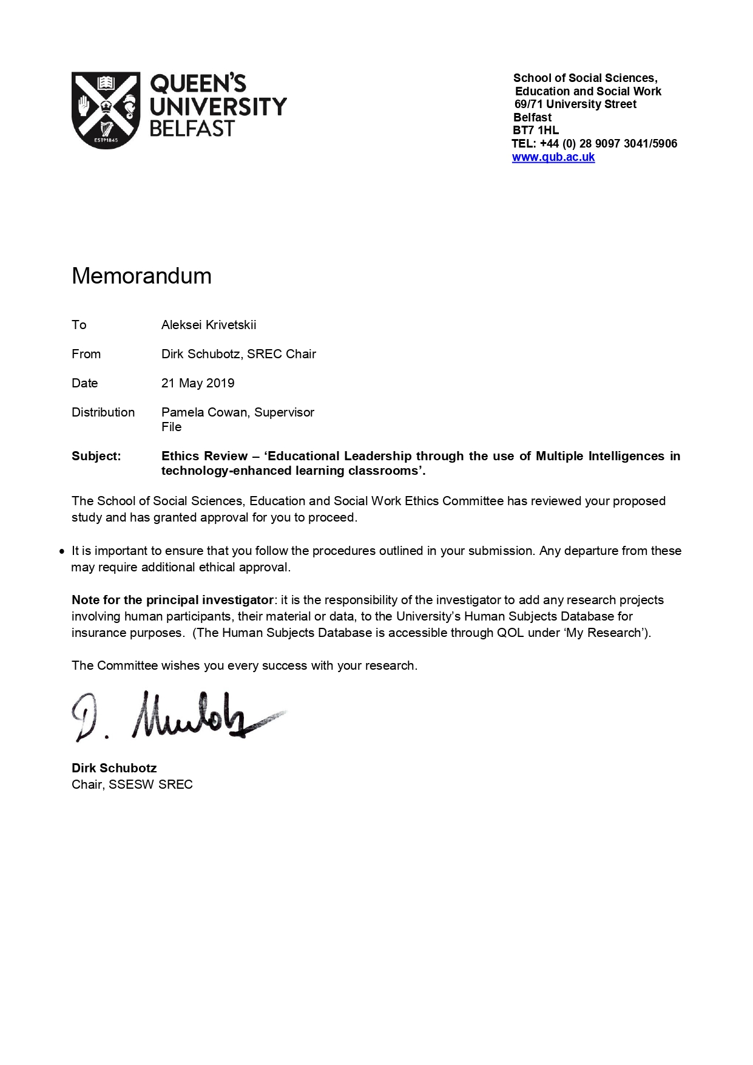

## Appendix B: Participant information and Consent form

**Participant Information and Consent Document**

**Educational Leadership through the use of Multiple Intelligences in technology-enhanced learning classrooms**

**Study description**

The research project is a part of the Masters Degree requirements in the Educational Leadership course at the School of Social Sciences, Education and Social Work, Queen’s University Belfast.

The aim is to establish the role of Multiple Intelligences (MI) in technology enhanced learning classrooms in post-primary classrooms by exploring the views of educational leaders of ICT/ ICT teachers guiding whole school technology development in post-primary schools in Northern Ireland.

We are interested in understanding: To what extent are teachers aware of Multiple Intelligences and to what extent are MI being used in teaching of ICT/computing. Additionally, we seek to understand what areas/topics in computers science support the use of MI, who influences the change in topics being taught in ICT/computing and what the drivers for innovation are.

We will engage with teachers from ICT departments via a link to an online survey during the months of May and June.

**What will participation involve?**

This letter is designed to provide you with information about the study and seek your consent to be involved. Anonymized data will be collected via the online survey which should take approximately 20mins to complete in full. Please note that if you do not wish to participate you are free to withdraw at any stage before you click the Submit option in the survey.

**How will the information been stored?**

The data will be anonymized and no personal details will be collected. We will not use real names or identify institutions/organisations. Similarly we will avoid asking for identifying job roles or titles, where there is a risk of identifying individual participants.

The raw survey data will be stored in a password-protected online repository and will be further processed and kept on the researcher’s password protected QUB computer account.

In accordance with the Ethics policy of School of social Sciences, Education and Social Work at Queen’s University, all materials will be held for a period of no less than 5 years and then destroyed safely and securely.

**What will happen with the information?**

The data will be primarily used to complete a Masters Dissertation project. We may also present elements of the research at conferences and workshops and submit papers to academic journals for publication.

**Confidentiality**

We will take all steps possible to ensure the confidentiality of all participants. This means we will not tell anyone who has participated, names will only be recorded to check sample size of invited participants. Names will not appear in any written documents we produce. The name of schools or specific organisations will not be used when writing papers or presenting findings.

Given the focus of the study we do not anticipate any disclosure of illegal activity, however, if any disclosures of criminal activity emerge, the researcher is required to report it to the relevant authority. Confidentiality and anonymity cannot be guaranteed in such circumstances.

**Withdrawing from the research**

Participation in the research is voluntary and **you are under no obligation to take part.** If you agree to participate and then decide later that you no longer want to participate in the research you can withdraw. However, please note that you will be unable to withdraw from the research after the data has been anonymously submitted. You are free to withdraw at any stage before you submit the survey. The decision to withdraw will not have any negative consequences and will not adversely impact your relationship with the researchers or Queen’s University Belfast. The survey will be open to 30 June 2019.

**Contact details**

If you have any further questions please contact:

Aleksei Krivetskii

MSc Educational Leadership student

School of Social Sciences, Education and Social Work

Queen’s University Belfast

T: 077 6050 9102

E: akrivetskii01@qub.ac.uk

Or my supervisor, Dr Pamela Cowan, [p.cowan@qub.ac.uk](mailto:p.cowan@qub.ac.uk) or 028 9097 5931.

**This research project has been reviewed and approved by the School of Social Sciences, Education and Social Work’s Ethics committee at Queen’s University Belfast.**

**Consent Form**

|  |
| --- |
| I understand that I am being asked to participate in the online survey.  I confirm that I have been given, have read, and understand the information form for the above consultation. I have had the opportunity to ask and receive answers to any questions I had.  I understand that my participation is voluntary and that I am free to withdraw at any stage before I submit the survey.  I understand that all data from the online survey will be treated securely and stored appropriately, and that all identifiable information will be anonymised by the researchers.  I understand that my name and that the name of the school will not be used in this  Study.  I understand that the information I provide may be published in publicly available reports and recounted in verbal presentations.  **By ticking this box, I am indicating that I agree to take part in this research.** |
|
|
|
|
|
|

**Contact details**

If you have any further questions please contact:

Aleksei Krivetskii

MSc Educational Leadership student

School of Social Sciences, Education and Social Work

Queen’s University Belfast

T: 077 6050 9102

E: akrivetskii01@qub.ac.uk

Or Dr Pamela Cowan, Supervisor, 029 9097 5931.

## Appendix C: Copy of online survey questionnaire

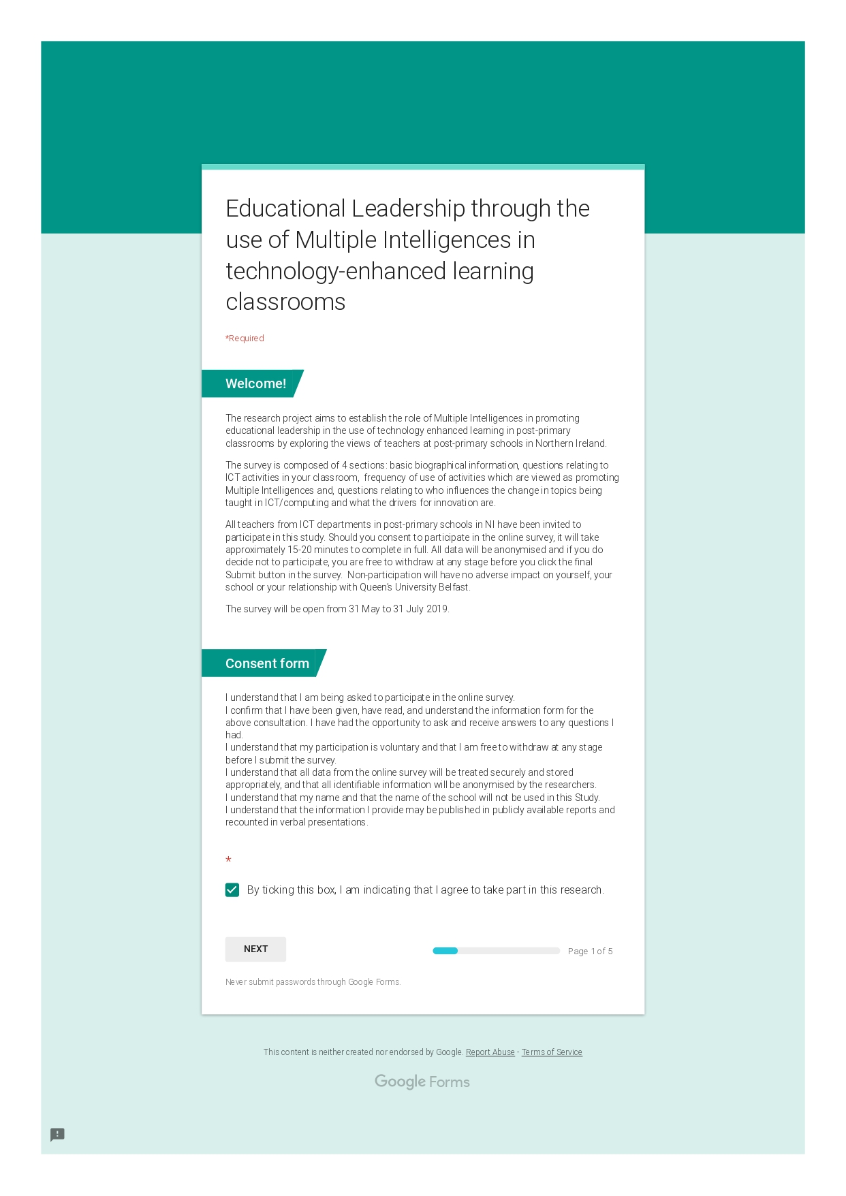

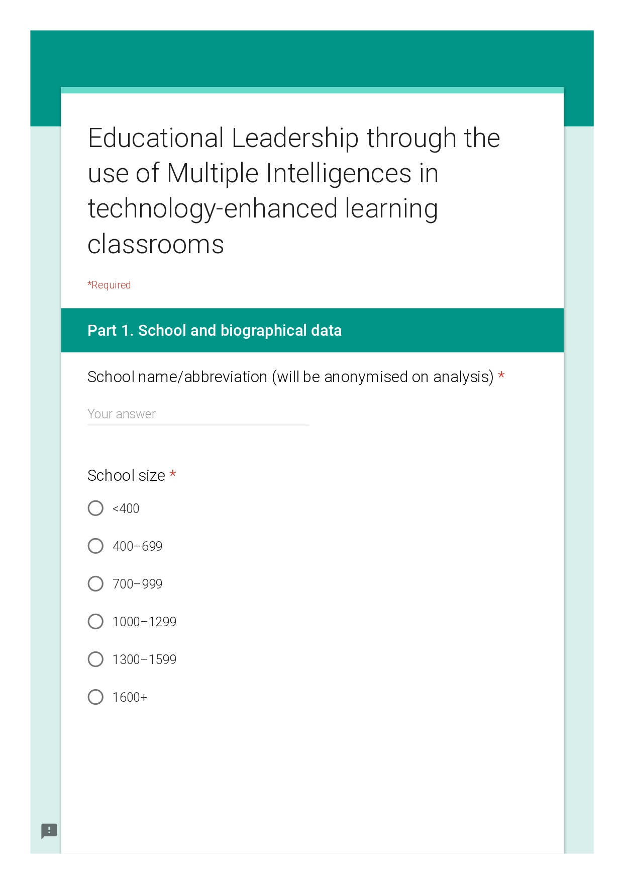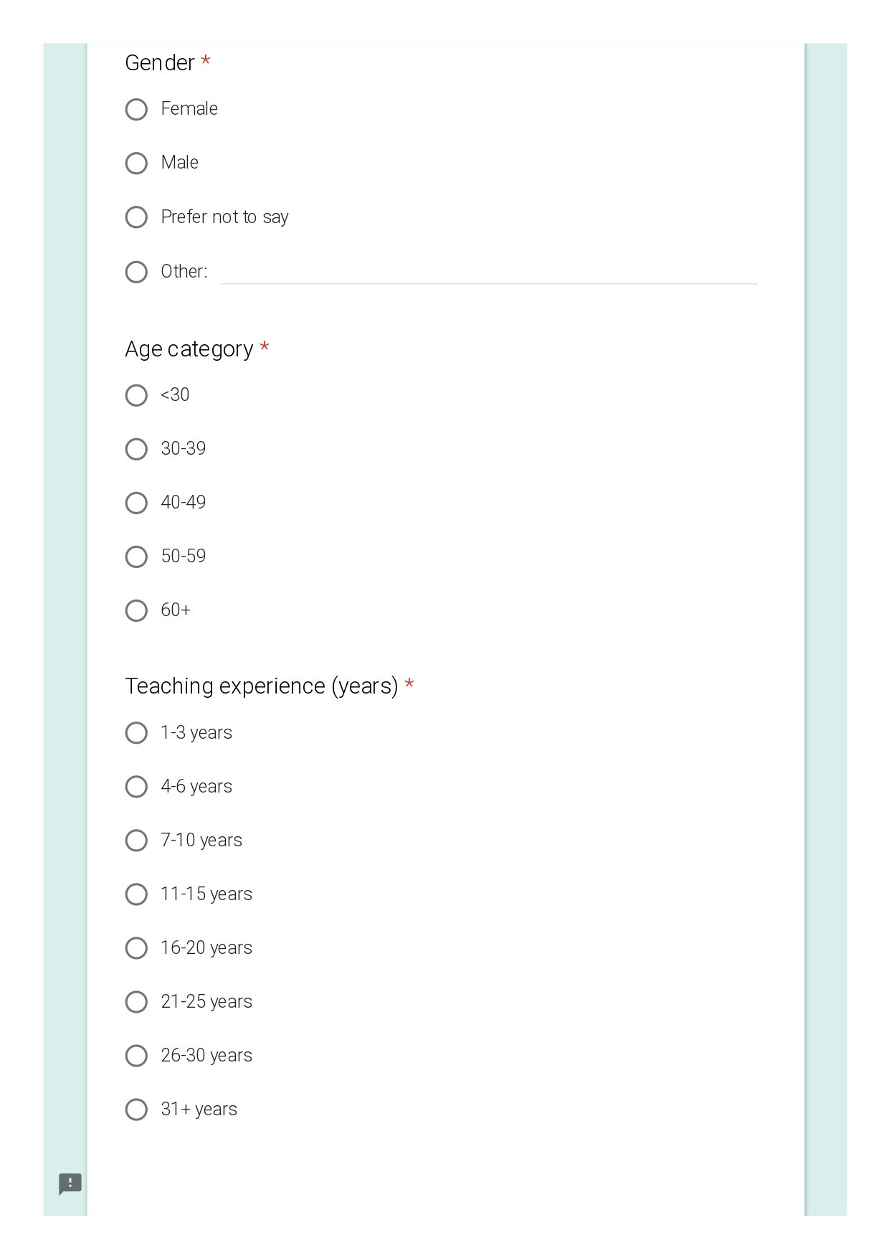

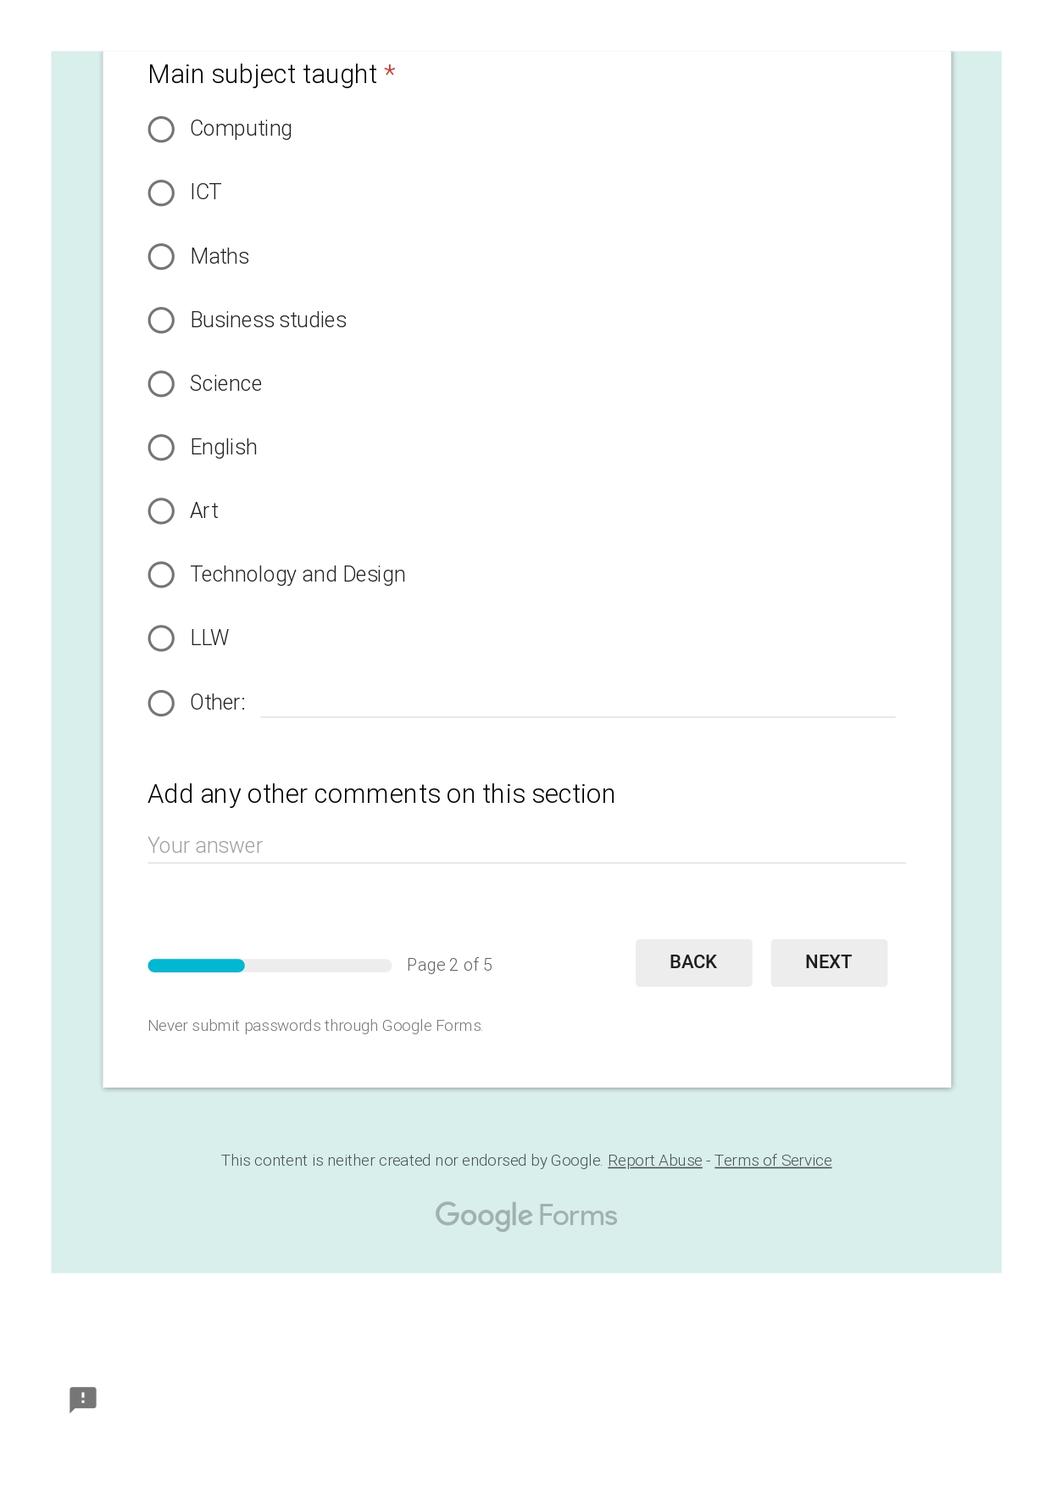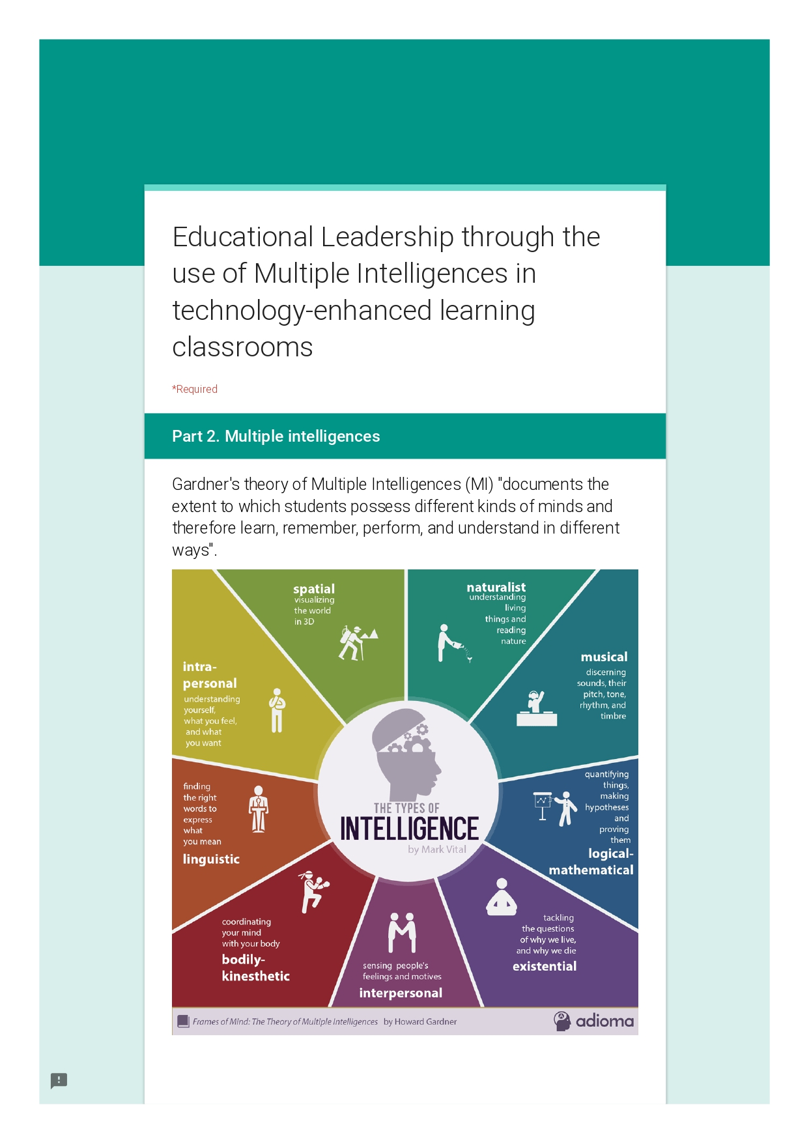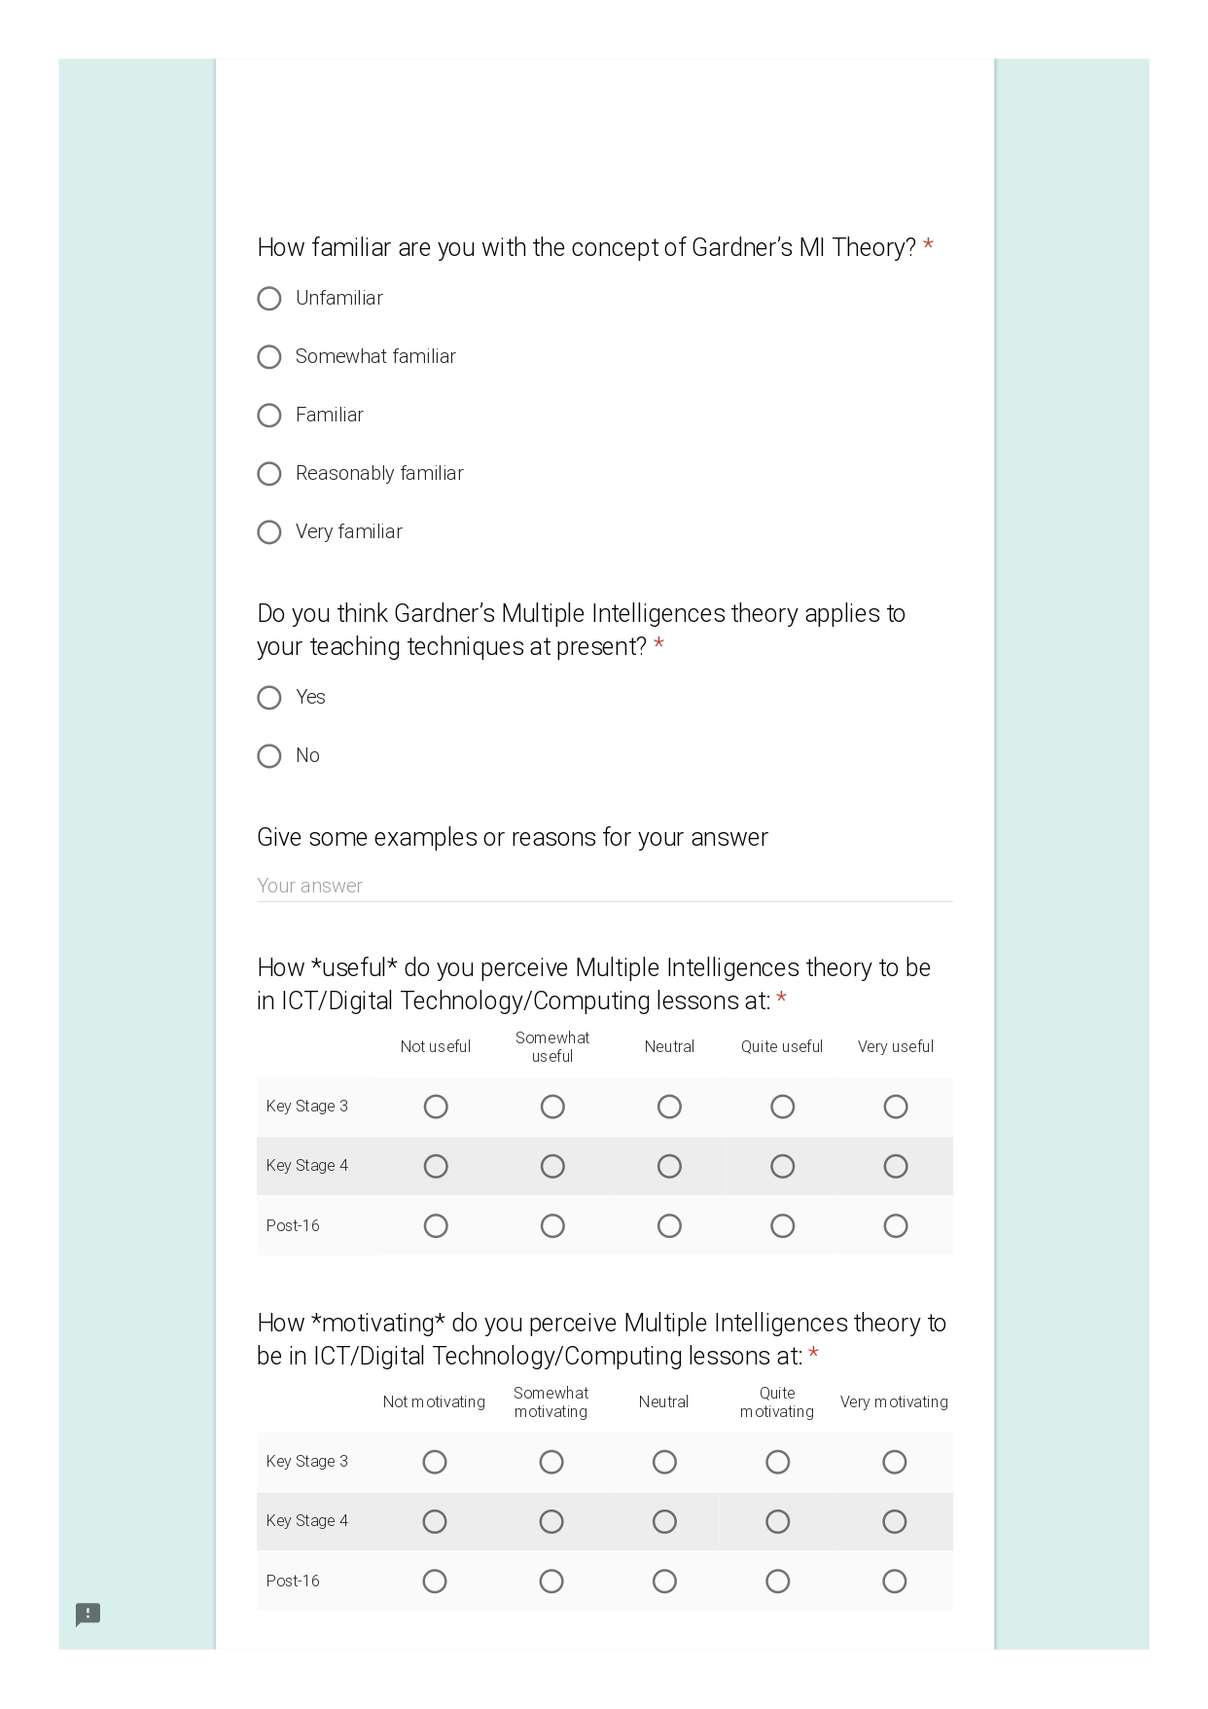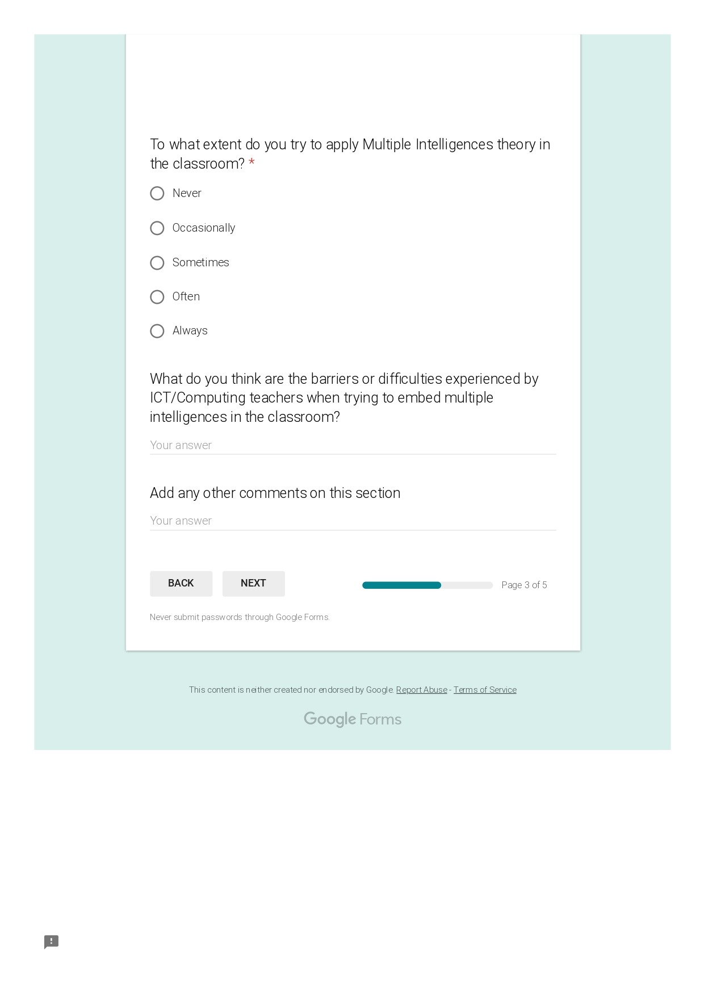

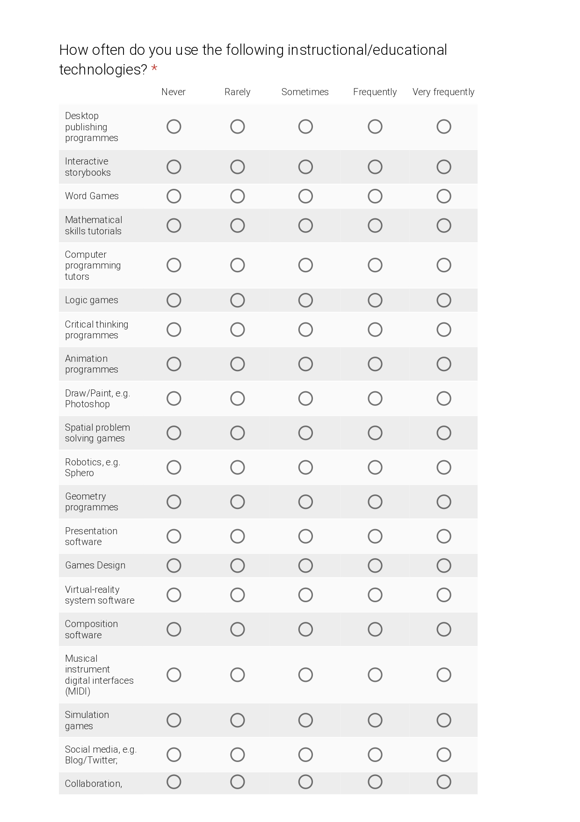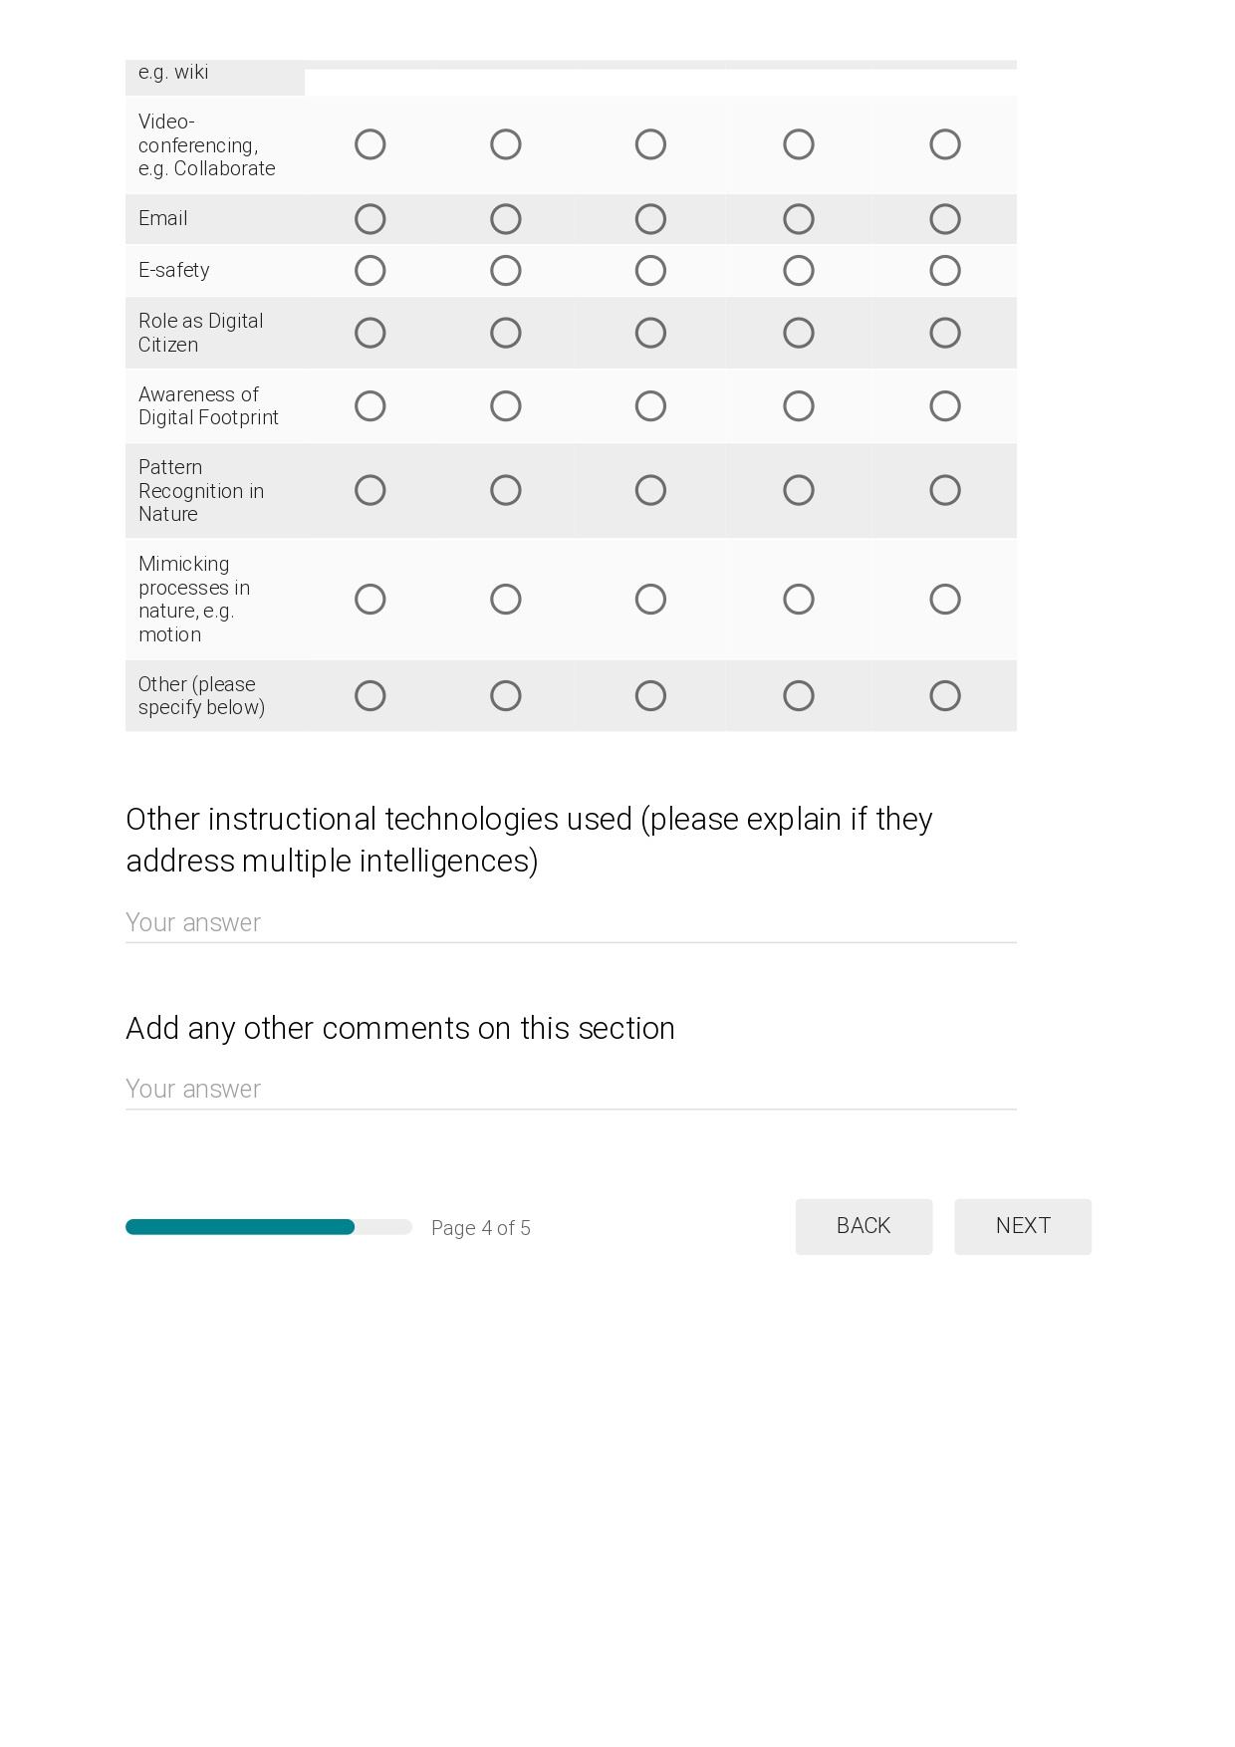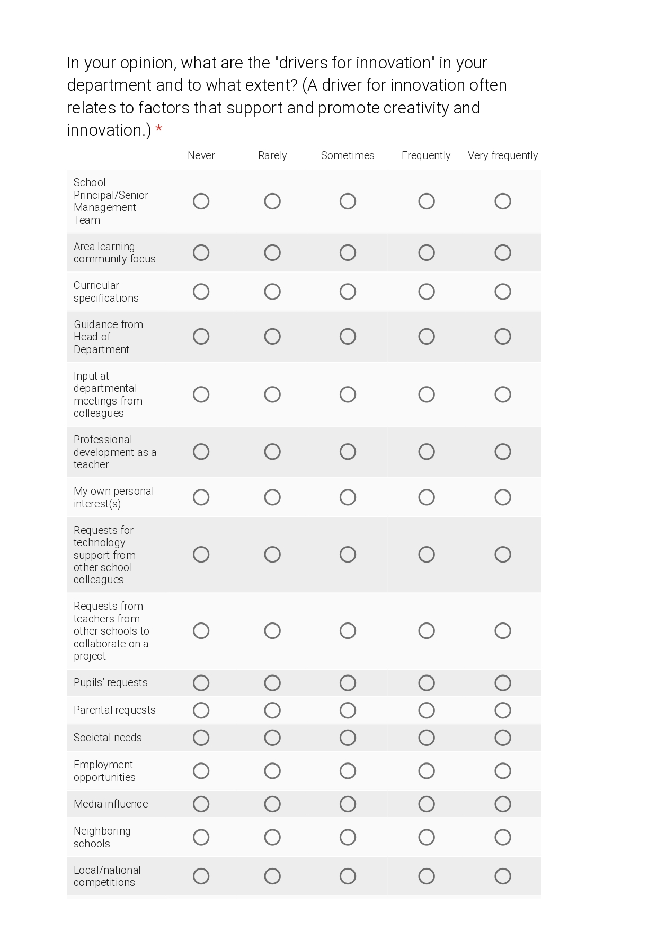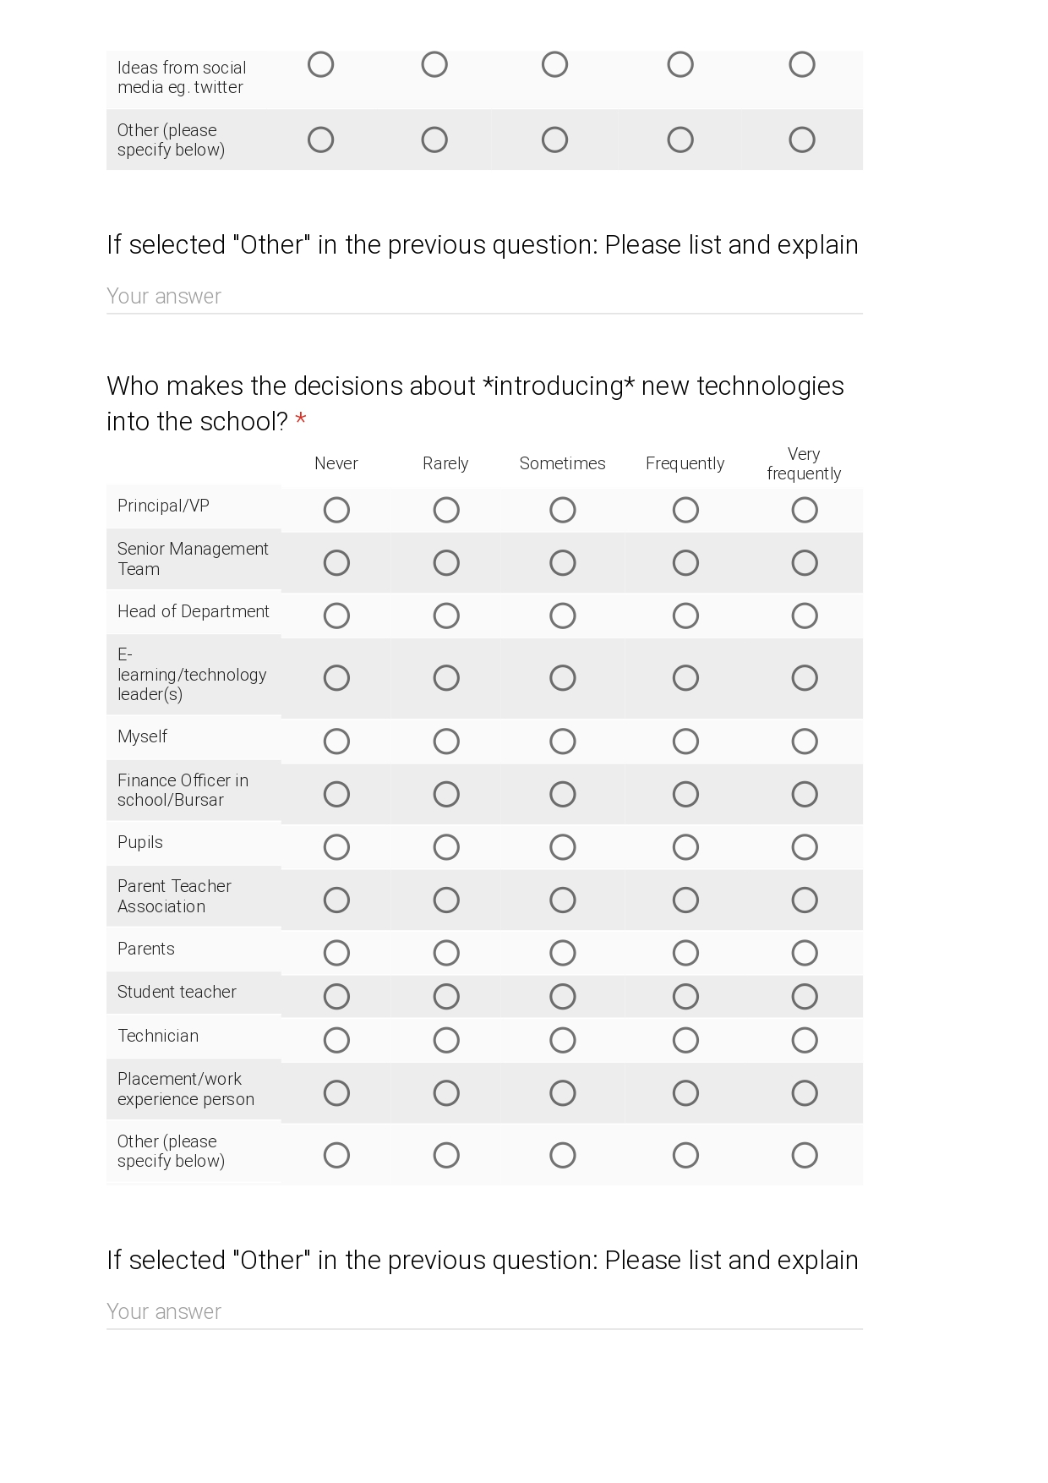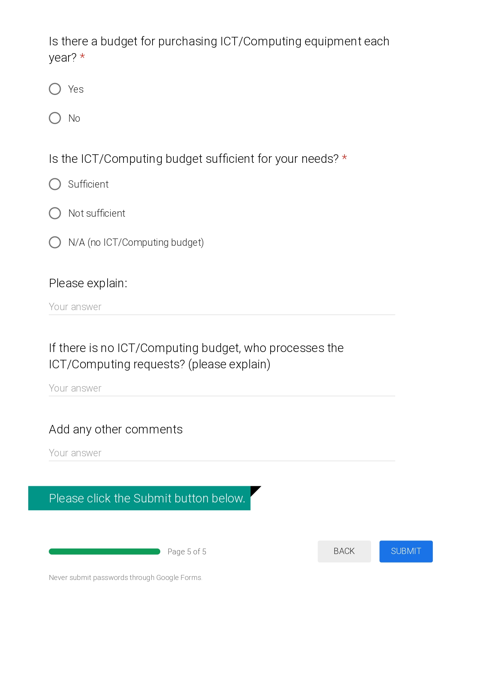

## Appendix D: The types of intelligence

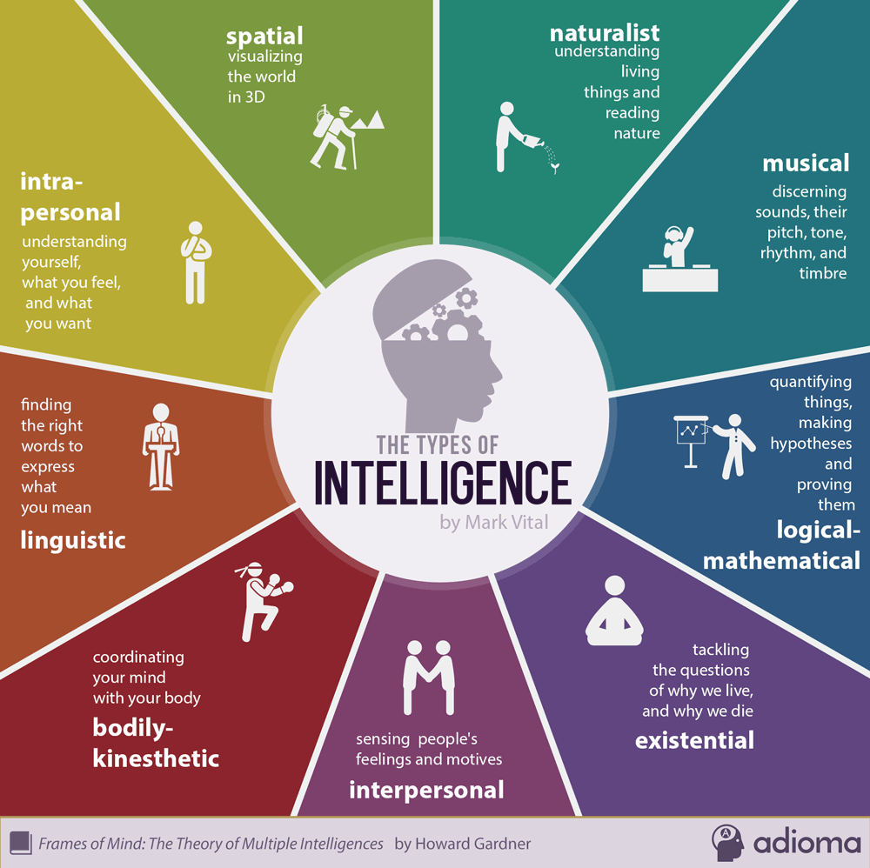

Source: Vital (2014)

## Appendix E: Thematic analysis of qualitative survey data

***Survey question: Do you think Gardner’s Multiple Intelligences theory applies to your teaching techniques at present? Give some examples or reasons for your answer***

Respondents’ answers:

|  |  |
| --- | --- |
| **RN** | **Comment** |
|  | Logical/mathematical - object oriented programming |
|  | Teaching techniques and process within the classroom are low priority within the school, and do not appear in any ***School Development Plan***. |
|  | To some extent I would agree. Pupil’s all learn in different ways. In teaching these are catered for and ***resource*** are provided for them. |
|  | I think Gardner’s Multiple Intelligences applies to every subject in education. In education we aim to develop ***well-rounded individuals who can think for themselves, be resilient, have empathy with others and solve problems*** and I think Gardner’s Multiple Intelligences covers everything we seek to do in education, regardless of the specific subject we specialise in. |
|  | Certainly see a lot of the logical-mathematical type in Computing |
|  |  |
|  | partly, interpersonal can be interpreted of the paired programming I am experimenting with at present. Its actually slower than individual work, but more accurate and stays with the pupil longer |
|  | To a certain extent. I mainly teach programming concepts/skills and so I would consider that I focus on the ‘logical/mathematical intelligence’ |
|  | During my career I have always found that students all have different ways of learning remembering performing etc. It is vital that I use a range of strategies to ***establish what suits each student.*** |
|  |  |
|  |  |
|  | In all my subjects I use word to present images and text to pupils, I get pupils to act out scenes from a topic in History, I get pupils to present to class topics of discussion in all my subjects. Pupils use Microsoft excel and access to create tables and present graph for analysis, interpretation and evaluations in Geog, and BS GCSE etc. |
|  |  |
|  |  |
|  | Evident in any classroom that students learn in different ways and my teaching has to be adapted to match those differing needs. I make an attempt at KS3 to use a variety of techniques including activities to engage more Kinesthetic learners e.g. computational theory introduced using unplugged activities - building bridges using lollipop sticks and elastic bands |
|  | I believe that the acquisition of practical skills and application of software to solving specific problems does not lend itself to clear categorisation within the areas stated. If additional information was presented that clarified how each linked to the world around us, it may be possible to identify links with tasks conducted within ICT classes. If kinaesthetic incorporates the idea of ‘learning by doing’ then this would be a focal point for skills acquisition and development. |
|  | your subject automatically dictates the method you use, especially in practical subjects. any good teacher/department would try to use a range of alternative strategies in the delivery of other components. personally with in theory components I provide the students with the material and actively encourage them to alter it to suit their learning style. giving students notes is not learning engaging them with the notes is the learning. |
|  |  |
|  |  |
|  |  |
|  |  |
|  |  |
|  | Each child is different |
|  |  |
|  |  |
|  | coding in maths. create formula in spreadsheet for maths |

Colour coding key for emerging themes:

|  |
| --- |
| Using variety of techniques; MI theory applies to all subjects |
| Different ways of learning; all pupils are unique - pedagogy |
| Examples of activities catering for MI categories |
| Focus on logical-mathematical intelligence in teaching ICT/Computing |
| Subject dictates the method to use |
| Enhanced quality of learning when catering for MI |
| Low priority of teaching techniques and process in the classroom |

***Survey question: What do you think are the barriers or difficulties experienced by ICT/Computing teachers when trying to embed multiple intelligences in the classroom?***

Respondents’ answers:

|  |  |
| --- | --- |
| **RN** | **Comment** |
|  | Trying to complete the specification in a very short time frame |
|  | Training, time. |
|  | Lack of time to develop multiple versions of ***resources***, ***special educational needs*** need to be considered. The content that needs to be delivered, particularly at KS4 and Post 16 is quite heavy which makes it difficult. |
|  | Confined by the specification requirements, limited time and timetable constraints. Budget cuts, lack of training and effective CPD. |
|  | Realistically there are some of the types which are not relevant to ICT/Computing teaching |
|  | Time to assess each individual students needs |
|  | ***sufficient examples***, I would challenge myself to justify is that one or not |
|  | As indicated earlier, my focus is primarily on problem solving. I suppose that when students work in pairs to solve a problem, there is some interpersonal development but I don’t really consider the other intelligences relevant to what I teach, |
|  | The main difficulties are class sizes and the time needed to establish which of the multiple intelligences suit best each student. |
|  | Topics are not always suited to MI Theory |
|  |  |
|  | Lack of facilities, if equipment is not maintained by C2K, costs to increase RAM in computers - as many are slow, |
|  | Pressure of results |
|  | Non specialist teachers |
|  | As always, particularly at KS4 + KS5, what limits any attempt to embed new practices is the time constraints forced upon teaching, but having to deliver to an examination specification. Only really do I feel I have time to attempt different approaches at KS3. |
|  | Differentiation in skill levels can mean that whilst other pupils might be suitably able to complete a task and subsequently reflect and improve upon it, other may only be able to complete the basic elements of a task given the time available. |
|  | in KS3 95% the content is skills based so very little room for interpretation or reflection. plus there is only an outline of a curriculum. in KS4/5 you have more content to work with but often time limitation is the contributing factor. time to deliver the content and time for the teacher to prepare.  [Other comments on this section]: it is wrong but many schools are still exam factories and this will not change while we have to school system operating in its existing results driven format. many have no choice but to teach to the test. |
|  |  |
|  |  |
|  |  |
|  | Mostly time: in terms of preparing resources to suit multiple intelligences and takes up valuable class time to deliver a lesson which suits multiple intelligences. |
|  |  |
|  | Special need students |
|  | facilities & resources are outdated. Class sizes are too big. |
|  | . Teaching is very complex and teachers are asked to take many things into account in every lesson. To be successful something like this would have to have well organised lesson plans and effective lessons. Maybe good lessons have some things incorporated without the teacher using the specific language. |
|  | lack of resources for all |

Colour coding key for emerging themes:

|  |
| --- |
| Time |
| Pressure of results/specification requirements/content |
| Lack of facilities/resources and budget cuts |
| CPD/training |
| Some MI types irrelevant to ICT teaching |
| Differentiation at skills level/student needs |
| Class size |
| Complex content, hard to adapt |

***Survey question: Other instructional technologies used (please explain if they address multiple intelligences)***

**Respondents’ answers:**

|  |  |
| --- | --- |
| **RN** | **Comment** |
| 3 | Games e.g. Kahoots for end of topic summaries before assessments to determine understanding. |
| 15 | Web design technologies using Dreamweaver; |
| 25 | Started to use minecraft which could use multiple intelligences in a wide variety of ways. Going to use small basic to teach coding but still in development stage. Web design also being introduced into year 10. |

***Survey question: In your opinion, what are the ‘drivers for innovation’ in your department and to what extent? / Other***

Respondents’ answers:

|  |  |
| --- | --- |
| **RN** | **Comment** |
| 3 | Pupil’s interests |
| 9 | Input from Colleagues as a response to curricular needs and drive from Head of Department are the most popular drivers of innovation. |
| 15 | qualification specification |

***Survey question: Who makes the decisions about introducing new technologies into the school? / Other***

Respondents’ answers:

|  |  |
| --- | --- |
| **RN** | **Comment** |
| 9 | Government spending policies. |
| 16 | Suggestions to introduce new technologies have been suggested in the past only to be withdrawn as a potential pathway due to ‘a change of heart’ on the part of more senior staff members |
| 20 | Colleagues in department |

***Survey question: Is the ICT/Computing budget sufficient for your needs? / Please explain:***

Respondents’ answers:

|  |  |  |  |
| --- | --- | --- | --- |
| **RN** | **ICT budget** | **Comment** | **School management type** |
|  | Sufficient |  | Controlled Grammar |
|  | Sufficient | ICT infrastructure development is in line with needs of SDP [school development planning] | Controlled Secondary |
|  | Not sufficient | We need new computers throughout the school for all staff but after receiving new machines in 2 ICT classooms last year, there is little money for new machines elsewhere. | Maintained Secondary |
|  | N/A (no ICT/Computing budget) | We do not have an ICT/Computing budget as such. I have to justify to the Principal why something is needed and how it will ***impact on learning and teaching*** and then a decision is made to grant it or not.  [Who processes the ICT/Computing requests?]  Principal ***in conjunction*** with ICT/Computing HOD | Maintained Secondary |
|  | Not sufficient | We are restricted by a budget and have to prioritise needs | Controlled Grammar |
|  | Not sufficient | Require upgrades in terms of ICT infrastructure move away from IWB [interactive whiteboards] and introduce Touch screens | Maintained Secondary |
|  | Not sufficient | no government, school budgets crushed. We have no money for even paper. Staff is reducing and teaching in ***non specialist subject areas*** to accommodate reduced staff numbers  [any other comments] Its very hard to juggle. I ordered robots last year, they never arrived, nor did the money for them back in the budget. I’m considering getting parents to fund text books this year I have so little in the budget | Controlled Grammar |
|  | Not sufficient | Hardware such as trolley of iPads need updated/replaced as do a number of interactive whiteboards but there isn’t funds to do so.  [Who processes the ICT/Computing requests?] The bursar (with SLT) | Maintained Grammar |
|  | Not sufficient | It has been cut year on year. | Maintained Secondary |
|  | N/A (no ICT/Computing budget) | [Who processes the ICT/Computing requests?]  SLT and Bursar | Maintained Grammar |
|  | N/A (no ICT/Computing budget) | ***whole school rather than departmental budget used***  [Who processes the ICT/Computing requests?]  SLT and the Bursar | Maintained Grammar |
|  | Not sufficient | lack of fiancé [finance] from DENI and EA | Maintained Secondary |
|  | N/A (no ICT/Computing budget) |  | Controlled Grammar |
|  | Not sufficient |  | Controlled Grammar |
|  | Sufficient |  | Controlled Secondary |
|  | N/A (no ICT/Computing budget) | The purchase of new equipment is not controlled by the IT Department but instead by a ***senior member*** of staff.  [Who processes the ICT/Computing requests?]  Equipment purchasing is controlled by the C2K Manager in school. [C2K is the information and communication network funded by the European Union responsible for providing all schools in Northern Ireland with internet and other services to support the Northern Irish Curriculum.] | Controlled Grammar |
|  | Sufficient | It is a department budget but I would not buy new machines or large pieces of equipment. these come from a ***main school budget*** and is negotiated/monitored by the principal and the ICT technician. | Controlled Grammar |
|  | Sufficient |  | Controlled Secondary |
|  | Not sufficient |  | Controlled Secondary |
|  | Not sufficient |  | Controlled Grammar |
|  | Not sufficient | Our budget is mostly consumed by photocopying costs. | Controlled Grammar |
|  | Sufficient |  | Maintained Secondary |
|  | Sufficient |  | Controlled Secondary |
|  | Not sufficient | funding of schools is atrocious yet principals, parents, inspectors, politicians poor demands on us.enough is enough.  [Who processes the ICT/Computing requests?]  no money. teachers not listened too any more and treated like dirt. | Maintained Grammar |
|  | Sufficient | [Who processes the ICT/Computing requests?]  Processed as requested- this usually depends on age of computers and curriculum needs. | Controlled Grammar |
|  | Not sufficient | technology goes out of date too quickly and training isn’t always available | Maintained Secondary |

Colour coding key for emerging themes:

|  |
| --- |
| identification of a problem with budget availability |
| personal leadership initiative / solving a problem |
| suggestions of innovation needed |
| specific drivers for innovation |